



United Nations Development Programme
Project title: Democratic Republic of the Congo National Child Project under the Africa Minigrids
Program
Country(ies): Democratic Republic of the Congo (DRC) | Implementing Partner (GEF Executing Entity): Agence Nationale de l’Electrification et des Services Energétiques en milieux Rural et Périurbain (ANSER) |  |  |  | Execution Modality: Full NIM  (NIM)
Contributing Outcome (UNDAF/CPD, RPD, GPD):
UNSDCF Outcome 1.1: By 2024, the Congolese people enjoy sustainable inclusive economic growth driven by agricultural transformation, economic diversification open to innovation and the promotion of entrepreneurship among young people and women.

CPD Output 2.4: Solution adopted to improve access to clean affordable and sustainable energy.
UNDP Social and Environmental Screening Category:  Substantial |  |  | UNDP Gender Marker:  GEN3
Quantum Award ID: 1212265 |  |  | Quantum Project ID: 01001601
UNDP-GEF PIMS ID number: 6702 |  |  | GEF Project ID number: 11043
LPAC meeting date: TBD
Last possible date to submit to GEF: 22 September 2023
Latest possible CEO endorsement date: 19 December 2023
Project duration in months: 48 months
Planned start date: 1 June 2024 |  |  | Planned completion date: 30 May 2028
Expected date of Mid-Term Review (MTR) submission to the GEF: 1 June 2026 |  |  | Expected date of Terminal evaluation (TE) submission to the GEF: 30 May 2028
Expected Operational Closure Date: 31 May 2029 |  |  | Expected Financial Closure Date: 31 December 2029
Brief project description:
The Africa Minigrids Program (AMP) is a UNDP/GEF-supported regional technical assistance program, aiming to support access to clean energy by increasing the financial viability and promoting scaled-up commercial investment in renewable energy (RE) minigrids, with a focus on cost-reduction levers and innovative business models. The AMP consists of a Regional Project and several national projects in a total of 21 AMP participating countries. The AMP DRC Project (‘project’) is a national project under the AMP.

The project objective is to “support access to clean energy by increasing the financial viability, and promoting scaled-up commercial investment, in low-carbon minigrids in the DRC with a focus on cost-reduction levers and innovative business models”. The Project will be nationally implemented by ANSER over a 4-year period.

The project is aligned with and will directly support the implementation of the minigrid component of the ‘Local Development Program dedicated to the 145 territories’ (PDL-145T), the largest rural infrastructure investment program of the government to date with a focus on rural territories.

The project is expected to bring about the commissioning of at least 11.971 MW in solar photovoltaic (PV) generation capacity and 29.187 MWh of battery storage. The lifetime greenhouse gas (GHG) emissions reduction from project activities, particularly investment in minigrid pilots, is estimated at 665,103 metric tons of carbon dioxide equivalent (tCO2eq) (direct) and 3,195,842 tCO2eq (indirect). The number of direct beneficiaries is estimated at 342,168 people, of which at least 50% percent are women, as a result of 69,133 new minigrid connections.
Financing Plan
GEF Trust Fund grant |  |  | USD 408,716
UNDP TRAC resources |  |  | USD 500,000
Confirmed cash co-financing to be administered by UNDP |  |  | USD 0
- Total Budget administered by UNDP |  |  | USD 908,716
- Total confirmed co-financing to this project not administered by UNDP |  |  | USD 60,642,000
- Grand-Total Project Financing (1)+(2) |  |  | USD 61,550,716
Signatures:
Signature: print name below |  | Agreed by Government Development Coordination Authority |  | Date/Month/Year: within 6 months of GEF CEO endorsement
Signature: print name below |  | Agreed by Implementing Partner |  | Date/Month/Year: within 6 months of GEF CEO endorsement
Signature: print name below |  | Agreed by UNDP |  | Date/Month/Year: within 6 months of GEF CEO endorsement

I. Table of Contents
II. Development Challenge 6
III. Strategy 21
IV. Results and Partnerships 35
V. Project Results Framework 53
VI. Monitoring and Evaluation (M&E) Plan 56
VII. Governance and Management Arrangements 68
VIII. Financial Planning and Management 73
IX. Total Budget and Work Plan 76
X. Legal Context 82
XI. Risk Management 82
XII. Mandatory Annexes 86
Annex 1: GEF Budget Template 87
Annex 2: GEF execution support letter Services (Not applicable) 91
Annex 3: Project map and Geospatial Coordinates of project sites 92
Annex 4: Multi Year Work Plan 94
Annex 5: UNDP Social and Environmental Screening Procedure (SESP) 96
Annex 6: UNDP (Atlas) Risk Register 107
Annex 7: Overview of Project Staff and Technical Consultancies 112
Annex 8: Stakeholder Engagement Plan 114
Annex 9: Environmental and Social Management Framework (ESMF) 132
Annex 10: Gender Analysis and Gender Action Plan 132
Annex 11: Procurement Plan 133
Annex 12: GEF focal area specific annexes 136
Annex 13: Co-financing letters 136
Annex 14: Additional agreements 136
Annex 16: GEF Core indicators 137
Annex 17: GEF 7 Taxonomy 138
Annex 18: Partners Capacity Assessment Tool and HACT assessment 140
Annex 19: UNDP Project Quality Assurance Report 140

List of Tables
Table 1: Expected results for the PDL-145T. 7
Table 2: Overview of institutional actors in the DRC's energy sector 9
Table 3: Overview of the regulatory framework governing the on-grid and off-grid electricity sectors 11
Table 4. Key risks and barriers to develop renewable energy minigrids 16
Table 5. Policy context for renewable energy minigrids in the DRC 17
Table 6: Overview of the DRC's minigrid delivery model 31
Table 7. List of co-financed activities 50
Table 9: Budget Notes 80
Table 10: Stakeholder engagement plan 119

List of Figures
Figure 1. Africa Minigrids Program’s Architecture 21
Figure 2. Africa Minigrids Program’s participating countries list and map 22
Figure 3. Africa Minigrids Program’s Theory of Change 23
Figure 4. AMP’s Key Areas of Opportunity 25
Figure 5. Conceptual outline of minigrid delivery models 26
Figure 6. Digital and data opportunities for minigrids in the AMP 27
Figure 7: Overview of the zones of the three implementation agencies for the PDL-145T. 30
Figure 8: Overview of the implementation arrangement for the UNDP-led PDL-145T minigrid component. 31
Figure 9: Project governance structure 69

List of Box Inserts
Box 1. UNDP’s DREI Framework 24
Box 2. The Concept of a Minigrid Delivery Model 25
Box 3: Digitalization and Minigrids 26
Box 4: Key principles for AMP minigrid pilot implementation 33
Box 5: AMP Regional Project Indicative Service Offering 34
Box 6: Indicative Specifications for AMP Projects Digital Platform 46
Box 7: GEF-7 Core Indicators 57
Box 8: M&E linkages to the AMP Regional Project 59

List of Acronyms
AMP | Africa Minigrids Program
ANSER | L’Agence Nationale de l’Electrification et des Services Energétiques en milieux rural et périurbain (National Agency for Rural and Peri-Urban Electrification)
ARE | L'Autorité de Régulation du secteur de l'Electricité (Electricity Regulatory Authority)
BCeCo | Bureau central de coordination (Central Coordination Bureau)
CFEF | Cellule d’exécution des financements en faveur des États fragiles (Unit for Execution of Funding towards Fragile States)
CNE | (National Energy Commission)
DRC | Democratic Republic of Congo
DREI | Derisking Renewable Energy Investment
FSP | Full Sized Project
GEF | Global Environment Facility
GEFSEC | Global Environment Facility Secretariat
MRHE | Ministry of Water Resources and Electricity
MSP | Medium Sized Project
PDL-145T | Programme de développement local des 145 territoires (Local Development Program for 145 Territories)
PIF | Project Identification Form
PIR | GEF Project Implementation Report
POPP | Programme and Operations Policies and Procedures
PPG | Project Preparation Grant
SNEL | Société nationale d’électricité de la RDC
STAP | GEF Scientific Technical Advisory Panel
UCM | Unité de Coordination et de Management des Projets du Ministère (Project Coordination and Management Unit of the MRHE)

II. Development Challenge

- Country context
  - Overview
The Democratic Republic of Congo (DRC), with a population of 96 million, is the largest country within Sub-Saharan Africa. Situated in the heart of Central Africa, the DRC shares borders with nine nations and spans an area of 2.3 million km², an expanse equivalent to the size of Western Europe. Comprising 26 provinces and 145 territories, the DRC is endowed with substantial natural resources. These include the richest and most diverse mineral reserves globally, significant hydropower potential, extensive arable land, rich biodiversity, and the world's second-largest rainforest. Since 2006, the nation adheres to a semi-presidential governance structure, with the President functioning as the state leader and the Prime Minister serving as the principal government executive. The executive power in the 26 provinces is held by democratically elected governors and their corresponding provincial ministers.

The DRC remains a nation fraught with political fragility, underscored by its extensive history of instability, political turmoil, and armed conflict. This enduring political instability stems, in large part, from various political factions and groups intent on exploiting the DRC's rich natural resources. Consequently, the majority of the DRC's population has been denied the benefits of their country's natural wealth. Widespread poverty pervades the nation, positioning it amongst the five poorest countries globally. In 2022, approximately 63% of its inhabitants were reported to be living in poverty, subsisting on less than $2.15 per day. As per the 2021-2022 Human Development Index, the DRC occupies the 179th position out of a total of 191 countries and territories. DRC’s Social Institutions and Gender Index (SIGI) value of 46.9 place it among countries with high gender inequality reflecting a discriminatory family code, and inequality in physical integrity, access to resources and assets, and citizen rights.

Between 2010 and 2020, the DRC experienced average economic growth of around 4%, surpassing the 2.6% African average, driven by structural reforms and institutional stability amid fluctuating commodity prices. However, this growth was limited to certain sectors, mainly extractive and agricultural, resulting in limited socio-economic improvement. The reliance on natural resource exports, including copper, cobalt, and coltan, has its drawbacks, including few employment opportunities and low productivity in the informal sector.

The country’s infrastructure is in a state of significant disrepair and access to essential services remains very low, even when compared to other countries in Sub-Saharan Africa. This acts as a significant impediment to sustainable, inclusive growth, and the delivery of services. The disparities are especially notable in the sectors of road transport, internet availability, electricity provision, and access to water and sanitation facilities. These substantial infrastructural deficiencies, coupled with ineffective governance, have led to geographical seclusion and socioeconomic discrepancies among provinces, as well as between urban and rural regions. Furthermore, they pose a considerable obstacle to business operations and amplify the expenses associated with any large-scale infrastructure project.

DRC has the second largest population without access to electricity in Africa with 76 million people lacking access, the majority of which (51 million) are located in rural areas. Moreover, the electrification rate in rural areas stands at 1%, the lowest in the African continent, while the national electrification rate stands at 21%.

  - Programme de développement local des 145 territoires (PDL-145T)
To address the lack of infrastructure in rural territories, in 2021 the government launched a substantial initiative to curtail spatial disparities and improve the living standards of rural Congolese inhabitants. The Programme de développement local des 145 territoires (Local Development Program for 145 Territories, PDL-145T) embodies the government's sustained efforts to significantly reduce poverty, mitigate territorial inequality, and promote development across the DRC's 145 territories. The program, estimated to cost around US$1.7 billion (constituting 2.7 percent of GDP), aligns with the stipulations of the National Strategic Development Plan. An overview of the expected results is provided in Table 1 below.

Table 1: Expected results for the PDL-145T.
Results | Values | Units
Rehabilitation of farm feeder roads | 8.844 | km
Maintenance of agricultural feeder roads | 30.091,5 | km
Construction of engineering structures (bridges, ferries and dalots) | 444 | Numbers
Construction of solar minigrids | 418 | Minigrids
Street lighting with solar system (1 to 3 km) | 471 | km
Construction of 150 m boreholes with integrated pumps | 3.071 | Boreholes
Development of water sources | 447 | Numbers
Construction of modern markets with living space | 238 | Markets
Construction of an administrative building in each territorial capital | 145 | Buildings
Construction of an administrative building in each sector capital | 636 | Buildings
Construction of housing for territory management staff | 1.450 | Housing
Construction, rehabilitation and equipping of health centers | 788 | Health centers
Construction, rehabilitation and equipping of schools | 1.210 | Schools
Structuring and professionalization of local producers by promising agricultural sectors | 500.000 | Households
Area developed and equipped by territory and for 4 sectors | 43.500 | ha
Supply of inputs and seeds to local producers | 500.000 | tons
Acquisition of production, processing and transformation equipment | 4.340 | Equipment

Three different implementing agencies have been tasked by the government to implement the PDL-145's interventions. These include two subunits of the Finance Ministry, the Bureau central de coordination (Central Coordination Bureau, BCeCo) and the Cellule d’exécution des financements en faveur des États fragiles (Unit for Execution of Funding towards Fragile States, CFEF), alongside the United Nations Development Programme (UNDP). UNDP will implement the PDL-145T in nine provinces spanning 54 rural territories, following a cost-sharing agreement with the DRC Government. The remaining provinces (14) will be managed by the other two implementing agencies.

The PDL-145T's operational tasks will be executed under four components: (i) Development of basic socio-economic infrastructure, (ii) Revitalization of local and rural economies, (iii) Strengthening of local governance, and (iv) Development of a geo-referenced information system for PDL-145T monitoring. The program's implementation is expected to substantially reduce poverty and spatial disparities, improve rural populations' access to essential socio-economic infrastructure and services, augment rural agricultural producers' income, enhance food security, bolster access to income-generating activities for the youth and women, and improve management of risks confronting rural populations. Furthermore, the program will help to fortify local governance and the resilience and initiative capacity of vulnerable communities.

The funding for PDL-145 is partially sourced from the International Monetary Fund’s Special Drawing Rights (SDR) allocation of August 2021. The government resolved to allocate half of the SDR towards bolstering international reserves, whilst directing the other half (approximately US$714 million) as budgetary support. A segment of this budgetary support was earmarked for partially financing the PDL-145 initiative. The PDL-145 allocates $511 million towards the construction of schools, administrative buildings, and health centers, and $105 million is reserved for the electrification of rural territories.

- Energy Sector
  - Overview
The power sector in the DRC faces substantial hurdles, including insufficient generation and transmission capacity, substandard electricity supply quality, and limited electricity access in the country's rural areas. Although the nation is endowed with a significant hydropower potential of 40 GW, only a marginal fraction of this capacity has been harnessed thus far.
The installed electricity generation capacity stands at approximately 3,067 MW. The state-operated utility, Société nationale d’électricité de la RDC (SNEL), controls 2,624 MW (85.5%) of this capacity, with private producers controlling 363 MW (11.9%) and other public entities controlling 80 MW (2.6%). The nation's generation capacity predominantly relies on hydroelectricity (> 98%), followed by thermal generation (< 2%) and photovoltaic generation (< 1%). A considerable proportion of the country's generation capacity is frequently offline due to technical issues resulting from underinvestment and a lack of proper maintenance.
Industrial customers, primarily from the extractive industry, dominate electricity consumption, accounting for 68% of the total. The remaining consumption is shared between the residential sector (17.5%) and public and commercial services (14.5%). Over the past half-decade, the DRC has experienced a steady rise in electricity consumption, resulting in a cumulative growth rate nearing 40 percent between 2017 and 2021. This consumption surge is fueled by the extractive sector, which nearly doubled, while residential and service sector consumption remained stable, notwithstanding population growth and the expansion of the capital Kinshasa and other major cities.
Across all customer segments, the DRC's power system fails to satisfy both existing and projected demand. A considerable portion of residential demand remains unfulfilled due to the pronounced lack of energy access. Industrial customers also grapple with inadequate energy access, often resorting to self-generated power using imported fossil fuels. Furthermore, demand in both sectors is projected to increase dramatically over the coming decade, underscoring the urgency to enhance the state of the power system.
Urbanization serves as a critical factor in the DRC's energy sector dynamics. Approximately 43% of the country's population resides in urban areas, a figure that is increasing annually. The national energy access rate stands at 21%, with 44% of the urban population enjoying energy access, contrasted by 1% of the rural population.
  - Legal and institutional framework
The foundation of the DRC’s energy sector is the Electricity Sector Act of 2014. This law liberalized the country's energy sector, providing market access to power generation, transmission, and distribution. Additionally, it initiated a decentralized electrification program across the nation's 145 territories and opened the regional integration of the electrical system to investor engagement. The legislation's overarching objective is to facilitate universal access to electricity and catalyze substantial enhancements in the country's energy sector.
The Société Nationale d'Électricité (SNEL) serves as a critical actor within the DRC's power infrastructure. As the principal industrial and retail power supplier with a customer base exceeding 800,000, SNEL oversees approximately 85% of the country's electrical infrastructure.
Institutional governance of the electricity sector is a multi-tiered structure involving the central government, the country's 26 provinces, the Electricity Regulatory Authority (ARE), the National Agency for Rural and Peri-Urban Electrification (ANSER), and the National Energy Commission (CNE). At the central government level, responsibility is partitioned amongst the Ministry of Water Resources and Electricity (MRHE), the sector's supervising entity; the Ministry of Portfolio (MPF), representing the state as the sole shareholder in SNEL; the Ministry of Economy, responsible for tariff-related issues; and the Ministry of Environment and Sustainable Development (MEDD), in charge of environmental concerns. Additionally, the Project Coordination and Management Unit of the MRHE (Unité de Coordination et de Management des Projets du Ministère, UCM) is dedicated to the coordination and management of all donor-financed energy projects. The main governmental body in charge of mainstreaming gender into the energy sector is the Gender, Energy and Development Cell (CGED) of the MRHE.
The governors and provincial energy ministers of each of the DRC's 26 provinces are, within the legal boundaries, responsible for the promotion, regulation, and monitoring of sectoral activities and ensuring the nationwide application of the Electricity Act and its accompanying regulations.
Table 2: Overview of institutional actors in the DRC's energy sector
Institution | Mandate
Ministry of Water  Resources and Electricity (MRHE) | Ministry with responsibility for the design and implementation of energy policy. Responsibilities include design and implementation of electricity master plans, regulatory mechanisms, sector reforms, and monitoring and control of water and electricity production, transmission, and distribution. Within MRHE, the CGED oversees gender mainstreaming in the energy sector.
Ministry of the Environment and Sustainable Development (MEDD) | In relation to the energy sector, the ministry is responsible for:  - the design and implementation of policies related to environmental management  - assessment and review of environmental and social studies related to projects.
Ministry of the Portfolio (MPF) | The MPF is the sole shareholder of SNEL and as such responsible for SNEL’s administration and management.
Electricity Regulatory Authority (ARE) | ARE is the DRC’s energy regulator established as part of the 2014 Electricity Sector Act and operationalized in 2020. Its tasks include promoting competition and private-sector involvement in the energy industry, ensuring compliance with concession contracts and licenses, overseeing network access, monitoring industry standards, facilitating dispute resolution, and proposing tariffs based on cost elements provided by operators.
National Agency for Electrification and Energy Services in rural and suburban areas (ANSER) | ANSER is the DRC’s rural electrification agency established as part of the 2014 Electricity Sector Act and operationalized in 2020. Its objective is to promote and finance electrification in rural and peri-urban areas. Its tasks include collecting and sharing national energy potential data, creating electrification plans, supporting initiatives through technical and financial assistance, managing tender processes, facilitating project implementation, and handling financing and relationships with lenders. In 2022, ANSER adopted a Gender Strategy and Gender Action Plan.
National Energy Commission (CNE) | CNE is an advisory and coordination body created in 1981. Its mission includes defining energy policy, coordinating energy-related departments and organizations, promoting research and development of national energy resources, planning energy activities, implementing energy programs, disseminating energy sector information, addressing various energy issues, and providing practical training for executives.
Provincial  governors and ministers provincial energy | Provinces are responsible for promoting, controlling, and monitoring electricity activities within their jurisdictions, ensuring compliance with electricity sector laws and regulations. They collaborate closely with MRHE, ARE, ANSER, and CNE. Provinces grant concessions for energy sources or power grids of local interest, following specifications provided by ARE and approved by provincial authorities. Concessions must align with national electricity policy and avoid negative environmental impacts on other provinces or neighboring countries. Provinces also grant licenses for production or marketing of electrical energy to decentralized territorial entities or provinces, with applications reviewed by ARE before final decisions by provincial authorities. Concessions and licenses are awarded through a tender process following public procurement procedures.

- Minigrid Sector
  - Overview
In the DRC, the traditional model of centralized power generation and grid expansion has faced significant challenges as described above, resulting in a power system unable to meet demand and in very low energy access rates in rural areas of the country. In the wake of the liberalization of the energy sector with the 2014 Electricity Sector Act, off-grid solutions like renewable energy minigrids have gained traction in rural and peri-urban energy markets. They provide electricity to residential and institutional needs, support productive energy uses, and serve key community service providers.
Given the opportunity presented by minigrids, numerous initiatives and programs are being executed or planned by the public and private sector as well as international organizations (See Section 3.3).
  - Minigrid legal and institutional framework
The government of the DRC has not identified a specific minigrid delivery model and no minigrid-specific policy framework exists to date, i.e., minigrids have to comply with the prevailing (on-grid) regulations as part of the 2014 Electricity Sector Act.
However, the government and the various institutions in the energy sector have been working actively to catalyze minigrids and are implementing several initiatives in parallel and in collaboration with a variety of international organizations. The common thread in these initiatives is that private sector participation plays a significant part, ranging from providing public subsidy support to unsolicited private sector projects to procuring private firms to operate and maintain government-owned assets.
The principal institution in the DRC’s minigrid sector is ANSER with the mission to increase energy access in the country’s rural and peri-urban areas. It is responsible for reviewing and approving applications for concessions in concurrence with national or provincial government counterparts. Additionally, ANSER performs electrification planning exercises in collaboration with the national energy ministry MRHE as well as the national energy advisory body CNE.
The regulator ARE is responsible for reviewing and approving tariff applications.
The policy regime for minigrids is summarized in the table below. In brief, as for on-grid projects, private actors can apply for Concession, License and Authorization (CLA) for solicited or unsolicited projects to ANSER who will review it in collaboration with either the national minister or the provincial governor. In a separate process, private actors have to apply for a tariff determination with the ARE. Additionally, local, regional, and national regulations may apply to such projects, such as requirements to perform environmental impact assessments.
While the existing regulations and responsibilities are clear in theory, in practice private operators have had difficulty navigating these institutional and regulatory processes. This is a result of the recent operationalization of the main institutions ANSER and ARE, which began in 2019 and 2020, causing a lack of capacity and familiarity with these complex subjects and a lack of coordination with the other responsible institutions, particularly provincial governments. Additionally, the lack of a minigrid specific framework presents challenges, as on-grid projects typically require more burdensome application materials than is feasible for smaller minigrid operations.
Table 3: Overview of the regulatory framework governing the on-grid and off-grid electricity sectors
Legal regimes | Activities | Responsibility
Concession | Production established in the public domain, as well as those for the transport and distribution of energy and electricity. | National Government | Provincial Government
Concession |  | For energy sources or electricity networks of national interest, the national government grants the concession. | For energy sources or electricity networks of provincial or local interest, the provincial government grants the concession.
License | - Independent production of electrical energy with a power equal to or greater than 1,000kW is carried out outside the public domain.  - Import and export of electrical energy.  - Commercialization of electrical energy. | National Government | Provincial Government
License |  | The license for importing or exporting is granted by the central government. | The license for the production or for the sale of electrical energy to cover the needs of an ETD is granted by the provincial government.
Authorization | - Self-production installation outside the public domain, with an installed capacity of between 100kW and 999.99kW.  - Establishment of private power lines using or crossing a public road, or a point located less than 10 meters horizontal distance from an existing power, communication, or telecom line on a public domain. | Provincial Government | Decentralized Territorial Entity (ETD)
Authorization |  | Granted by the province under the conditions set by regulation, on a proposal from ARE. | Granted by ETDs under the conditions set by regulation, on a proposal from ARE.
Declaration | Power to be installed by a self-generator, outside the domain. It needs to be between 51 and 99Kw. | Decentralized Territorial Entity (ETD)
Declaration |  | Make a written declaration to the local administration in charge of electricity, which has to acknowledge receipt.
Unregulated | - Installation of power plants whose power is less than or equal to 50Kw.  - The installation of private power lines is free when the structures are fully established on private land concession. | Not applicable

  - Existing and planned minigrid initiatives and programs
    - Government initiatives
PDL-145T
As described in the country context section, the most significant government investment initiative on minigrids to date is the rural electrification component of the PDL-145T. Through this project, the government is allocating $105 million, a substantial sum in relation to the government’s overall budget, to the development of minigrids throughout rural areas. For 54 rural territories in 9 provinces, this initiative is being executed through UNDP, as one of the three selected implementing agencies. The implementation arrangement in all provinces includes ANSER, which will be responsible for the operations and maintenance as well as monitoring aspects of the program. Details on this implementation arrangement are provided in the strategy section.
ANSER
Since its operationalization in 2020, ANSER has taken an active role in shaping and catalyzing the country’s minigrid sector. While the government has not decided upon one specific minigrid delivery model, ANSER states that the bulk of the investment for rural electrification will have to come from the private sector and describes its own role as a facilitator for these private investments.

ANSER is spearheading a number of initiatives related to minigrids which include:
- Electrification Plan 2030 and Priority Investment Plan
  - ANSER developed an Electrification Plan 2030 in 2021 with a detailed analysis of the sector and demand growth predictions for each province. Based on the Electrification Plan, a number of high-priority projects were condensed into a Priority Investment Plan which has guided ANSER’s work over the last two years.
- Mwinda Fund
  - The Mwinda Fund is a result-based subsidy fund aiming to accelerate the electrification of the country, deploying funding for minigrids, solar home systems (SHS), and other off-grid systems based on verified enabled energy access of end users. The fund has been piloted and is currently being expanded. ANSER is furthermore in discussions with donor organizations to increase the investment volume of the fund.
- Decentralization
  - ANSER has opened six regional offices to increase the organizations presence and effectiveness throughout the country. These offices will support the coordination and alignment of ANSER’s work with provincial, territorial, and local governments.
- Deployment of investment budget
  - ANSER has deployed its first government-funded investment budget to develop 20 minigrid pilot projects. These pilot projects serve to generate learnings in the areas of minigrid delivery models, project development, technical and economic indicators as well as impacts, which will guide ANSER’s ongoing work in the off-grid sector.

In addition to these initiatives, ANSER is collaborating with a variety of development partners in multiple areas of technical assistance, as described below.
Regarding minigrid policy frameworks, ANSER and ARE have established a working group to identify revisions to existing laws and regulations to enable mini-grid specific approval processes. This working group commenced recently and it is expected that it will take several years to finalize recommendations, after which the findings need to be discussed among all national and provincial energy institutions for finalizing the new policy and initiating the required legislative processes.
    - Private sector initiatives
The following table lists the most important private-sector led minigrid projects in the DRC:
Private-sector Actor | Details
Nuru | Nuru owns 1.69 MWp production and distribution assets across 4 solar sites plus battery storage system and gensets around Goma, Beni and Haut-Uele province providing 24/7 services with 99% system uptime with more than 2600 connections.  Nuru has attracted investment from major energy access investors, including Renewable Energy Performance Platform (REPP), Proparco and E3 Capital.
Fonds de Promotion de industries (FPI) | FPI is building a 10MWp solar project around Tshipuka, Kasai with a value of $19 million.
Equatorial Power | Ugandan minigrid developer, Equatorial Power has successfully developed a system to power agricultural projects on Idjwi Island in DRC since 2019 which serves more than 300 homes and small businesses.
Bboxx | Bukavu project: 29.7 kWp of solar, 88.8 kWh of lithium-ion battery storage capability in a 20-foot container.  Bboxx plans to launch 24 additional mini-grid projects with the telecommunications company Orange across the DRC over the coming months, electrifying 150,000 people by 2024.
Manono PV powerplant | 1MW project commissioned in 2018 and under the management of SNEL. The project was built by Congo Energy in the Province of Tanganyika

In general, the private sector minigrid developers and associated firms are very active and keen to expand the sector. At the moment, they are hampered by barriers that are described further below.
    - Initiatives by international organizations
There are numerous international organizations who are actively participating in the DRC’s minigrid sector:
World Bank Group
The World Bank (WB) is a longstanding development partner of the government of DRC, particularly regarding the energy sector. In the area of energy access, the WB is currently executing the Access Governance and Reform for the Electricity and Water Sectors Project with the following components:
- Top-down Electrification of Selected Provincial Capitals: Led by the International Finance Corporation (IFC), the WB is deploying approximately $200 million through its Scaling Minigrids Program (SMG) to build metrogrids in the cities of Kananga (population 1.2 million) and Mbuji-Mayi (population 3 million). The SMG approach entails the comprehensive upstream preparation of these two projects via detailed feasibility assessments and site studies as well as the financial and guarantee facilities. The goal is to prepare a high-quality and bankable tender offering for these two sites, reducing risks for developers and allowing for high-quality bids.
- Bottom-up Electrification: The WB is additionally providing capital for the Mwinda Fund, a results-based facility to which minigrid operators can apply for subsidies for unsolicited projects based on meeting certain criteria.
- Capacity Building: In line with the two components above, the WB is providing capacity building to the institutions involved in the minigrid sector.
In addition to these activities, the World Bank is leveraging its convening authority to hold regular meetings with other development partners to coordinate on projects in the energy sector.
UKAID/FCDO Essor Programme
Essor was a five-year program funded by the UK’s Foreign, Commonwealth & Development Office to improve incomes of the poor in the DRC, with a dedicated program component to increase energy access. As part of this component, Essor deployed $100 million to finance the construction of three minigrids in the cities of of Bumba, Gemena, and Isiro, located in the north of the country. These projects will have an estimated combined power capacity of 35 MW and 23,100 connections within 5 years, and approximately 46,000 connections within 22 years.
The Essor project spearheaded the development of the DRC’s minigrid sector by creating bankable projects that attracted credible investors and developers, upfront de-risking of projects, and close coordination with all stakeholders in the sector.
Sustainable Energy For All
Sustainable Energy For All (SE4All) created the Universal Energy Facility (UEF), a results-based finance (RBF) facility established to significantly speed up and scale up energy access across Sub-Saharan Africa. The UEF provides incentive payments to eligible organizations deploying energy solutions and providing verified end-user electricity connections (including minigrids and stand-alone solar systems) and clean cooking solutions based on pre-determined standards.
An UEF application window for the DRC was launched in the fourth quarter of 2022. In July 2023, SE4All announced that a $3.8 million grant agreement was signed with Electrilac S.A.S, a subsidiary of Green Enesys, for 6,500 connections. Additional grant agreements are under considerations with other bidders.
United States Agency for International Development (USAID)
USAID and its Power Africa initiative are pursuing multiple projects related to minigrids in the DRC:
- Empower East and Central Africa (EECA): The EECA project seeks to increase the availability of and access to affordable, reliable, sustainable, and clean energy in East and Central Africa in order to reach measurable development outcomes. Its primary activities consist of providing technical assistance to support the off-grid energy sector. Project implementation is expected to commence in early 2024.
- Health Electrification and Telecommunication Alliance (HETA): Through the HETA projects, health facilities will be outfitted to provide renewable energy and digital connectivity to improve healthcare service delivery. The systems will include solar, battery, and other innovative energy technology to provide reliable energy to the mobile networks and health facilities. The HETA model will generate surplus energy allowing nearby businesses and homes to purchase the excess electricity. The project is currently being implemented in other countries in Africa and is expected to be deployed in the DRC in 2024.
- Productive Use of Energy: USAID is currently preparing a project focused on productive use of energy (PUE) opportunities in the off-grid energy sector.
- Capacity building: In line with the projects above and the approach of the Power Africa initiative, USAID supports the provision of embedded advisors to provide capacity building to institutions in the energy sector.
- USAID Power Africa Off-Grid Program supported ANSER to develop its gender equality strategy and action plan.
Global Energy Alliance for People and the Planet (GEAPP)
GEAPP has recently begun operations in the DRC and is building a regional office in Kinshasa. Its activities are focused on minigrids and metrogrids, with a specific focus on providing technical assistance for off-grid policy framework, for minigrid cost reduction, and for PUE applications. Additionally, GEAPP has initiated a development partner coordination forum to ensure that all international organizations are aware of each other’s activities and coordinate on current and planned projects.

United Nations Development Programme (UNDP)
UNDP has been a core development partner of the DRC government in the area of energy and energy access. With respect to off-grid energy and minigrids, the UNDP is currently executing three projects:
- "Programme de Développement Local des 145 territoires (PDL-145T)": As described in previous sections, UNDP is one of the implementing agencies for the PDL-145T, a major government initiative to increase access to infrastructure such as health clinics, schools, and electricity in all rural areas of the country. UNDP’s mandate involves the implementation of the PDL-145T in 9 provinces of the country, as described in the previous section.
- “Promotion of mini & micro hydropower plants in Congo DR”: This project is financed primarily by GEF and aims to promote investment into mini and micro hydropower plants in the DRC. The project’s activites includes the strengthening of regulatory frameworks to promote investment for small-scale hydropower systems, supporting the capacity of the local workforce and local technology production, and the development of pilot hydropower projects. Several micro hydropower plants are operational (Masisi, Mitwaba) and feasibility studies for other sites have been completed. The project also supported the development of a national energy policy for the DRC of which the final version is currently being reviewed by the government. The learnings from this project are reflected in the design of this AMP project and will also serve to inform the implementation of this AMP project.
- “Access to Green Energy to Reduce the Impacts of COVID-19”: This project is financed by UNDP’s Rapid Financing Facility whose objective is to address the COVID-19 pandemic, and it focuses on promoting access to better health infrastructure, drinking water conditions, hygiene, and economic opportunities. The project targets the territory of Mambasa in Ituri province, with a population of 950,000. One urban center in the territory, Mambasa center, will be electrified with a minigrid.

The African Development Bank (AfDB)
The African Development Bank (AfDB) announced in 2019 that it had approved the allocation of $89 million of which $40 million in loans (AfDB window and GCF), $32 million in grants and $15 million equity to support renewable-based, minigrid solutions to the off-grid cities of Isiro, Bumba and Genema. AfDB’s Green Mini-Grid Program will “serve as the pilot to an innovative private-led electrification approach to deploy renewable-based mini-grid solutions in the central African nation. The program will supply power to cities with sizeable populations, some of them with a few hundred thousand inhabitants, without any access to modern energy”.

The AfDB is also providing a $1m grant for “advisory services to the Government of the Democratic Republic of Congo for the procurement of solar PV mini-grid system”. Under this project, 5 minigrid sites were prepared for procurement. At the moment, the procured consulting firm for this assignment is developing a minigrid tariff methodology and tool to assist the government to review tariff applications from minigrid developers.

Renewable and Appropriate Energy Lab (RAEL) at the University of California Berkeley
During the 27th Conference of the Parties (COP 27), a formal agreement was established between ANSER and RAEL. This collaboration aims to devise methods for gathering essential socio-economic information to pinpoint potential value chains and productive applications to be advanced in ANSER's electrification projects as well as to collaboratively examine the influences of such electrification projects on the growth of the identified regions.

  - Risks and barriers to minigrid development
Despite the significant potential, several risks and barriers exist for renewable minigrid development and scaling up. These have been assessed for the DRC based on the Derisking Renewable Energy Investment (DREI) methodology developed by UNDP, and are summarized in the table below. The summary is based on a baseline analysis as well as comprehensive stakeholder consultations with public and private stakeholders as well as development partners.
Table 4. Key risks and barriers to develop renewable energy minigrids
Risk Category | Underlying Barriers | Description | Risk Level
Energy Market Risk | Market access, competition and grid expansion | Currently no specific regulatory framework is in place for minigrids and projects must be developed in line with prevailing (on-grid) regulations. The absence of a minigrid-specific regulatory framework generates uncertainty for investors and developers.  Additionally, under the existing frameworks, processes and authorities are often not clearly delineated, leading to extended timelines for securing necessary permits or approvals. Developers are also often required to coordinate between various institutions on the national, provincial, and local level regarding permits and approvals, adding further complexity to the development process. | High
Energy Market Risk | Tariffs | There are no minigrid-specific tariff regulations in place. Developers must apply for a review of the proposed tariff to the regulator ARE with the same documentation as on-grid projects.  ARE and ANSER are currently in discussions to coordinate on new regulations that would allow for minigrid-specific tariff determination processes. It is not clear when such a framework will be implemented. | High
Social acceptance risk | Unfamiliarity with minigrids | Rural populations in the DRC are unfamiliar with minigrids and related technologies such as prepaid payment systems and the integration of mobile payment systems. | Medium
Hardware risk | Availability and quality of hardware | Minigrid hardware must be imported and the transport of relevant equipment through rural areas presents a major challenge to the development of minigrids. Transportation infrastructure is very limited and thus negatively impacts the availability to access core components and spare parts. | Medium
Hardware risk | Customs | The import of products related to electrical infrastructure is generally exempt from import duties. In practice, however, private sector actors have described that relevant government officials are often unfamiliar with the relevant regulations, increasing uncertainty. | Medium
Labor risk | Inadequate capacity | There is a shortage of skilled technicians and engineers in the DRC, particularly in remote areas. This limits the ability of developers to install, operate, and maintain minigrids effectively. | Medium
Financing risk | Capital scarcity | Financing avenues for minigrid projects in the DRC are constrained. Commercial banks and financial institutions often exhibit reluctance towards lending to developers, citing the perceived high risks associated with minigrid investments. Moreover, venture investors willing to take risks provide capital at steep costs, making it challenging for developers to offer competitive and affordable services. These high capital costs can deter many households from connecting to the grid, and consequently, low-income households may remain unconnected even when electricity becomes available in their vicinity. | High
Financing risk | Limited experience with minigrids | Investors are generally unfamiliar with minigrids and related financing options and are reluctant to invest in these assets. | High
Sovereign risk | Various uncertainties not specific to minigrids | Decades of political instability and conflict have made it challenging for investors to operate in certain regions, limiting the potential for minigrid development. | Medium

  - Alignment with national priorities
The table below provides an overview of the policy context for minigrids in the DRC.

Table 5. Policy context for renewable energy minigrids in the DRC
Policy / planning document |  | Relevance
Sector Policies | National Energy Policy | A National Energy Policy is currently under preparation.
Strategies and Plans | National Strategic Development Plan (PNSD) 2019-2023 | The focus is to harness the potential of the extractive and agricultural sectors, with an ambition to establish a diversified economy characterized by inclusive growth and middle-income status to eradicate poverty. This developmental journey is structured in three phases: ascending to a middle-income nation through agricultural transformation and subsequently attaining emerging country status through the accumulation of knowledge. The PNSD is founded upon five key pillars. For electrical infrastructures, four sectoral objectives have been identified:  • Objective 1: Ensure dependable electricity access for all socio-economic demographics.  • Objective 2: Convert the electricity and water sector into a cornerstone for rejuvenating and growing the Congolese economy.  • Objective 3: Foster sub-regional interconnection to enable electricity exports.  • Objective 4: Encourage the utilization of gas and all sources of renewable energy.
Strategies and Plans | PDL-145T | The main aims of the PDL are to reduce spatial inequalities, revitalize local economies, and transform the living conditions and environment of Congolese populations living in areas hitherto poorly served by basic infrastructure and social services. In particular, the program calls for the construction of 418 solar photovoltaic micro power plants and 471 km of 100% solar-powered, autonomous public lighting networks.
Strategies and Plans | National Adaptation Plan 2020-2024 (PNA) | Climate change policy, strategy and action plan to strengthen resilience, the production and monetization of carbon credits and the management of large tropical peatlands in line with REDD+ mechanisms and the reduction of emissions from deforestation and forest degradation. In terms of energy transition, the government favours the modern and sustainable use of renewable energy models.
Strategies and Plans | Plans Locaux d’Electrification (PLE) | The PLE defines the projects and the various optimal electrification strategies adapted to each territory across the country to bring the rate of access to electricity to 30% by 2025 and 60% by 2030.
Strategies and Plans | NDC Update 2021 | Five goals:  - RE promotion for rural, peri-urban and urban electrification: increase from 3GW hydropower (2020) to 4GW (2030); increase from 2.9 MW solar, geothermal, wind (2020) to 42.7 MW (2030)  - Promotion of improved cookstoves: increase average efficiency from 12% to 30%; 3m households use improved cookstoves  - Adaptation of electricity law from 2014 to RE  - LPG and biogas for cooking (goal not quantified); briquettes from agricultural or household organic waste (goal not quantified)  - 130,000 ha bioenergy plantations
Strategies and Plans | Practical Action Guide for Gender Mainstreaming in the Energy Sector in DRC | In absence of a national strategy on gender and energy (which should be issued in the coming years) this document, drafted by CGED, serves as a guide to government orientations on mainstreaming gender equality in the energy sector.
Laws | 2014 Electricity Sector Act | Law No. 14-011 of June 17, 2014, relating to the electricity sector, amended, and supplemented by Law 18/031 of December 13, 2018, liberalizes the power sector, removing SNEL’s monopoly status, and provides a new legal and regulatory framework to promote public-private partnerships.
Laws | Loi n° 18-031 modifiant et complétant la n° 14 011 sur l’électricité | Modifies clause 52 of 2014 law: 2014 law had imposed maximum duration of 30 years for concessions. This maximum duration has now been removed.
Laws | Decree n°16/014, dated 21 April 2016 | Creation of the National Agency for the Electrification of Rural and Peri-urban areas (Agence Nationale des Services Energétiques Ruraux, “ANSER”), with the mandate of increasing access to energy services in rural and peri-urban areas and to oversee accompanying the private or community project leaders.
Laws | Decree n°16/013, dated 21 April 2016 | Creation of the Electricity Regulatory Authority (Autorité de Régulation de l’Electricité, “ARE”), with the mandate of monitoring sector reforms and private sector participation, including tariff determination.
Laws | Other relevant laws | A number of sector-specific laws complete the legal framework for the electricity sector:  - Law 18-020 of July 9, 2018 on price freedom and competition;  - Law 11-009 of July 9, 2011 on the fundamental principles of environmental protection;  - Act 02-004 of February 21, 2002 on the Investment Code  - Law 73-021 of July 20, 1973 on the general property, land and real estate regime and the security regime, as amended and supplemented to date.  There are no specific laws or regulations on renewable energies, energy efficiency or the off-grid projects.
Laws | Concessions | Decree No. 18/052 of December 24, 2018, setting the procedures for selecting operators, awarding, modifying and cancelling concessions, licenses and authorizations.  Ministerial Order No. 85/CAB/MIN/ENRH/18 of 27 December 2018 on standard concession and delegation contracts, models of licenses and authorizations for the electricity sector
 | Tariffs | The final price of electricity is regulated by interministerial order 009/CAB/MINECONAT/2018 and 013/CAB/MIN-ENRH/2018 of March 15, 2018 determining the rules, procedures and terms for setting and revising electricity purchase tariffs for electricity producers, tariffs for access to electricity transmission and distribution networks, and tariffs for the sale of electricity to end consumers.  Electricity tariffs are set according to the principles of fair pricing, equality, equity and nontransferability of charges. True pricing means that tariffs must reflect all costs, including operating costs incurred in supplying electricity to consumers. These costs are accounted for clearly and transparently, and verified by the AER. Equality means that tariffs represent, for each category of consumer, the costs incurred to supply them with electricity. Fairness means that tariffs are deemed acceptable for each category of consumer. Non-transferability means that tariffs reflect the structure of costs incurred at different voltage levels.
 | Public Procurement | Law 10-010 of April 27, 2010 on public procurement lays down new fundamental rules for the preparation of projects, the awarding of public contracts, their execution and monitoring, inspired by the systems adopted by the Organization for Economic Cooperation and Development (OECD). The functions of managing, awarding and controlling public contracts are strictly separated from each other
 | Public private partnerships | Law 18-016 of July 9, 2018 on public-private partnerships regulates the institutional framework for public-private partnerships. The law includes the integration of the notion of partnership contract into the Congolese legal taxonomy and the creation of supporting institutions for the design and conclusion of public-private partnership contracts.
 | Customs | Decree No. 18/054 of December 27, 2018 specifies that materials, equipment, tools and spare parts used for electrical infrastructure are exempt from customs duties and value added tax (VAT) on import.

III. Strategy

- The Africa Minigrids Program (AMP)
  - Programmatic approach
This project is part of the broader Africa Minigrids Program (AMP), a regional technical assistance program with the objective of supporting access to clean energy by increasing the financial viability and promoting scaled-up commercial investment in renewable minigrids, with a focus on cost-reduction levers and innovative business models. The programmatic approach aims to achieve greater impact by creating new minigrid markets across the African continent, which, in aggregate, will create scale and momentum, attracting private sector interest and investment. It will also allow for a broader sharing of knowledge and good practice, and create economies of scale in providing program services.
  - Program design
As shown in Figure 1 below, AMP is comprised of two main elements: (i) a Regional Project, acting as the knowledge, advocacy and coordinating platform of the Program; and (ii) a cohort of an initial 21 AMP National Projects that share a common approach, seeking to reduce minigrid costs via five country-level components: (i) policy and regulations, (ii) business model innovation with private sector, (iii) scaled-up financing (iv) digital and knowledge management, and (v) monitoring and evaluation (M&E).
Figure 1. Africa Minigrids Program’s Architecture
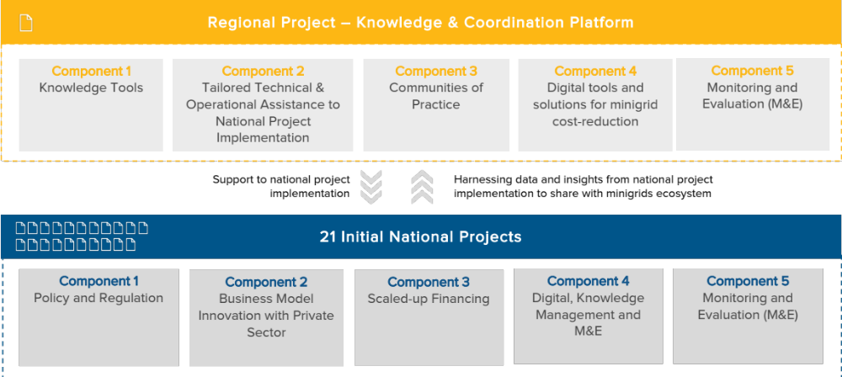
The program is initially supporting three rounds of national projects, totalling 21 in number, which together host an estimated total of 396 million people without electricity, or more than two thirds out of the 587 million total people without access to electricity in Africa. The initial AMP participating countries are show in Figure 2 below.
Figure 2. Africa Minigrids Program’s participating countries list and map
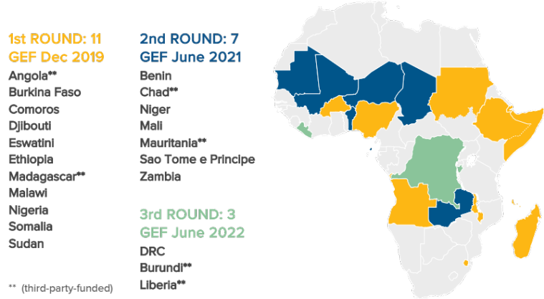

  - Project’s Theory of Change (TOC)
This project will follow the AMP Theory of Change (TOC), developed in the Program Framework Document (PFD) and set out in Figure 3 below. This TOC is premised on a baseline context where, while good progress is being made, several risks and barriers are driving high financing costs (equity and debt) and reducing the competitiveness of minigrids with respect to fossil-fuel based alternatives. As a result, renewable energy minigrids do not get financed and built at scale. By focusing on cost-reduction levers and innovative business models, the project can improve the financial viability of renewable energy minigrids which in turn can accelerate and scale up their adoption as part of the effort towards achieving universal energy access. When renewable energy minigrids are more competitive, private capital and commercial financing will then flow, resulting in various program benefits: investment at scale, GHG emission reductions, and electrification and lower tariffs for end-users.
Figure 3. Africa Minigrids Program’s Theory of Change
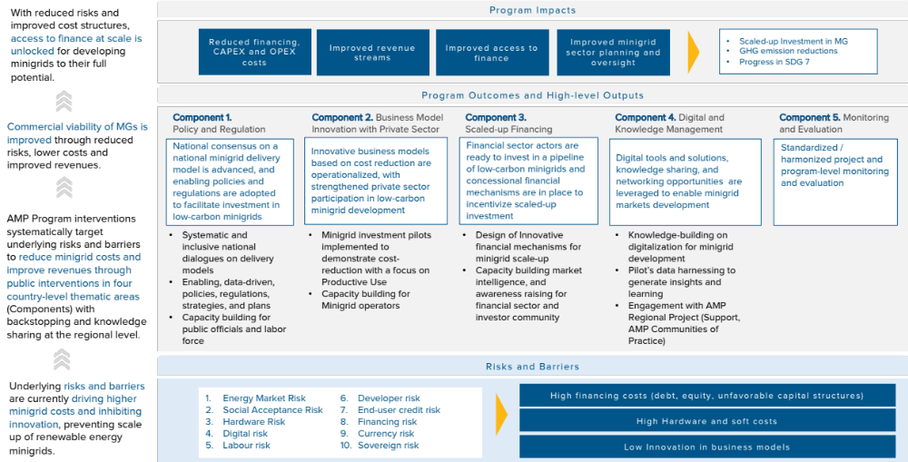
  - Alignment with GEF focal areas
The proposed strategy is aligned with the GEF Strategic Focal Area CCM-1-1 “Promote innovation and technology transfer for sustainable energy breakthroughs for de-centralized renewable power with energy storage”. It also contributes to GEF-7 Programming Directions to accelerate “the speed and scale of sustainable energy investment in developing countries”, to develop “innovative business models that go beyond business as usual” and to foster innovation.

  - UNDP’s Derisking Renewable Energy Investment (DREI)
The Program’s TOC draws on UNDP’s Derisking Renewable Energy Investment (DREI) Framework by focusing on cost reduction levers across the themes of policy and regulation, business model innovation and private sector as well as innovative finance that can be employed to reduce risk (e.g. policy derisking), compensate for risk (e.g. financial incentives) or transfer risk (e.g. financial derisking). DREI is an innovative, quantitative framework to support policy makers to cost-efficiently promote private investment in renewable energy. As regards AMP, UNDP’s DREI framework will be applied either qualitatively and quantitatively at various points in the project cycle, both at the national level in each country, and then aggregated into regional knowledge products by the AMP Regional Project and disseminated widely. The DREI framework, both at the national and regional level (in aggregate), will act as the program’s mechanism to harvest and disseminate data on changes in the financing costs, hard and soft costs, and resulting costs for minigrids.
Box 1. UNDP’s DREI Framework
A central focus of the DREI framework is on private sector financing costs (equity and debt) for renewable energy which are often high in early-stage markets due to underlying investment risks and barriers. Higher financing costs and reduce the competitiveness of minigrids relative to alternative sources of energy (e.g., diesel generators). All else being equal, the need for higher returns that reflect these risks translates into higher energy prices that, in turn, or require larger subsidy requirements for rural electrification programs.
An opportunity is for policymakers to systematically address these investment risks, lowering financing costs and leading to competitive investment. Although there are both public and private strategies to address investment risks, the DREI framework is concerned mainly with public strategies, and identifies three central ways – often used in combination – that the public sector can improve the risk-return profile of private sector investment opportunities: (i) Reducing risk, targeting underlying barriers that create investment risk. These instruments are typically policies, such a legislation, or technical programmes (“policy derisking”); (ii) Transferring risk, shifting risk from the private to public sector. These include instruments such as guarantees, or credit lines to commercial banks for on-lending (“financial derisking”); and (iii) Compensating for risk, increasing the return of investments. These are typically targeted subsidies for renewable energy (“direct financial incentives”). As RE minigrid markets mature, an opportunity also exists for diversifying risk through aggregation of multiple mini-grid assets (“portfolio derisking”).
DREI provides a structure for policymakers to identify and understand investment risks with the aim of selecting public instruments that can derisk and promote investments in RE minigrids. The DREI derisking table introduces a taxonomy of ten independent investment risks, 17 underlying barriers, and associated stakeholder groups; it then sets out matching policy and financial derisking instruments.
  - Program’s ‘Key Areas of Opportunity’
The AMP has adopted a common architecture of four key components - a combination of enabling policy and regulations, business model innovation with private sector involvement, innovative financing and digital innovation - as the levers to lower investment risks, thereby reducing financing, hardware and soft costs while increasing revenues and improving system efficiencies. Within this architecture, AMP will emphasize - and seek to develop comparative advantages - in three ‘key areas of opportunity’: (i) an emphasis on advancing national dialogues on minigrid delivery models, (ii) promoting productive uses of electricity, and (iii) leveraging data and digital solutions for minigrid cost-reduction. Collectively these three areas can guide AMP’s overall direction, creating a niche identity for the program. This approach, illustrated below in Figure 4, is structured to advance the program objectives of cost-reduction and innovation for minigrids and give effect to the TOC. The way in which this project will address these areas of opportunity is described in detail further below.
Figure 4. AMP’s Key Areas of Opportunity
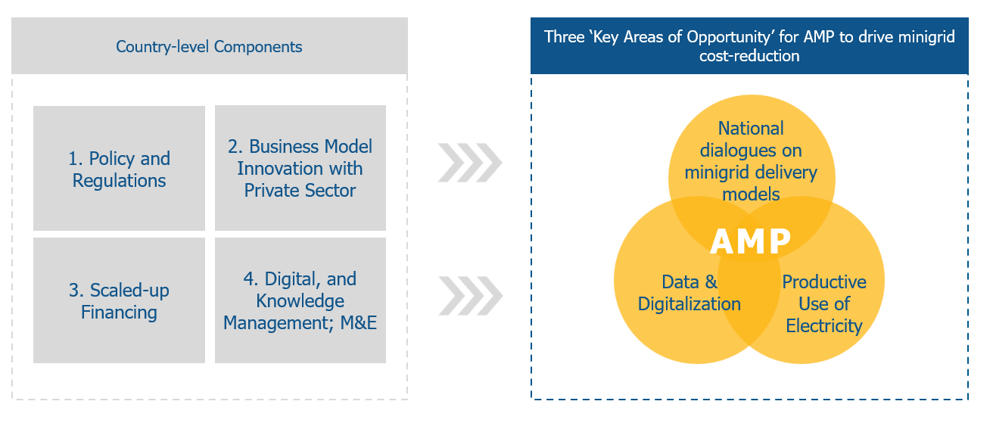

  - National dialogues on minigrid delivery models.
A delivery model (refer concept in Box 2) that is suitable to country expectations and context for minigrids has proven critical to establish an enabling and attractive investment environment for minigrids. Equally, a delivery model that has not been defined or is not consistent with the national context, will be an impediment to scaled-up investment. An important focus of the AMP is therefore to encourage a national dialogue between key stakeholders, including relevant women’s groups, in support of a suitable delivery model being defined.
Box 2. The Concept of a Minigrid Delivery Model
The concept of a minigrid ‘delivery model’ is a key concept for this project. This text box seeks to set out a common understanding of the concept and its importance to the project.

Definition: A minigrid delivery model, determined by the national government, is the cornerstone of a country’s over-arching minigrid regulatory framework. It defines who owns, finances, builds, and who operates and maintains the minigrids. Where applicable, it seeks to engage the private sector. A minigrid delivery model is closely associated to other key components of a minigrid framework, including tariff structures/mechanisms and subsidy levels/mechanisms.

In each country, identifying one (or more) delivery models will provide a framework for all sector stakeholders to plan for the longer term, particularly with regard to mobilizing private investment as one of the main objectives of the project. The figure below describes the spectrum of design options for delivery models, across a number of different elements (ownership, policies, finance etc.)
Figure 5. Conceptual outline of minigrid delivery models
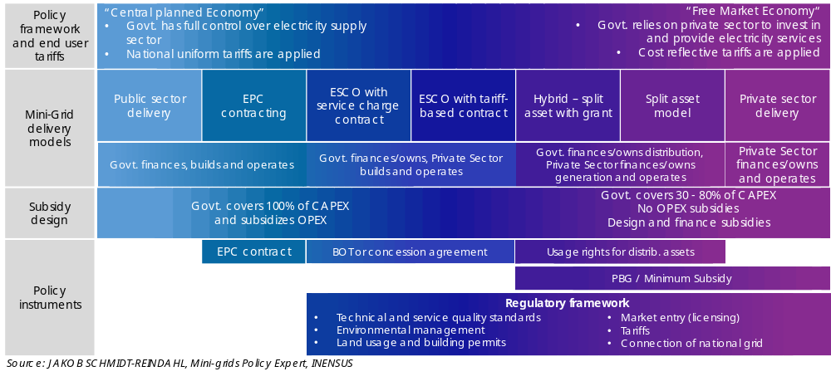
This decision-making process around identifying a delivery model is complex and should ideally be done in the form of a national dialogue involving all relevant stakeholders to varying degrees (different ministries such as energy, finance, health and environment, local authorities, the public, the media, the beneficiary communities, utilities, the private sector, and other key stakeholders) in order to build a national consensus on the basis of which large-scale deployment of minigrids can be accelerated and have a sustainable impact.

Minigrid pilots planned under this project will also seek to fit into this framework. The more clarity there is on the part of the government regarding the choice of delivery model, the easier it is to develop or plan business models which can reduce minigrid costs. A clearly identified delivery model minimizes the risk of investments being made based on assumptions that are not in line with government expectations and may lead to conflicts and economic losses down the line. It also helps the government to answer the important questions related to the rural electrification sector to provide clarity for private investors and operators and build confidence.

  - Digitalisation (digital solutions and tools) and harnessing the data opportunity.
The emergence of minigrids as a viable solution to electrify remote and isolated communities relies strongly on digital tools and solutions. Digital technologies and solutions are fundamental to enabling off-grid electrification and offer significant potential to lower minigrid costs, reduce risks, and address barriers to scale. Many of the opportunities around digitalization are related to leveraging the large amount of data generated by minigrid projects to surface insights, learning and optimization. Data is a tremendously valuable asset in the minigrid sector that remains underutilized. The programmatic approach allows the AMP to make an impactful contribution to growing a data asset and harmonized digitalisation in the sector. Employing digital integration as catalyst for the minigrid sector reflects the UNDP digital transformation strategy that initiated a comprehensive process of connecting knowledge within the organisation and across networks, creating opportunities, improving operational efficiencies and building and maintaining partnerships and alliances. It also echoes the broader UN data-driven strategy and commitment to advance global “data action” with insight, impact and integrity.
Box 3: Digitalization and Minigrids
Digital opportunity for minigrids. Figure 6 below shows different categories of digital solutions in the minigrid sector: (i) digital planning, (ii) digital operations, (iii) digital aggregation platforms, and (iv) digital payments. In common to all these is the potential of digital technologies – whether used by policy makers, financiers or minigrid developers - to lower minigrid costs, reduce risks, and address barriers to scale.

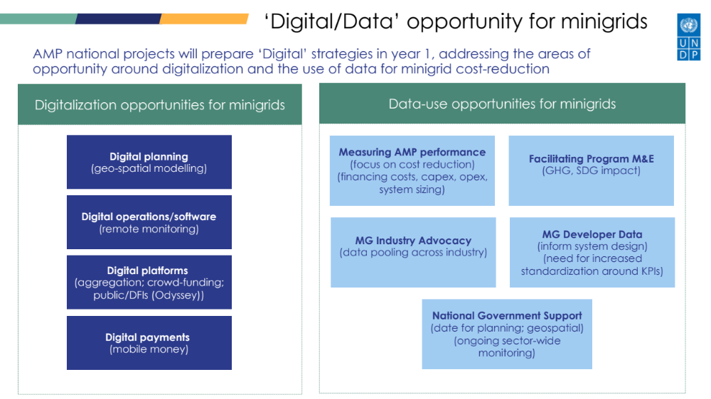
Figure 6. Digital and data opportunities for minigrids in the AMP

Data use opportunity for minigrids. Many opportunities around digitalization are related to leveraging the large amount of data generated by minigrid projects to surface actionable insights, learning and optimization to consolidate business models and technical solutions for scaling-up minigrids. For instance, the use of operational performance information from existing systems to forecast demand and design future minigrids can help avoid a very common pitfall of many minigrid systems which are significantly oversized and hence not financially viable.

Opportunities across the Program, and with the AMP regional project. The AMP provides a unique opportunity to develop a single set of metrics and guidelines for data collection and use them to collect data from minigrid investment pilots across different national projects which the AMP Regional Project can then aggregate, derive insights from, and systematically disseminate knowledge with participating AMP countries and with the broader minigrids sector in Africa. At the same time, the link between the regional project and the various national projects provides a unique ‘distribution channel’ opportunity across Africa for AMP to mainstream the use of digital tools and solutions for minigrids cost-reduction and scale-up.

  - Productive uses of energy (PUE)
While PUEs are widely recognized as a key element to improve the viability and sustainability of minigrids, the AMP focus is uniquely tailored, taking a deliberate, integrated approach across a broad ambit of the Sustainable Development Goals (SDGs). With the benefit of global experience and best practices, the AMP pursues solutions where productive uses are embedded in agricultural value chains or around which economic activity can be anchored. The AMP’s emphasis on energizing agricultural production is based on the demonstrated impacts and amplified benefits resulting from (i) improved product quality and increased yields, (ii) contributions to value addition, (iii) increased value retention within the rural communities, and (iv) contributions to socio-economic developmental objectives for rural areas, which in turn has a positive effect on the minigrid revenue model. Further recognizing that these multiple benefits cannot be assumed with energy access, but depend on wider development programmes, the AMP approach combines the delivery of electricity infrastructure with innovative business models and various interventions aimed at encouraging economic activity, support business development and stimulate rural economic transformation with an emphasis on improved wellness, empowering women and youth as well as ensuring sound social and environmental stewardship.
  - PDL-145T minigrid investment pilots contribution to the Program’s TOC
Minigrid pilots have a key role within AMP by contributing to demonstrate cost-reduction which can be leveraged to improve the financial viability of renewable energy minigrids. In this project, that role is played by minigrid pilots which will be developed as part of a separate project, the PDL-145T, and considered as co-financing to this project. Although minigrid pilots are not developed as part of this project, this project’s activities have been designed to align with, complement, and contribute to the sustainability and scalability of minigrids developed under the PDL-145T.
The minigrid pilots (to be developed under the PDL-145T) are aligned with the key areas of opportunity mentioned above by demonstrating: (i) a particular delivery model or elements of a delivery model around which the government wishes to build capacity and mobilize further investment; and (ii) opportunities around digitalization and the use of data for minigrid cost reduction. Feedback loops to other project activities (e.g. national dialogues, capacity building) and with the AMP Regional Project (e.g. Community of Practice) are intended to actively disseminate the learnings from the pilots to inform both the policy and regulatory environment as well technical capacity building.

- AMP National Project in the DRC
  - Overview
The project is aligned with and will directly support the implementation of the minigrid component of the ‘Local Development Program dedicated to the 145 territories’ (PDL-145T), the largest rural infrastructure investment program of the government to date aiming to improve living conditions in rural territories hitherto underserved by basic infrastructure and social services.
The minigrid component of the PDL-145T foresees the construction of 418 solar photovoltaic minigrids with a budget of $105 million. UNDP is implementing part of this component on behalf of the government, developing 172 minigrids with a budget of $43 million.
The AMP DRC Project will be targeted to the UNDP-led minigrid component of the PDL-145T to build the capacity of public institutions involved in rural electrification, particularly ANSER, to roll-out and oversee minigrid programs using different delivery and business models, and coordinating effectively with national, provincial, and local governments. The specific activities will entail the coordination among stakeholders, techno-economic analysis, capacity building, and the provision of digital and data management tools.
The close alignment of the AMP DRC Project with the PDL-145T will ensure its effective implementation and its successful operation in the long term, thus enabling minigrids, government or privately owned, to be developed across the country.

  - Rationale
This strategy is a result of extensive consultations with the public and private sectors as well as international organizations active in the DRC. Although no minigrid-specific regulations are in place to date and not many new projects have been developed, the catalyzation of the minigrid sector has become a priority for all energy sector stakeholders, resulting in a multitude of initiatives with similar objectives and activities. The initiatives generally all center on market formation (creating effective minigrid policy and regulatory frameworks), cost reduction (improving efficiencies), productive uses of energy (increasing demand), subsidy regimes, and capacity building. Several of these initiatives focus on creating enabling conditions that will allow for private investment at scale to address urban energy access gaps through deployment of large minigrids. A key recommendation from stakeholders of all sectors has been to ensure that new projects do not replicate existing activities and that there is an urgent need for coordination among the various organizations.
As outlined in the previous section, the AMP is structured in a flexible way to allow consideration for national constraints and priorities and ensure that the project’s impacts are maximized in each country. In the DRC, the benefit of this flexible approach enables the project to complement rather than overlap with the variety of existing activities in the country.
As a result of these consultations, the minigrid component of the PDL-145T has been identified as a key opportunity for the AMP DRC Project to support the country’s minigrid sector and its electrification goals in rural and underserved territories. Despite the number of minigrid initiatives currently being executed, none focus on this complex, large-scale government investment program. The AMP DRC Project will thus tailor its activities to support the implementation of the UNDP-led minigrid component of the PDL-145T and thus contribute to the overall national objective of catalyzing the minigrid sector.
  - UNDP-led PDL-145T
An overview of the implementation agreement for the PDL-145T is provided in Figure 8. The Government of the DRC designed the overall program and strategy and is providing its funding. It has selected three separate agencies for implementing the program, among them UNDP. An overview of UNDP’s implementation zone is provided in Figure 7.
UNDP’s strategic approach for executing its mandate relies on an elaborate theory of change and an assortment of operating principles aimed at achieving the transformational goals of the program. This includes the use of special procedures to minimize contracting and execution times as well as an integrated product offering to develop infrastructure through a single platform. UNDP is coordinating this work with the other implementation agencies through program-level steering committees as well as on individual components of the program.
The timeline of the PDL-145T envisions that the minigrids will be developed and operations and maintenance contracts put in place over the period 2023 – 2025.
With respect to the minigrid component of the PDL-145T, UNDP’s approach involves the commissioning of detailed feasibility studies which will provide guidance on details of the project’s implementation, including planning, siting, procurement, technology, monitoring, the obtaining of approvals and permits, and all other aspects of minigrid deployment. As instructed by the government, UNDP and the two other implementing agencies are closely coordinating their work on minigrids with ANSER, given the complexity of these projects and ANSER’s expertise in the sector.
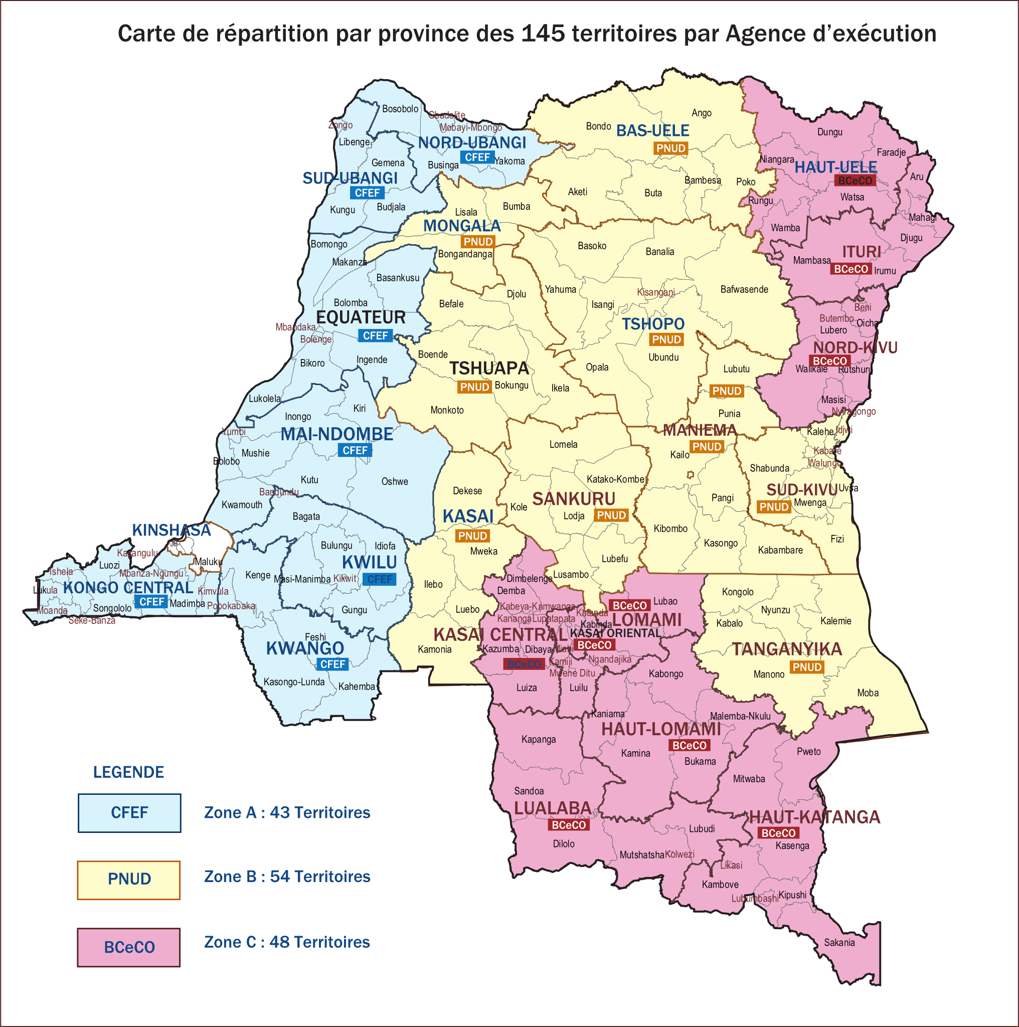
Figure 7: Overview of the zones of the three implementation agencies for the PDL-145T.

The implementation arrangement for the UNDP-led PDL-145T minigrids project is depicted in Figure 8. In the first phase of the program, UNDP is responsible for the procurement and construction of the 172 minigrids. Based on the commissioned feasibility studies, UNDP will prepare a procurement for the 172 minigrid sites in batches and oversee their construction. Depending on the findings of the feasibility study and stakeholder discussions, the procurement process may entail services beyond the construction of minigrids, e.g. the provision of custom software to operate and maintain the procured systems.
In the second phase of the project, UNDP will hand over the minigrids to ANSER. After handover, ANSER will be responsible for procuring private operators to perform operations and maintenance (O&M) on all sites. Additionally, ANSER will be responsible for monitoring the minigrid sites and ensuring that the private operators are meeting key performance indicators (KPIs).

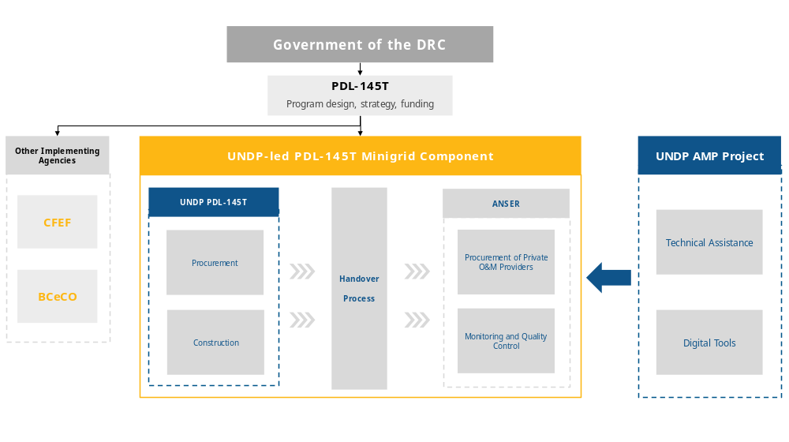
Figure 8: Overview of the implementation arrangement for the UNDP-led PDL-145T minigrid component.

  - Minigrid Delivery Model
The DRC government hasn't established a distinct minigrid model or a dedicated policy framework; thus, minigrids currently adhere to the regulations stipulated in the 2014 Electricity Sector Act. Despite this, the government and relevant energy sector institutions have been proactively fostering minigrid development, implementing multiple initiatives in tandem with various international organizations. The significant role of the private sector is a consistent theme across these initiatives.
Under current regulations, private minigrid developers can apply for Concession, License, and Authorization (CLA) for both solicited and unsolicited projects with ANSER, who review the applications alongside either the national minister or the provincial governor. Additionally, private entities must submit a tariff determination application to the ARE. Various local, regional, and national regulations may also apply, including environmental impact assessment requirements.
Though regulations are theoretically clear, private operators have encountered difficulties navigating these institutional and regulatory procedures due to the recent operational commencement of key institutions like ANSER and ARE in 2019 and 2020. This resulted in limited familiarity with complex topics, inadequate capacity, and poor coordination with other institutions, particularly provincial governments. Furthermore, the absence of a minigrid-specific framework poses challenges, given that on-grid projects often require more extensive application materials than smaller minigrid operations can feasibly provide.

Table 6: Overview of the DRC's minigrid delivery model
Aspect | Current Status
Ownership and Operation | Not defined. At this stage, the country has not identified a preferred delivery model(s). The electricity sector has been liberalized since 2014 and it is expected that private sector participation will play a significant part in the minigrid delivery model.
Tariff mechanisms | Not defined. Minigrid developers have to submit a tariff application to the national regulator which is reviewed in the same way as applications for larger on-grid projects.  To apply for a tariff, developers submit an application to ARE for review. There is no standardized template or methodology for the preparation of the tariff application, i.e., developers their own justification for the tariff and ARE has to review them on an ad-hoc basis. The only requirement is that the tariff application distinguishes the costs among the different components of the tariff, i.e., generation, transmission, distribution, etc.
Subsidy mechanisms | There are several subsidy mechanisms in place, but to date it is not clear which mechanism will be implemented in the long term. The top-down approach entails the preparation of larger sites for tendering to international bidders, allowing the government to develop the project while deploying private capital and operators to build and operate the assets. The bottom-up approach entails a results-based subsidy facility, the Mwinda fund.
Regulations | Not defined. The electricity sector has been liberalized since 2014, but no specific regulations for off-grid or minigrid uses have been stipulated. To date, minigrids have to adhere to the prevailing (on-grid) regulations.

The alignment of the AMP DRC Project with the UNDP-led minigrid component of the PDL-145T will contribute to the development of key insights from the various minigrid delivery models currently being implemented in the DRC. The PDL-145T’s minigrid delivery model includes the development of publicly-owned and privately-operated minigrids. Other delivery models have a stronger focus on private sector delivery and include private ownership and operation that is supported with subsidies from the government (Mwinda Fund) or international organizations. The AMP DRC Project will strengthen ANSER’s capacity to oversee the sector and to advance different types of minigrid delivery models. Additionally, it will create the first national forum in which a specific minigrid delivery model will be discussed among all stakeholders on a continuous basis, paving the way for coordination and alignment on minigrids in the country.
  - Minigrid Pilots Plan and key principles for minigrid pilot implementation
In general, all AMP national projects include investment support for minigrid pilot projects which will demonstrate different types of delivery models, various approaches to minigrid development or hybridization, or the addition of Productive Use of Energy approaches to existing sites. In the context of the AMP DRC Project, direct minigrid investments will be funded by government co-financing allocated within PDL-145T for the development of an estimated 172 minigrids across 45 territories and 9 provinces. This is a result of the alignment of the project with the UNDP-led minigrid component of the PDL-145T. In addition to the PDL-145T, numerous pilots are being planned or executed by government institutions and development partners. As such, the addition of further pilots was deemed ineffective, and project activities have been directed to providing technical assistance to strengthen ANSER’s capacity to oversee PDL-145T as well as broader minigrid development in DRC and enable larger minigrid roll-outs.
The 172 minigrid sites will be developed by UNDP and thus in accordance with UNDP Policies and Procedures and requisite environmental, social, and gender performance standards. In addition to these, the AMP framework has developed the principles described in the box below for the development of minigrid pilots within AMP national projects. During the project implementation of the AMP DRC Project, efforts will be undertaken to ensure that these principles are reflected in the development of minigrid sites. This will include the development of a Minigrid Pilot Plan, which in other AMP national projects serve as the activity to plan the respective project’s pilots. In the case of the AMP DRC Project, a Minigrid Pilot Plan will be developed to ensure that the minigrids of the PDL-145T are aligned, as applicable, with AMP principles and key areas of opportunity. The Minigrid Pilot Plan will also seek to ensure that the co-financing and results for the minigrids will be tracked such that the project complies with reporting requirements.
Box 4: Key principles for AMP minigrid pilot implementation
- Principle 1. Digital platforms. The use of digital platforms for tendering the pilots is a central element of the overall AMP and digital strategy for the project. With digital platforms emerging as critical enabler for procurement and operation of cost-effective and viable minigrids, using a digital platform for pilot projects provides an opportunity to build capacity of key stakeholders in using this facility which can then set the foundation for later using digital platforms for sector-wide, large-scale tenders or results-based financing programs. Digital platform software can manage the selection, Monitoring and Evaluation (M&E) and payments of pilots including capacity building of the Implementation Partner, Project Management Unit and minigrid developers.
- Principle 2. Productive use: third party ownership model. For pilots that will financially support the purchase of productive use equipment using an allocation under the GEF INV, it is required that the project will only provide its support via a third-party ownership model, as opposed to a self-ownership model. Third party ownership models involve the minigrid asset owner purchasing the productive use equipment, and then effectively leasing it back to the end-user, as part of an “energy as a service” offer.
- Principle 3. Clear methodological basis for additionality for calculating the level of subsidization of minigrid pilots. AMP CAPEX subsidies are meant to mobilize and catalyze investment from other sources, including the private sector, with the goal of making investments in AMP pilots commercially viable and sustainable. It is critical that the appropriate use of grant funding to the pilots be ensured, requiring a methodological basis for which the level of subsidy will be determined during implementation using the principle of minimal concessionality so that scarce concessional resources (AMP CAPEX subsidies) are allocated efficiently.
- Principle 4. Minigrid pilots data sharing. Pilot beneficiaries (e.g. minigrid operators) receiving support from the project will be required to share minigrid performance data with the national and regional project. Specific terms and conditions for data-sharing and how best to operationalize the commitment and its adoption by the beneficiaries will be defined and agreed upon with minigrid operators during project implementation, with support from the AMP Regional Project.
- Principle 5. Compliance with UNDP Social and Environmental Safeguards and Gender requirements. Pilot projects receiving project funding are required to comply with all the relevant national standards of the country as well as UNDP standards as it pertains to social and environmental safeguards and gender equity. In support of this principle, an Environmental Safeguards Management Framework (ESMF), developed for the program, and a gender action plan accompany this ProDoc (Annexes 10 and 11). The ESMF will have to be incorporated and considered in developing the environmental and social management plans for pilot projects. A critical consideration under this framework is the need to ensure environmentally sound management of replaced equipment, including batteries, inverters and solar panels, after their usage. The responsible handling of waste with recycling of batteries and other recyclable equipment, should be clearly documented, budgeted and monitored in compliance with national and UNDP safeguards requirements.

  - Linkages to the AMP Regional Project
The project will align with the AMP Regional Project to foster knowledge sharing, learning, and synthesis of experiences in a multi-directional manner– i.e., flowing from the AMP Regional Project to the DRC project, and vice versa, and between the DRC project and other national projects within the Program. The main role of the AMP Regional Project is to make best practices in regulations and policies, innovative and inclusive business models, digitalization and financing available to all AMP beneficiary countries, while providing technical and operational support for national projects’ on-the-ground implementation. Box 5 below provides a summary of the technical and operational support that will be available to the project. A full detailed elaboration of these offerings and the protocols attached to each service will be communicated to the project at the DRC project’s inception workshop. The areas of support, listing of available firms/individual consultants under contract by the regional project and protocol for how the project can request and/or access such expertise (if needed/requested) will be elaborated in the first year of regional project implementation and disseminated to this project and the staff of all other participating AMP national projects.

Box 5: AMP Regional Project Indicative Service Offering
Digital, Knowledge management and monitoring and evaluation (M&E)
- Knowledge building/sharing. The regional project will curate, develop and share knowledge with the project on program’s thematic areas (Policies and regulation, innovative business models, financing, digitalization).
- Insight Briefs development and dissemination. National projects will gather data and audio-visual content (video footage, photos, etc.) highlighting national project activities which will be the subject of an ‘insight brief’ to be developed and widely disseminated by the AMP Regional Project.
- Communities of Practice. One of the primary ways national project staff will interface with the regional project is via the ‘Communities of Practice’ (CoPs) and associated activities/platforms. While it is expected that many of the activities will be undertaken virtually (via internet-based platforms, webinars or digital platforms) it is also expected that the CoPs will include actual in-person workshops, meetings or training events that project staff will participate on.
- Common M&E Framework/QAMF. The AMP Regional Project will develop, with inputs from national projects, a Quality Assurance and Monitoring Framework (QAMF) for measuring, reporting and verification of the sustainable development impacts of all minigrid pilots supported by national projects, including GHG emission reductions.
- Data aggregation platform. The AMP Regional Project will deploy and use a web-based data management platform to aggregate data from all national project pilots based on the QAMF to track Results Framework indicators as well as program objectives, SDG impacts and GHG emission reductions.
- Systematic data analytics and insights. The regional project will harness data shared by the national projects to extract insights and learnings which will be disseminated across all national projects and within the broader minigrids ecosystem.
Technical and operational support for national projects’ implementation
  - Access to specialized expert international consultants in selected areas hired, retained, contracted and paid for by the AMP regional project and made available to all participating national project staff and selected beneficiaries on as needed basis. This support may range from virtual assistance to in-country missions.
  - Database of qualified international consultants and firms provided for information purposes to the project in an effort to assist in identifying high-quality experts and firms who may be available for contracting by national governments under their own procurement rules and modalities.
  - Generic terms of reference (ToR) for various standard activities will be provided to projects for information purposes.
  - Specialized advisory support for implementing UNDP’s minigrid DREI analyses. During project implementation, the UNDP DREI Core team, working with the regional project, will make available to national teams and consultants the resources and tools to conduct full quantitative DREI applications, and will provide ongoing support and quality assurance.
- Operational support for national projects. The AMP Regional Project will provide support to the project, on an ad-hoc and as-needed basis, through its PMU staff or by hiring or recommending subject matter experts, for the project to execute activities. Further details on specific support around M&E activities provided in Section VI (Monitoring and Evaluation Plan).

IV. Results and Partnerships

- Greenhouse Gas (GHG) Emissions Mitigated
This project will result in GHG emissions reductions which will be measured via the GEF7 Core indicator 6: Greenhouse Gas Emissions Mitigated and include both (i) direct emissions reductions attributable to the minigrid pilot investments made during the project's implementation period, totaled over the lifetime of the investments (20 years); and (ii) Indirect emissions reductions resulting from the increased uptake of minigrids for off-grid electrification of rural areas due to replication, scaling-up and market change to which the project has contributed by creating a general enabling investment environment for minigrid market development, and facilitating subsequent investment flows. Annex 12 describes the methodology used to define targets for direct and indirect GHG emissions mitigated.

- Project components, outcomes, outputs and activities

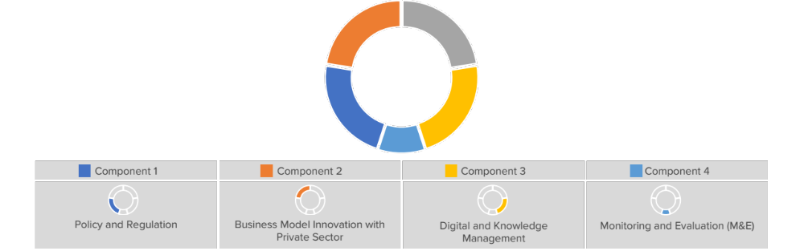
AMP
DRC

1.1 An inclusive national dialogue to identify minigrid delivery models is facilitated, clarifying priority interventions for an integrated approach to off-grid electrification | 2.1 Feedback loop established between the project and the PDL-145T minigrid pilots | 3.1: A project Digital Strategy is developed and implemented, including linkages to and following guidance from the AMP Regional Project | 4.1 M&E and Reporting, including (i) Conducting inception workshop and preparing report, (ii) Ongoing M&E, (iii) Mid Term Evaluation and (iv) Terminal Evaluation
1.2 Minigrid DREI techno-economic analyses carried out to propose most cost-effective basket of policy and financial derisking instruments |  | 3.2: A ‘Minigrids Digital and Data Management Platform’ implemented to run tenders and manage data, and to support minigrids scale-up and cost-reduction
1.3 Capacity building provided to public officials to design procurement/tender processes that incorporate cost-reduction levers and innovative business models |  | 3.3: A Quality Assurance and Monitoring Framework for measuring, reporting and verification of the sustainable development impacts of minigrids
 |  | 3.4 Engage with the regional AMP project, via (i) Communities of Practice and (ii) capturing and sharing lessons learnt

  - Component 1: Policy and Regulation
Outcome 1: Stakeholder ownership in a national minigrid delivery model is advanced, and appropriate policies and regulations are adopted to facilitate investment in low-carbon minigrids.

An inclusive national dialogue to identify minigrid delivery models is facilitated, clarifying priority interventions for an integrated approach to off-grid electrification
The DRC is at a critical juncture regarding its minigrid delivery model, with various approaches being implemented across different projects and discussions underway among the key energy sector stakeholders and development partners (World Bank, AfDB, UNDP) to align on minigrid specific regulatory frameworks.
The AMP DRC Project will contribute to this dialogue by providing technical assistance to the UNDP-led minigrid component of the PDL-145T. The deployment of the program’s 172 minigrids will be based on a unique delivery model: The UNDP will, on behalf of the government, procure the construction of the minigrid sites; subsequently, UNDP will initiate a handover process to ANSER, whereby ownership remains with the government and ANSER will be tasked with procuring private operators for the operation & maintenance of these assets. ANSER will furthermore be responsible for ensuring that the operators meet key performance indicators.
To ensure the effective implementation of this complex and large-scale investment program that involves different types of procurement processes, the AMP DRC Project will create a working group for this project for all stakeholders in the sector. This will ensure that 1) the project incorporates relevant feedback from stakeholders, strengthening the structuring of the program, 2) increases awareness of the state and timeline for the project, ensuring the private sector is prepared to contribute to tenders when they are launched, and 3) will share learnings about the project, particularly about the specific minigrid delivery model and its strengths and weaknesses thus contributing to the broader national-level dialogue on delivery models for minigrids. This working group will be the first national forum involving all minigrid stakeholders, ensuring that there is continuous exchange of knowledge and learnings and enhancing collaboration and coordination in the sector. It will integrate women’s organizations (NGO and business association) to represent women’s and gender equality concerns in the discussions on the minigrid delivery model.
The following specific objectives are expected to be achieved:
- National coordination: The minigrid component of the PDL-145T is an immense public infrastructure investment initiative that targets hard-to-access rural areas of the country and aims to provide them with state-of-the-art off-grid energy systems that can be operated and monitored remotely. On the national level, this project will require coordination, collaboration, and alignment between many stakeholders to ensure the successful implementation. The coordination group on the national level will meet monthly, whereby ANSER will be responsible for setting the agenda based on potential challenges it foresees. On the government coordination side, examples of such challenges include: coordinating of UNDP’s siting of minigrids in line with ANSER’s electrification plan and priority investment plan as well as related plans of the CNE; obtaining of concessions, permits, and licenses in alignment with the regulator ARE and other government institutions; ensuring that public procurement processes are coordinated appropriately (currently only ARE is legally permitted to issue tenders in the energy sector, i.e., ANSER will need to prepare tender documents and provide them to ARE to initiate the procurement process).
- Provincial coordination: The project will additionally require coordination on the provincial level. This is needed on the government side as certain approval processes, for example concession and license application, are reviewed by provincial governors and their associated staff. Given the nascence of minigrids and the relative complexity of the minigrid development process, a continuous exchange of information will be required between stakeholders at the provincial level to ensure that the projects can be implemented effectively. This provincial-level coordination will benefit from the regional offices that ANSER opened and operationalized over the last two years.
- Local coordination: The project will additionally require coordination on the local level for each minigrid. While local coordination is expected to be more ad-hoc and less frequent than national and provincial-level coordination, it is nevertheless critical to ensure that projects are implemented effectively. The experience of stakeholders in the DRC has demonstrated that local officials are often unfamiliar with minigrid systems and need support from a trusted source to guide their decision-making and associated approval processes.
- Coordination with the private sector: The involvement of the private sector throughout the implementation of the minigrid component of the PDL-145T is critical to ensure the success of the program. The private sector is an important part of the project, as private sector service providers will be requested to bid for performing operations and maintenance services on the constructed minigrids. Additionally, the private sector is an important resource for the project, given the longstanding experience and expertise of minigrid developers with all aspects of the development process, including choice of minigrid systems and technologies, the obtaining of required permits and approvals, the recruitment of local staff, the operation of remote minigrid sites, and others. The private sector could in particular provide feedback to the procurement process for the construction of minigrids, advising on required standards and characteristics for equipment.
- Coordination with donors: The coordination among donors as well as the coordination between donor-led and government-led activities is a high priority for all stakeholders in the sector. The national-level coordination forum will, in the first instance, ensure that donors are aware of the current status of the AMP DRC Project and can, if applicable, align their activities to provide additional technical assistance and support. More broadly, the national-level coordination forum will serve to create a national dialogue on minigrids and minigrid initiatives, providing an opportunity for donors to share their current and planned projects and aligning them with other ones in the DRC.
The working groups will additionally serve as forums to solicit stakeholder feedback for the various activities of the AMP DRC Project. In particular for the activities on capacity building (1.3), digital strategy (3.1) and digital procurement (3.2), the contributions from all stakeholders through the various coordination groups, primarily the national coordination group, will serve to strengthen the final design and implementation of the activities. For example, for the capacity building activity, the AMP DRC Project could coordinate joint capacity building exercises that include government ministry and agency officials, in addition to ANSER staff. For the activities on digital strategy and procurement, feedback from the private sector in particular will be helpful as there are multiple experienced minigrid operators in the country who can advise on the development of a national digital database and tools and thus improve the activities’ outputs.
This output includes the following activities:
    - Establish multi-stakeholder working groups related to the minigrid component of the PDL-145T. Support the establishment of a working groups at the national, provincial, and local levels that includes all relevant stakeholders from Government, local authorities, private sector, and development partners, including women’s groups.
    - Establish feedback loop between national dialogue and the project. Align the ongoing dialogue with activities implemented in parallel under the other outputs and loop respective (pre-)results back into the discussion. This should include, but not be limited to, activities which can shed light on trends and progress regarding minigrid cost reduction (e.g. DREI analyses and tracking of minigrid costs, resulting subsidy levels and electricity tariffs that will apply for minigrid pilots).

Minigrid DREI techno-economic analyses carried out to propose most cost-effective basket of policy and financial derisking instruments and contribute to AMP Flagship Report on Cost Reduction
As noted in the AMP PFD, UNDP’s Derisking Renewable Energy Investment (DREI) is an innovative, quantitative framework to support policy makers to cost-efficiently promote private investment in renewable energy. In late 2018, UNDP expanded the DREI framework to include solar PV-battery minigrids, releasing open-source analytic and financial modelling tools to track investment risks, financing costs, and to support the private sector and policymakers in modelling levelized costs, tariffs and subsidies for minigrids.
As regards AMP, UNDP’s DREI framework will be applied either qualitatively and quantitatively at various points in the project cycle, both at the national level in each country, and then aggregated into regional knowledge products by the AMP Regional Project and disseminated widely. The DREI framework, both at the national and regional level (in aggregate), will act as the program’s mechanism to harvest and disseminate data on changes in the financing costs, hard and soft costs, and resulting costs for minigrids. When carrying out the risk and barrier analysis, AMP will carry out a further analysis and consider the gender dimension of the different investor risks. The DREI analysis will qualitatively assess how the added dimension of gender increases/decreases the probability and impact of the risks categories defined in the DREI framework and the implications this has for the selection of policy derisking instruments.
DREI, by interviewing the private sector, is a well-suited tool for this task. The risk environment and instrument selection stages of DREI deliver quantitative insights into financing costs and the impact of public instruments in lowering these costs. The financial modeling stage captures hardware and soft costs to determine the levelized cost of electricity (LCOE) of the technology being assessed.
DREI conclusions and recommendations will feed into the development of policies, regulations and sector plans (Output 1.2) and be considered as part of the national policy dialogue on delivery models (Output 1.1).
This output includes the following activities:
    - Initial, full quantitative national DREI analysis (Year 1). A full quantitative DREI application will be conducted in the first year of project implementation. The PMU will assemble a task team to perform the national DREI analysis including consultants (international, national), government stakeholders, and members of PMU. Deliverables will include interviews, completed financial models, and national reports/knowledge products. Initial TORs for these consultants will be made available by the AMP Regional Project and should include a provision for an additional DREI analysis dimension that considers the gender lens. This national analysis will be funded by the national project. The AMP Regional Project can in turn provide various support on DREI to the national project, including: (i) finalizing TORs for the country-level; and (ii) sharing recommendations (in the form of a vetted roster of consultants) on international consultants that are trained on DREI already, as well as resources and tools (Excel models etc.) to conduct the DREI analysis. Results from the full quantitative national DREI analysis will be shared with the regional project to feed into a regional flagship AMP knowledge product across all AMP countries (funded by the regional project), on DREI and lowering minigrid costs. This full quantitative analysis can act as a mechanism to engage national stakeholders in a comprehensive dialogue around the derisking measures necessary to advance the market, and to also allow for the project team to engage in early adaptive management in project design, as needs be.
    - Dissemination of DREI analyses and adaptive management (Year 2). In the first half of Year 2, the project will disseminate the national DREI analysis and, in the second half of Year 2, the flagship DREI regional knowledge product (south-south learning) through dissemination activities at the national level. Together, these dissemination activities will encompass 3 or 4 round-table workshops with government, private sector and other key stakeholders, over a 12-month period. Along-side these dissemination activities, the PMU will utilize the findings of the national DREI analysis to inform any adaptive management of the national project’s outputs/activities, to address identified needs for public measures arising from the national DREI analysis.
    - Coordination with regional project on national DREI analysis update (Year 4). In the final year, or year 4, of the national project’s implementation period, whichever happens first, the original national-level DREI analyses will be refreshed to track evolutions in financing costs as well as in hardware and soft costs. For administrative efficiency, the regional project will fund and execute this update (a ‘light quantitative DREI analysis’), on behalf of the national project. The deliverable will be a brief note of 2-5 pages on the DREI national update. The data from the national refreshed DREI analysis will be fed into an update note to the year 2 AMP flagship regional DREI knowledge product, which will provide an end-of-program overview of the evolution in minigrid costs across AMP countries. The national project’s contribution to this activity will be: (i) facilitating the DREI national update (to be funded and executed by the regional project); and (ii) disseminating the findings of the national DREI update note, and the update to the regional flagship DREI product.

Capacity building provided to public officials (regulator, ministries) specifically to design procurement/tender processes that incorporate cost-reduction levers and innovative business models
The UNDP-led minigrid component of the PDL-145T is a complex and large-scale investment program that involves different types of procurement processes and interfacing between UNDP and ANSER, as well as other stakeholders. Based on discussions with the relevant stakeholders, five specific processes were identified to which the AMP DRC Project’s technical assistance is targeted:
- Procurement of EPC services to construct minigrids
  - While the construction of minigrids is under the purview of UNDP, ANSER is closely collaborating with the UNDP PDL-145T to ensure that its experiences and understanding of the sector are utilized to strengthen the procurement process and the procurement’s Terms of Reference. Because of the complexity of the procurement, capacity building to ANSER will be required to ensure that it foresees all challenges and opportunities of this process and can provide high-quality feedback to UNDP to improve the procurement.
  - For 172 sites, minigrid equipment needs to be procured, installed, and commissioned. This is a complex undertaking by itself, and it is complicated by the location of the sites in rural areas of the DRC, which is a geographically large country with very limited transportation infrastructure. The required equipment thus needs to conform to high-quality standards applicable for use in off-grid contexts, with consideration for difficulty of access and thus limited availability of quick maintenance services and spare parts.
  - Another important consideration is the need to comply with all the relevant national standards of the country as well as UNDP standards as it pertains to social and environmental safeguards and gender equity. In support of this principle, an Environmental Safeguards Management Framework (ESMF), developed for the program, and a gender action plan accompany this ProDoc (Annexes 9 and 10). A critical consideration under this framework is the need to ensure environmentally sound management of replaced equipment, including batteries, inverters and solar panels, after their usage. The responsible handling of waste with recycling of batteries and other recyclable equipment, should be clearly documented, budgeted and monitored in compliance with national and UNDP safeguards requirements.
  - An additional consideration is to ensure that the procurement includes the provision or creation of operational software. Different minigrid system components (generation, battery energy storage systems, inverters, smart meters, mobile payment systems, etc.) often have their own firmware, requiring that the developers or operators either procure systems that can integrate all system components or design their own, proprietary software. Given the project’s procurement of a large number of minigrids, it is worthwhile to include the provision of such software in the overall deliverables. However, the specifications for the software need to be discussed in detail with ANSER and private sector operators to ensure that key learnings are integrated into its design.
  - The deployment of such a large number of minigrids additionally allows for training to be included. The tender documents could contain clauses requiring the awardee to train certain people about the technical aspects of the equipment, maintenance and repair guidelines, and the use of operational software. Contract clauses could also include the provision of O&M services for a certain amount of time (e.g., 1 year) during which local staff will be trained in O&M processes.
- Handover process from UNDP to ANSER
  - The commissioned minigrids will be handed over to ANSER, after which ANSER will be responsible for procuring private operators for O&M and for quality and performance control of the sites. The handover will be a complicated process to ensure that rights and responsibilities are clearly delineated and ANSER has the resources it needs to proceed to the next steps in the project effectively.
- Procurement of private operators to provide O&M services
  - After the handover process, ANSER will be responsible for procuring private operators to provide O&M services for all minigrid sites. To ensure that the procurement process reflects best practices, the AMP DRC Project will provide technical assistance during this process.
- Monitoring of minigrid sites
  - ANSER will be responsible for monitoring the performance of the minigrid sites, ensuring that the private O&M providers are fulfilling their obligations to ANSER and to the end-users and that the assets are being maintained. ANSER does not yet have a process to monitor minigrid performance. The AMP DRC project will provide support to create such guidelines and processes, including a quality assurance and monitoring framework and digital tools that will be used for these activities, as described in the digital tools section below.
- Gender issues/ opportunities related to minigrids, agricultural value chains, and unpaid work
  - AMP will provide capacity building on gender aspects related to minigrid, including PUEs, agricultural value chains and labour-saving technologies to alleviate women’s unpaid work.
The capacity building activities will be targeted at ANSER as well as other institutions relevant to the rural electrification sector in the DRC, such as ARE, UCM, etc.

This output includes the following activities:
    - Capacity needs assessment. At the beginning of the project’s implementation, a capacity needs assessment will be conducted across institutions based on the objectives of the PDL-145T and the required workflows to implement it. Based on the findings of the assessment and the priorities of the project, ANSER will determine which capacity building topics to pursue and which organizations to include. Particular attention will be paid to capacity building related to digital and data management platforms as part of the Project’s Activity 4.2 to ensure the most effective use of these systems.
    - Provide capacity building on technical aspects of minigrids with support from the AMP Regional Project. This activity seeks to enhance knowledge and competences relevant to the technical aspects of minigrids. This knowledge will be important for the involved stakeholders to guide their approaches in the various procurement processes and other activities.
    - Provide capacity building on procurement processes and other aspects of the implementation of the PDL-145T. This activity will support relevant public officials throughout the various procurement processes described above. Support will entail the identification of specifications for relevant terms of reference, coordination of workshops to obtain stakeholder feedback on the projects, and other assistance as needed and requested by the relevant institutions. Capacity building could include the following topics:
      - leadership: inspiring a motivating work environment for staff
      - transparency: accountability to the public, transparency in decision-making and in tracking applications/projects
      - efficiency: development of KPIs to measure institutional efficiency (number of days between request and response, number of internal feedback cycles/loops) and way to improve them; streamlining and standardizing processes that are not currently standardized (application, complaints management, tariff revision)
      - information management: databases and integration of live information in websites, automatic data sharing through APIs/public interfaces
      - Increase impact: understand the bottle necks for integrating gender equality and providing access to vulnerable groups would allow for identification of strengthening livelihood opportunities
      - project management: training of technical staff (engineers, lawyers) in project management; potentially, certification of institutions in quality management system
      - HR: attract highly capable talent, improve diversity (women, collaborators from DRC’s regions)
      - Gender and environmental and social (E&S) safeguards: understanding of safeguards related to minigrid development and implementation; design, implementation, and creation of compliance systems for gender and E&S safeguards

  - Business Model Innovation with Private Sector
Outcome 2: Innovative business models based on cost reduction are operationalized, with strengthened private sector participation in low-carbon/renewable energy minigrid development.

Feedback loop established between the project and the PDL-145T minigrid pilots
The project will establish a feedback loop with the PDL-145T as it relates to the development of minigrid investment pilots to ensure the flow of information that will allow this project to better target its technical assistance to the PDL-145T minigrid component, and to harness data and lessons learned from pilot implementation.
Various aspects of the approach that will be followed by the PDL-145T to develop minigrid investments are yet to be defined. The UNDP PDL-145T PMU will determine the location, sizing, configuration, and all other details based on findings from a comprehensive feasibility study which is currently being executed and which is expected to be finalized in Q4 2023 / Q1 2024. At the time of writing, the following information is available for the PDL-145T minigrids:
- The construction of all minigrids will be fully funded by the government through the PDL-145T.
- Once construction is completed and the responsibility of the sites is handed over from UNDP to ANSER, ANSER will be required to procure private sector operators to operate and maintain them.
- All minigrids will be based fully on solar energy and batteries, i.e., the projects will not utilize fossil fuel backup generation.
- The total budget for the 172 sites is $43 million.
- Several gender actions are proposed including data collection (time-use surveys), ensuring women are represented in decision-making local bodies, training and capacity building, market analysis for dissemination of PUEs.
As such, activities under components 1 and 3 are intended to complement the deployment of minigrid investments undertaken under the PDL-145T and contribute to their success and sustainability. At the same time, this project is intended to capitalize on the minigrid pilots and their contribution to demonstrate cost-reduction, innovative business models, and key aspects of the delivery model underpinning those investments. To meet those goals, this component will establish a feedback loop between the project and the PDL-145T minigrids so that information can flow between the projects.
This output includes the following activities:

    - Compile the project’s ‘Minigrid Pilot Plan’. The PMU will lead and develop, in close collaboration with other stakeholders and support from the AMP Regional Project, a detailed plan (the project’s ‘Minigrid Pilot Plan’) for advancing project activities that are directly related to the minigrid pilots. Since the pilots will be developed by the PDL-145T the Minigrid Pilot Plan will serve to capture information on the PDL-145T minigrid investments that is not yet available at this stage of project preparation. It will also allow the PMU to assess progress in the UNDP-led minigrid component of the PDL-145T and identify adaptive management measures as needed to ensure technical assistance activities under components 1 and 3 are aligned to the needs arising from the construction as well as O&M phases of the minigrid pilots. It will validate alignment with AMP key principles and areas of opportunity and assess consistency with UNDP social and environmental safeguards policies and requirements (SES) and gender principles. Once prepared, the project’s Minigrid Pilot Plan will first be reviewed for clearance by UNDP (CO and BPPS NCE), and then shared with the Project Board. This activity should be completed in year 1.
Building on the initial design information in this project document and its annexes, including the key principles for minigrid pilot implementation described in Box 4, the project’s Minigrid Plan Pilot Plan will confirm and/or clarify, among other aspects, the following:
- Clear objective for the pilots in the context of PDL-145T and in relation to expected minigrid market transformation;
- Details for the deployment of the PDL-145T minigrids based on completed detailed feasibility studies (e.g., location for all sites, system sizing and configuration, community engagement activities, social and environmental safeguards (SES) assessments, gender assessments);
- Details and status of the procurement process to engage EPC contactor(s) and status of minigrids deployment;
- Details and status of the procurement process to engage O&M operator(s);
- Alignment with AMP Key Principles described in Box 4;
- Approach to productive uses of electricity (PUE) in PDL-145T minigrids;
- Approach to data sharing from PDL-145T minigrids;
- The project’s approach to ensure financial and operational sustainability of minigrids under private sector O&M.

    - Monitor pilots, collect and aggregate data shared by pilots. After commissioning of minigrids and before/after handover from UNDP to ANSER, data generated by the pilot(s) will be collected using the relevant digital platform, connecting directly - to the extent possible -to remote monitoring and smart metering equipment. Data that are not amenable to be collected by remote sensing will be collected either by the minigrid operator or some alternative way to be defined by the PMU supported by appropriate expertise.
ANSER will require minigrid operators to share minigrid performance data with the national project following a common data reporting framework (See Component 4, Output 4.3). Specific terms and conditions for data-sharing and how best to operationalize the commitment and its adoption by the minigrid operators will be defined and agreed upon during project implementation.
Data collected from the pilot(s) will be used by ANSER to, among other purposes: (i) track the performance of the minigrid systems; (ii) validate the underlying pilot(s) assumptions and business case; (iii) track performance enhancement in minigrid capacity utilization; and (iv) generate insights and lessons learned to share with the AMP Regional Project. Also, data collected from pilot(s) will be shared with the AMP Regional Project for aggregating and analysing data across all AMP national child projects. The regional project will use these data to: (i) generate insights and lessons learned; and (ii) inform the development of knowledge products, both to be disseminated across AMP participating countries and the broad minigrid sector.

  - Component 3: Digital and Knowledge Management
Outcome 3: Digitalization and data mainstreamed, across stakeholders, into local minigrid market development. Increased knowledge, awareness and network opportunities in the minigrid market and among stakeholders, including benefitting from linkages to international good practice.

A project digital strategy is developed and implemented, including linkages to and following guidance from the AMP Regional Project
Digital tools are critical for the minigrid sector, supporting the consolidation and provision of information, the design and execution of procurement processes, the monitoring of minigrid sites, and other uses. In the DRC, off-grid energy sector stakeholders are familiar with digital tools for minigrids. The World Bank supported the pre-screening of minigrid sites through software deploying GIS and satellite imaging. Additionally, various options for digital procurement processes have been piloted with various institutions.
ANSER recently launched a procurement process for the provision of a digital platform to support its activities. The platform will incorporate existing information obtained through prior projects (location of electrical infrastructure, electrification rates, information on existing projects, generation potential, demand potential, transport infrastructure, etc.) and deploy them in a GIS database, allowing different levels of access to the information through a web portal for different user types. Once this digital platform is developed, ANSER is planning to expand it to include the provision e-tendering for future projects, such as the procurement of government-funded minigrids or the procurement of private-sector minigrid operators.
In regard to the UNDP-led minigrid component of the PDL-145T, the relevant stakeholders expressed the need for the following digital tools:
- Monitoring of minigrids performance: The current efforts on digital tools for minigrids focus on the consolidation and provision of information and on procurement processes. Stakeholders expressed a need to devise a strategy to enable the monitoring of minigrid sites. This will be particularly relevant for the minigrid component of the PDL-145T, as ANSER will be responsible for monitoring the performance of the private sector O&M service providers.
- Minigrid O&M software: Given the large-scale procurement of minigrids through the PDL-145T, some stakeholders proposed the development of a minigrid O&M software as part of the procurement. In addition to being deployed for the PDL-145T minigrids, this software could be provided to other developers and O&M service providers. The objective would be to assign ownership of the software to ANSER, who will oversee its development and continuous upgrading, while it is being provided at low cost to private actors for minigrid O&M. This would additionally simplify ANSER’s mission of remotely monitoring minigrid sites.
This output includes the following activities:
    - Develop and implement a project digital strategy (the ‘Project Digital Strategy’). All AMP national projects will develop a Project Digital Strategy in year 1 which will be implemented thereafter. The Project Digital Strategy will be updated on an annual basis to reflect learnings from project implementation, guidance received from the AMP Regional Project on digital/data tools and solutions, and insights gained from minigrid pilot(s) data. In the context of the AMP DRC Project, the development of the digital strategy will entail close consideration for the digital needs of the UNDP-led minigrid component of the PDL-145T, including for relevant procurement and O&M processes.
As part of this activity, an assessment will be conducted that will analyze how digital tools can support the effective implementation of the project and ANSER’s mission overall. The assessment will include consideration of existing digital tools for the off-grid sector (such as the one ANSER is currently procuring), other planned procurements of such systems from government or donor organizations, and the collaboration on these systems across institutions (e.g., between ANSER and CNE).
The project can request guidance from the AMP Regional Project to conduct, as a preliminary step for developing a digital strategy, a digital readiness assessment (DRA) to assess the country’s and sector’s readiness to adopt technology and digital solutions into the implementation of minigrids, and to identify and prioritise digital interventions in all aspects of the project. The outcome of the DRA exercise will aid in enhancing digital interventions and adoption. The Method used to perform a DRA will be a SWOT analysis (Strengths, Weaknesses, Opportunities, and Threats), particularly for the implementation of minigrids and digital adoption.
The strategy will be reviewed by a gender consultant so that it highlights the importance of collecting users’ data to document the different needs and usages of men and women. This should be reflected in one of the strategy’s objectives, in action points or activities and the strategy M&E plan.
    - Develop recommendations for a national-level digital strategy for minigrid development. Upon implementation of the Project Digital Strategy and based on lessons learned around opportunities to leverage digital tools and solutions for minigrid sector development, the project will develop a set of evidence-based recommendations for rolling out digital solutions for minigrids at the national level. These recommendations will be shared with key national stakeholders and provide the basis for developing a digital strategy for minigrid development post-project. The national-level digital strategy will review existing and planned initiatives regarding digital tools for the minigrid sector, with particular consideration for ANSER’s ongoing efforts in creating relevant databases and platforms.

A ‘Minigrids Digital and Data Management Platform’ implemented to run tenders and manage data, and to support minigrids scale-up and cost-reduction
Most AMP national projects will deploy and use a digital and data management platform with the overall objective of digitizing and streamlining the management of the country’s minigrid programs. With digital platforms emerging as critical enabler for minigrid sector management, using a digital platform for the projects provides an opportunity to build capacity of key stakeholders in using this facility which can then set the foundation for later using digital platforms for sector-wide, large-scale tenders or results-based financing programs.
As ANSER is already working with the World Bank to procure and implement a data management platform for minigrids, the project will review its implementation and, if applicable, support its operationalization. In addition, the project will review if the existing digital and data management platforms support the following objectives:
- Provide a centralized database for all distributed energy projects/programs at national level hosting all available technical and financial data on existing and potential minigrid sites (e.g. GIS, surveys, operations)
- Support sector-wide digital tenders or result-based financing programs
- Collect, manage and aggregate data from all minigrid sites
- Performance verification of minigrid systems for improved sector oversight
- Real-time monitoring and evaluation of electrification projects/programs
- Applying advanced analytics of minigrid portfolios to generate critical insights to advance the sector
In case any gaps are identified, the project will provide support in identifying potential solutions with stakeholders and procuring the relevant services.
This output includes the following activities:
    - Develop Terms of Reference (TORs) for procuring digital tools/platforms. Box 6 provides indicative specifications for a Minigrids Digital Platform which is used by AMP national projects. In the context of the AMP DRC Project, the development of the TORs will be based on these specifications as well as on the digital strategy (Activity 4.1) and include a review of existing digital tools being used by ANSER and other institutions. The objective is to ensure that the procured digital tools will support the effective implementation of the UNDP-led PDL-145T minigrids while building on existing approaches and tools that have already been developed.
    - Procure digital tools/platforms. The project will procure a minigrids digital platform based on the TORs developed under 4.2.1. The platform will serve several purposes, including supporting ANSER in the procurement of private O&M operators and monitoring the privately-operated minigrids to ensure fulfilment of key performance indicators. Based on the developed digital strategy and existing approaches, the platform will entail additional components.

Box 6: Indicative Specifications for AMP Projects Digital Platform
In the context of the AMP, the project digital platform will provide key functionality for the project in terms of acting as the (i) national digital convening platform for key stakeholders (public/private), (ii) providing ongoing data gathering and M&E on minigrids, including linking to the AMP regional project and (iii) acting as the mechanism for tenders for minigrid developers/sites.
Functionality | Details
National digital convening platform for key stakeholders | - Set up of a country-specific, web-based platform to manage all technical and financial data related to minigrid sites at the site and portfolio level  - Single site register of minigrid sites, with geospatial views and technical/financial benchmarks for site assessment  - Set of best-in-industry tools for analyzing minigrids, including demand forecasting, minigrid system design and optimization, and financial modeling  - Capacity-building and in-depth training of key government and other stakeholders to use analytical tools and data management technologies
National monitoring and evaluation platform (remote monitoring & analytics) | - Direct integration with smart meters and remote monitoring systems for live data feeds and monitoring (with options to address lack of remote monitoring systems or other restrictions)  - Big data analytics and customized reporting to calculate and report on standardized metrics for pilot performance, based on project QAMF  - Quality assurance of data quality, accuracy, relevance, consistency  - Interactive tools to analyze data, filter, and view at varying levels of granularity  - All pilot-specific data can be rolled up into national view, and all country-specific data can be rolled-up into regional view
Financing platform for running tenders to select minigrid pilot beneficiaries | - Complete end-to-end management of e-tenders for mini-grids customized to specific project/pilot needs (e.g. customized technology solutions, customized workflow, customized KPIs for pilot monitoring)  - Automated proposal analysis for quantitative proposal components  - Remote verification of connections through smart meter integrations  - Automated M&E analytics for all RBF program indicators (connections deployed, amounts paid, gender/environmental impact metrics, etc.)

A Quality Assurance and Monitoring Framework for measuring, reporting and verification of the sustainable development impacts of all minigrids pilots supported, including GHG emission reductions, is adopted and operationalized based on standardized guidance from the regional project

The AMP Regional Project will develop a Quality Assurance and Monitoring Framework (QAMF) for application in AMP minigrid pilots (AMP QAMF). The AMP QAMF will focus on measuring key performance indicators related to the fundamental challenge of delivering safe, reliable, and affordable power to remote customers through financially sustainable minigrids. To that end it will: (i) Define distinct levels of service with thresholds for power quality, reliability, and availability that will serve as a standardized technical framework for classifying minigrids and energy customers; and (ii) Establish a standardized framework for accountability and performance reporting including a transparent process for validating power delivery, monitoring and evaluating minigrid operators, and providing reliable information to customers, funders, and regulators through data aggregation. This AMP-QAMF will build upon the minigrid Quality Assurance Framework (QAF), which is a set of technical and financial performance monitoring indicator, developed by NREL, SEFA and others, as well as the considerable data gathering, pooling and analysis work ongoing by partners such as RMI, SE4All and AMDA.
The project will build on the AMP-QAMF developed in year 1 (2023 – 2024) of the AMP Regional Project, and disseminated to all AMP national projects, and tailor it to the DRC and PDL-145T context. The framework will have a clear emphasis on minigrid operators accountability and enabling ANSER and other government agencies, to assess the safety and reliability of the minigrid systems and determine if they are delivering the agreed-upon services as specified in the O&M contracts and relevant service agreements with end-users. The operationalization of such a framework includes implementation of technical and business reporting to ensure a well-defined and secure methodology for minigrid operators to convey relevant and important information to ANSER.
This output includes the following activities:
    - Develop a standardized Quality Assurance and Monitoring Framework for application in PDL-145T. Building off the AMP-QAMF developed in year 1 of the AMP Regional Project and disseminated to all national projects, the PMU will adapt it to the country context considering PDL-T145 specific needs to monitor the performance of minigrid systems operated and maintained by private sector.
It is expected that national project staff will provide both inputs and feedback on how to tailor this framework to the DRC and PDL-145T context as well as on how best to operationalize the committing to its adoption by the private sector minigrid operators engaged by ANSER to operate the PDL-145T minigrids. Concerns around data privacy or sensitive data on the part of minigrid operators will be considered and addressed in each case.
    - Operationalize the AMP-QAMF. The adoption and utilization of this framework and associated data reporting protocols will be a requirement for all minigrid pilots and ANSER will ensure that minigrid operators formally commit to using the QAMF as a condition of the respective O&M contract. The adoption of the AMP-QAMF by all minigrid operators/sponsors supported under AMP national projects will ensure that the regional project can aggregate common data metrics and track a standardized set of key performance indicators across all minigrid pilots supported by AMP across all partner countries and report this data to the donor on a programmatic level.
The operationalization of the framework includes implementation of technical and business reporting and the project will provide support to ensure ANSER and minigrid operators are able to implement the framework succesfully. Key aspects of technical reporting for minigrids include evaluating power quality, reliability, energy production, consumption, generation sources, and system efficiencies. Reporting business information is just as important as it allows to monitor financial and operational sustainability. The main elements of business reporting for minigrids include payment collection rates, electrification rates, customer characteristics, service calls, safety concerns, etc.

Engage with the regional project, including, but not limited to, via (i) participating in Communities of Practice and (ii) capturing and sharing lessons learnt.
The AMP Regional Project will support and facilitate knowledge management and information sharing between the regional project and national projects, among national projects, and between the program and the broader minigrid community. Its aim is to ensure that the latest developments, cutting-edge guidance and good practices in minigrids, as they relate to the program’s main thematic areas and areas of focus, are captured and made available to the project and to relevant stakeholders.
To that end, the project, as well as other AMP national projects, will engage with the AMP Regional Project by sharing information and lessons learned from project implementation, requesting and receiving operational and technical support for project implementation, participating in the Program’s Communities of Practice, and sharing monitoring and evaluation data.
    - Participate in AMP Communities of Practice (CoP). One of the primary ways national project staff will interface with the AMP Regional Project is via the ‘Communities of Practice’ (CoPs) and associated activities/platforms. While it is expected that many of the activities under the Regional Project Component #3 will be undertaken virtually (via internet-based platforms, webinars or digital platforms) it is also expected that the CoPs will include actual in-person workshops, meetings or training events.
    - Sharing of research and lessons learned with the AMP regional project. Research and lessons learned will be systematically shared with the regional project based on guidelines that will be defined by the regional project and shared at the project’s Inception Workshop. Capacity building will be provided to the national project PMU to compile lessons learned and share knowledge effectively.
    - Collaborate with the regional project on an ‘Insight Brief’. Every AMP national project is expected (in the course of the four-year implementation cycle) to collaborate with regional project staff on the development of at last 1 ‘insight brief’ capturing (in an accessible format) selected key highlights from a successful national project activity. The ‘insight brief’ can cover any activity of the project and take the form of a written brief or video brief. The regional project has budgeted resources to produce ‘insight briefs’ (under its Component #1 Knowledge Tools), but the success of regional staff in producing insight briefs highlighting national project activities will be dependent on content and data provided by the national project team and stakeholders.
In order to facilitate such collaboration, the project will hire a consultant or local firm to gather data and audio-visual content (video footage, photos, etc.) on the subject for the ‘insight brief’. The information and data collected at the national level will be provided to the regional project staff who will utilize this content and produce an ‘insight brief’ according to a standardized communications format for all AMP knowledge products for external audiences. The ‘insight brief’ will be produced in both the local/national language of the relevant national project as well as English for dissemination by the regional project to regional stakeholders and publishing on the AMP website.

  - Component 4: Monitoring and Evaluation (M&E)
This component will contribute to ensuring compliance with all mandatory UNDP/GEF monitoring, evaluation and reporting requirements, including the following: (i) conducting an Inception workshop and preparing an inception workshop report, (ii) ongoing monitoring of the project, (iii) conducting a project Mid-Term Evaluation (MTR) at the half-way mark of project implementation; and (iv) conducting a project Terminal Evaluation (TE) at the end of the implementation period. To that end, Component 5 includes a single output comprised of activities to meet each of the aforementioned requirements. which are described in more detail further below.
The AMP Regional Project will provide support to the project, through its PMU staff or by hiring or recommending subject matter experts, for the project to execute M&E activities such as the inception workshop, ongoing monitoring, and project evaluations. Further details provided in Section VI.

M&E and Reporting, including (i) Conducting inception workshop and preparing report, (ii) Ongoing M&E, (iii) Mid Term Evaluation and (iv) Terminal Evaluation
This output includes the following activities:
    - Conducting inception workshop and preparing report. A project inception workshop will be held to officially launch the project and, among other aims, familiarize key stakeholders with the detailed project strategy, roles and responsibilities of the project team, and project planning instruments such as the Total Budget and Work Plan (Section IX), multi-year work plan (Annex 4), Monitoring Plan (Section VI), and the Procurement Plan (Annex 11), among others. The national inception workshop will be carried at the beginning of project implementation within 60 days of CEO endorsement of this projectThe workshop will be organized by the PMU with support from the IP, and planned with support from the UNDP CO and AMP Regional Project staff. Staff from the AMP Regional Project PMU will participate either remotely or in-person in the Inception Workshop and will provide support to the project PMU to plan the workshop, and develop materials and content that will facilitate project planning activities including the template for the Inception Workshop Report. The Inception workshop report will be prepared by the PMU and submitted to UNDP within within 90 days of CEO endorsement of this project.
    - Ongoing project monitoring of Results Framework indicators. As set out in the Monitoring and Evaluation Plan (Section VI), data on Results Framework Indicators will be systematically collected and analyzed to provide the Project Board, project stakeholders, and the GEF with: (i) information on progress in the achievement of agreed objectives and the use of allocated resources, and (ii) regular feedback on performance of projects and programs taking into account the external environment. Information from systematic monitoring serves as a critical input to ongoing PMU management decisions (adaptive management), evaluation, and learning.
The GEF Core indicators (see Prodoc, Annex 16) included in the Results Framework (Section V) will be used to monitor impact at the Project Objective level. Progress towards these indicators will be determined annually for Project Implementation Review (PIR) reporting to the GEF as well as prior to the Mid-term Review (MTR) (Activity 4.1.4) and Terminal Evaluation (TE) (Activity 4.1.5).
    - Ongoing project monitoring of key project plans. Annual progress monitoring and reporting should also cover any gender, environmental and social risks and related management plans. The project is accompanied by various plans including Stakeholder Engagement Plan (Annex 8), mitigation plan for project risks (Risk Register in Annex 6), and Gender Action Plan (Annex 10). These plans will be reviewed according to the monitoring and evaluation requirements.
According to the project’s social and environmental risk rating, there is a need to carry out continuous monitoring of the social and environmental safeguards as proposed in the Environmental Social Management Framework (ESMF) and other SES frameworks/plans (Annex 9). The environmental and social management plan (ESMP) that will emanate from the application of the ESMF will also be monitored under this activity.
Data collected by monitoring GEF Core indicators, Results Framework indicators, project plans and social and environmental safeguards will be used to prepare the annual Progress Implementation Report (PIR) to report back to UNDP and/or GEF.
    - Conduct a Mid-term review (MTR) of the project. An independent mid-term review (MTR) will take place at the half-way mark of project implementation and will be conducted according to guidance, rules and procedures for such evaluations established by UNDP and GEF as reflected in the UNDP Evaluation Guidance for GEF Financed Projects. The MTR will be make widely available to all project stakeholders in the relevant language.
    - Conduct a Terminal evaluation (TE) of the project. An independent terminal evaluation (TE) will take place upon completion of all major project outputs and activities. The project’s terminal GEF PIR along with the TE report and corresponding management response will serve as the final project report package. The final project report package shall be discussed with the Project Board during an end-of-project review meeting to discuss lessons learned and opportunities for scaling up.

- Partnerships
A multitude of minigrid-related initiatives and projects are currently being executed or planned in the DRC by the public sector and development partners, requiring close coordination to ensure that activities are complementary and do not overlap. As such, it is a priority for the AMP DRC Project to closely align with the primary stakeholders. On the government side, this includes the ministry MRHE, energy-related donor projects coordinator UCM, the regulator ARE, the rural electrification agency ANSER, and the advisory body CNE. The project will also coordinate with development partners such as the World Bank Group (including IDA, IFC, and MIGA), AfBD, USAID/Power Africa, GEAPP, and the UK FCDO.

- Co-financed activities
Letters of co-financing for this project are attached in Annex 13 to this project document and summarized in the table below. Some of these co-financed activities correspond to funds not flowing through UNDP accounts and whose results are not included in the project results framework. In this case, UNDP is accountable to monitor the risk to realization of co-financing amounts and realization amounts annually in the GEF PIR, at mid-term and at terminal evaluation. Specifically, potential risks associated with co-financing that may affect the Project, including safeguards related risks that fall within the project context or area of influence, will be considered in safeguards due diligence and the project risk register and monitored accordingly. Risk management measures identified will be only those within the control of the UNDP project (e.g. managing reputational risk).
Table 7. List of co-financed activities
Co-financing source | Co-financing type | Co-financing amount | Included in project results?
UNDP (TRAC) | Grant | 500,000 | Yes
AfDB | Grant | 592,000 | No
Government of the DRC | Cash | 43,250,000 | No
Government of the DRC | Cash | 16,800,000 | No

Risks

Project social and environmental risk categorization. A Social and Environmental Screening Procedure (SESP) has been developed for the project to identify potential social and environmental risks associated with planned project activities and assess their likely significance (See Annex 5). Based on the SESP the overall risk profile of the Project has been assessed as “Moderate”. This is attributable to the nature of the AMP intervention as an enabling technical assistance project aligned with the minigrid component of the UNDP PDL-145T.
Note on social and environmental risks stemming from co-financed activities (i.e., minigrid pilots developed under the PDL-145T). The environmental and social risks of developing the planned 172 minigrids under the PDL-145T have been initially assessed in the respective risk screening instrument (SESP) applied by the PDL-145T project (not included in this Project SESP). Additional screening and assessment of social and environmental risks are ongoing as part of the feasibility studies conducted by the PDL-145T.
One of the key social and environmental risks of solar PV minigrids is related to the disposal of used batteries and equipment. Operation of minigrids will lead to the generation of different types of waste, in particular electronic waste (“e-waste”) in the form of solar panels and/or batteries at the end of their useful lives. Depending on the type of panels used, they may include heavy metals like lead and cadmium may be leachable if not disposed of properly. Lithium batteries, while generally safe when used, stored, and charged appropriately, can cause fires when improperly discarded or otherwise mismanaged at the end of their lives. Without proper handling directives, disposal and/or recycling mandate for obsolete equipment, this could result in additional waste generation, including of hazardous/phase-outs materials, chemicals or other pollutants (e.g., from batteries). Failure to recycle non-hazardous waste could also contribute to additional waste generation.
To treat this and other social and environmental risks, once the minigrid sites are confirmed, the PDL-145T PMU will complete detailed site-specific screenings/assessments and develop Environmental and Social Management Plans (ESMP) for the minigrid pilots. The relevant Social and Environmental Management Framework for the PDL-145T is currently under development.
These risks stemming from co-financed activities have been included in the project Risk Log (Annex 6). Risk 10 captures risks associated to the implementation of minigrid pilots under the PDL-145T and the social and environmental impacts that could materialize. Although this risk will be managed by the PDL-145T and not by the Project, to mitigate these risks the project provides support to strengthen ANSER's strategic role in the PDL-145 electrification component, including its capacity to monitor compliance with all the relevant social and environmental standards. A special focus of capacity building efforts in this respect will be on the need to ensure environmentally sound management of replaced equipment, including batteries, inverters, and solar panels, after their usage. For more details, reference is made to the Project Risk Log (Annex 6).

Stakeholder engagement and south-south cooperation
The following core stakeholder categories were identified: national government (MRHE, MEDD, MPF, ARE, ANSER, CNE), provincial and local governments (provincial governors and ministers of energy, other related officials), development organizations (World Bank, USAID, GEAPP, AfDB, FCDO), private sector, and academia. The Stakeholder Engagement Plan is presented in Annex 8. This Plan will be used as a tool for reference and be further detailed during the Project’s inception phase and updated annually. The Plan is a starting point for the design of the Project communication strategy and specific communication plans.

In addition, the project will contribute to UNDP’s South-South Triangular Cooperation platform and facilitate dissemination through global ongoing South-South and global platforms, such as Africa Solutions Platform, the UN South-South Galaxy knowledge sharing platform and PANORAMA. The project through the knowledge portal and other learning tools will make information, lessons learned, and practical experiences available for uptake to the UNDP’s solution provider mechanism designed to leverage south-south exchange.

Gender equality and Women’s Empowerment
A gender analysis was completed for DRC and a Gender Action Plan developed (Annex 10 provided as a separate document). The gender analysis considers existing gender-related institutions and policies by the government, including the main governmental body in charge of mainstreaming gender into the energy sector, the Gender, Energy and Development Cell (CGED) of the MRHE, which published the Practical Action Guide for Gender Mainstreaming in the Energy Sector in DRC; and the Gender Strategy and Gender Action Plan of ANSER, which aims to mainstream gender within ANSER’s governance, operations, and work culture and increase women’s access to energy in rural and peri urban areas.

Based on analyses by these institutions and an assessment of gender risks related to the AMP DRC Project, it was identified that the lack of a clear and consistent gender mainstreaming strategy presents the greatest gender equality-related risk. As a result, the Gender Action Plan sets forth Gender Actions for each of the AMP DRC Project’s activities, ranging from the inclusion of integration of women’s organizations into the multi-stakeholder working group to reviewing the gender effects of subsidies in the PDL-145T minigrids.

Innovativeness
Innovation is at the core of the AMP Program given its focus on cost-reduction and enhanced business models to reduce minigrid cost to increase affordability of RE-based electricity. Business involvement is sought to access private capital to leverage public investment and grant funding. De-risking of RE investments in combination with cost reduction translates into lower financing costs for the investor and increases economic and financial sustainability. Hardware, project development, and operational cost reductions are sought through competitive selection of minigrid project proponents to set a trend towards lower unit energy costs (LCOE) in the region. The incorporation of productive energy uses provides opportunities for income generation in communities improving local capacity to pay for, and sustain, the service.

The focus on the utilization of digital technologies is another innovation of the AMP, harnessing the opportunities of digitalization for improved efficiencies, lower costs and risks, facilitate the flow of investment and revenue streams, and thereby contribute to sector development in the region. So far, the minigrid market has not fully exploited the potential of digital tools and solutions to accommodate multiple, decentralized and distributed 'data points' in the minigrid system. Finally, the regional approach enables national projects and implementation partners to engage, learn and share experiences and best practices as input for national and regional policy agendas and programs.

Sustainability
The sustainability of the of the project and its activities will be ensured through the project’s close alignment with the PDL-145T and the increased capacity of ANSER. While renewable energy minigrids are already being supported by the government and various international donors with different delivery models, the PDL-145T is the largest minigrid program to date, deploying more than $100 million to develop minigrids in all rural areas of the country. Given the complexity of this activity, the AMP is ideally suited to support its implementation and strengthen the overall program. As a result, the program will spearhead the necessary development and approval procedures for more than 400 minigrids, ensuring that relevant government officials across all levels of government (national, provincial, and local) become familiar with minigrids, minigrid business models, minigrid technologies, tariffs, and other aspects related to their implementation. This will pave the way for future minigrid development that might or might not rely on the same minigrid delivery model. Similarly, the AMP DRC Project will strengthen the capacity of ANSER to implement its mandate of the PDL-145T and as a result, have increased capacity to direct the minigrid sector in the country.

Potential for Scale-up
The potential for scale-up is significant, given the large-scale deployment of minigrids through the PDL-145T. By leading the development of a large number of minigrids across all rural areas of the country, the DRC government is building the capacity of public institutions involved in rural electrification, particularly ANSER, and also ensuring that national, provincial, and local governments become familiarized with minigrid technologies, business models, and operations. The close alignment of the AMP DRC Project with the PDL-145T will ensure its effective implementation and its successful operation in the long term, thus enabling minigrids, government or privately owned, to be developed across the country.

V. Project Results Framework
This project will contribute to the following Sustainable Development Goal (s):
- SDG7: Ensure access to affordable, reliable, sustainable and modern energy for all
  - SDG 7.1 By 2030, ensure universal access to affordable, reliable and modern energy services
  - SDG 7.2 By 2030, increase substantially the share of renewable energy in the global energy mix
- SDG13: Take urgent action to combat climate change and its impacts;
- SDG5: Achieve gender equality and empower all women and girls
This project will contribute to the following country outcome (UNDAF/CPD, RPD):
UNSDCF Outcome 1.1: By 2024, the Congolese people enjoy sustainable inclusive economic growth driven by agricultural transformation, economic diversification open to innovation and the promotion of entrepreneurship among young people and women.

CPD Output 2.4: Solution adopted to improve access to clean affordable and sustainable energy

 | Objective and Outcome Indicators | Baseline | Mid-term Target | End of Project Target
Project Objective: | Supporting access to clean energy by increasing the financial viability, and promoting scaled-up commercial investment, in renewable energy minigrids in DRC with a focus on cost-reduction levers and innovative business models.
Project Objective: | Mandatory GEF Core Indicators  Indicator 1: Greenhouse gas emissions mitigated  Units of measure: metric tons of carbon dioxide equivalent (tCO2e) | Zero, since the project has not yet started | Zero, since the project pilot(s) have not yet been commissioned | Direct: 665,103 tCO2e  Indirect: 3,550,936 tCO2e
Project Objective: | Indicator 2: Number of direct beneficiaries benefitting from energy access via minigrids, disaggregated by gender and by customer segment (residential, social, commercial/productive use) as co-benefit of GEF investment  Units of measure: number of people | Zero, since the project has not yet started | Zero, since the project pilot(s) have not yet been commissioned | 342,168 people (of which 50% women)  -------  336,250 people (residential)  1,076 people (social)  4,842 people (commercial/PUE)  342,168 people (total)
Project Objective: | Indicator 3: Increase in installed solar PV capacity and battery storage  Units of measure: MW(solar PV) and MWh (battery storage) | Zero, since the project has not yet started | Zero, since the project pilot(s) have not yet been commissioned | Solar PV: 11.971 MW  Battery storage: 29.187 MWh
Project Component 1 | Policy and Regulation
Outcome 1  Stakeholder ownership in a national minigrid delivery model is advanced, and appropriate policies and regulations are adopted to facilitate investment in low-carbon minigrids. | Indicator 5: A minigrid delivery model to enable minigrid development is endorsed/adopted by the national government through a consultative process involving key stakeholders (e.g. relevant ministries, local authorities, rural populations, private sector, media, etc.)  Units of measure: binary (1/0) | Zero, since the project has not yet started | Multi-stakeholder, national dialogue platform on minigrid delivery models established and active. | At least one minigrid delivery model is identified and endorsed by the government through the work of the multi-stakeholder platform and dialogue.
Outputs to achieve Outcome 1 | Output 1.1: An inclusive national dialogue to identify mini-grid delivery models is facilitated, clarifying priority interventions for an integrated approach to off-grid electrification  Output 1.2: Minigrid DREI techno-economic analyses carried out to propose most cost-effective basket of policy and financial derisking instruments and contribute to AMP Flagship Report on Cost Reduction  Output 1.3: Capacity building provided to public officials (regulator, ministries) specifically to design procurement/tender processes that incorporate cost-reduction levers and innovative business models
Project Component 2 | Business Model Innovation with Private Sector
Outcome 2  Innovative business models based on cost reduction are operationalized, with strengthened private sector participation in renewable energy minigrid development | Indicator 7: PDL-145T Minigrid pilots implemented that demonstrate a delivery model, cost-reduction measure(s) and/or productive use of electricity  Units of measure: binary (1/0) |  | The project’s ‘Minigrid Pilot Plan’ for advancing the project’s activities related to PDL-145T minigrid pilots is developed, and cleared by UNDP and the Project Board. (1)  O&M tendering process for minigrid pilots is launched. (1) | 100% of the planned minigrid pilots, as identified in the project’s Minigrid Pilot Plan, are under O&M contracts. (1)
Outputs to achieve Outcome 2 | Output 2.1 Feedback loop established between the project and the PDL-145T minigrid pilots
Project Component 3 | Digital and Knowledge Management
Outcome 3  Digitalization and data mainstreamed, across stakeholders, into local minigrid market development. Increased knowledge, awareness and network opportunities in the minigrid market and among stakeholders, including benefitting from linkages to international good practice | Indicator 11: A project digital strategy is prepared and implemented by the PMU to contribute to project implementation and local minigrid market development.  Units of measure: binary (1/0) |  | The project digital strategy is developed and being implemented. (1) | The project digital strategy is implemented. (1)  Recommendations for rolling out digital solutions for minigrids at national level have been shared with key national stakeholders. (1)
 | Indicator 12: Number of minigrid pilots sharing data on minigrid performance with the regional project and other stakeholders following best practices received from the AMP Regional Project.  Units of measure: binary (1/0) |  | The project’s ‘Minigrids Digital and Data Management Platform’ is procured and operational, ready for data collection from the project’s mini-grid pilot(s), and for data sharing with the AMP regional project’s digital platform. (1) | 100% of the planned minigrid pilots, as identified in the project’s Minigrid Pilot Plan, are collecting and sharing data with the project’s digital platform (1)
Outputs to achieve Outcome 3 | Output 3.1: A project digital strategy is developed and implemented, including linkages to and following guidance from the AMP Regional Project  Output 3.2: - Minigrids digital platform implemented to run tenders and manage data from pilots, and to support minigrids scale-up and cost-reduction  Output 3.3: A Quality Assurance and Monitoring Framework for measuring, reporting and verification of the sustainable development impacts of all minigrids pilots supported, including GHG emission reductions, is adopted and operationalized based on standardized guidance from the regional project  Output 3.4: Engage with regional project, including, but not limited to, via (i) participating in Communities of Practice and (ii) capturing and sharing lessons learnt.
Project Component 4 | Monitoring and Evaluation
Outcome 4  Compliance with all mandatory monitoring and reporting UNDP/GEF requirements | Output 4.1: M&E and Reporting, including (i) Conducting inception workshop and preparing report, (ii) Ongoing M&E, (iii) Mid Term Evaluation and (iv) Terminal Evaluation

VI. Monitoring and Evaluation (M&E) Plan
Project-level monitoring and evaluation will be undertaken in compliance with UNDP requirements as outlined in the UNDP POPP (including guidance on GEF project revisions) and UNDP Evaluation Policy The UNDP Country Office is responsible for ensuring full compliance with all UNDP project M&E requirements including project monitoring, UNDP quality assurance requirements, quarterly risk management, and evaluation requirements.

Additional mandatory GEF-specific M&E requirements will be undertaken in accordance with the GEF Monitoring Policy and the GEF Evaluation Policy and other relevant GEF policies. The M&E plan and budget included below will guide the GEF-specific M&E activities to be undertaken by this project.

In addition to these mandatory UNDP and GEF M&E requirements, other M&E activities deemed necessary to support project-level adaptive management will be agreed – including during the Project Inception Workshop - and will be detailed in the Inception Report.

Minimum project monitoring and reporting requirements as required by the GEF:

Inception Workshop and Report: A project inception workshop will be held within 2 months from the First disbursement date, with the aim to:
- Familiarize key stakeholders with the detailed project strategy and discuss any changes that may have taken place in the overall context since the project idea was initially conceptualized that may influence its strategy and implementation.
- Discuss the roles and responsibilities of the project team, including reporting lines, stakeholder engagement strategies and conflict resolution mechanisms.
- Review the results framework and monitoring plan.
- Discuss reporting, monitoring and evaluation roles and responsibilities and finalize the M&E budget; identify national/regional institutes to be involved in project-level M&E; discuss the role of the GEF OFP and other stakeholders in project-level M&E.
- Update and review responsibilities for monitoring project strategies, including the risk log; SESP report, Social and Environmental Management Framework (where relevant) and other safeguard requirements; project grievance mechanisms; gender strategy; knowledge management strategy, and other relevant management strategies.
- Review financial reporting procedures and budget monitoring and other mandatory requirements and agree on the arrangements for the annual audit.
- Plan and schedule Project Board meetings and finalize the first-year annual work plan. Finalize the TOR of the Project Board.
- Formally launch the Project.

GEF Project Implementation Report (PIR):
The annual GEF PIR covering the reporting period July (previous year) to June (current year) will be completed for each year of project implementation. UNDP will undertake quality assurance of the PIR before submission to the GEF. The PIR submitted to the GEF will be shared with the Project Board. UNDP will conduct a quality review of the PIR, and this quality review and feedback will be used to inform the preparation of the subsequent annual PIR.
GEF Core Indicators:
The GEF Core indicators included as Annex 15 will be used to monitor global environmental benefits and will be updated for reporting to the GEF prior to MTR and TE. Note that the project team is responsible for updating the core indicators status. The updated monitoring data must be shared with MTR/TE consultants prior to required evaluation missions, so these can be used for subsequent groundtruthing. The methodologies to be used in data collection have been defined by the GEF and are available on the GEF.
Box 7: GEF-7 Core Indicators
As reflected in the Results Framework, the project contributes to the following GEF-7 Core Indicators:
- Core indicator 6: Greenhouse Gas Emissions Mitigated captures the amount of GHG emissions expected to be avoided through the GEF project’s investment in renewable energy minigrids. It should be measured above a baseline value. Mitigation benefits include:
  - Direct emissions reductions attributable to the investments made during the project's supervised implementation period, totaled over the respective lifetime of the investments.
  - Indirect emissions reductions that could result from a broader adoption of the outcomes of a GEF project plus longer-term emission reductions from behavioral change in the post-project period. Broader adoption of a GEF project proceeds through several processes including sustaining, mainstreaming, replication, scaling-up and market change.
- Context Sub-indicator 6.4: Increase in installed renewable energy capacity per technology captures the increase in renewable energy generation or storage capacity and should be disaggregate by type of renewable energy technology (biomass, geothermal, ocean, small hydro, solar photovoltaic, solar thermal, wind power, and storage).
- Core indicator 11: Number of direct beneficiaries disaggregated by gender as co-benefit of GEF investment captures the total number of direct beneficiaries including the proportion of women beneficiaries. Direct beneficiaries are all individuals receiving targeted support from a given project.

Independent Mid-term Review (MTR):
An independent mid-term review (MTR) will be completed by the mid-point of the project. The terms of reference, the MTR process and the final MTR report will follow the standard templates and MTR guidance for UNDP-supported GEF-financed projects available on the UNDP Evaluation Resource Center. The MTR must be submitted to the GEF by the mid-point of the project but no later than 48 months after CEO Endorsement. To meet the submission deadline, final MTR reports must be completed and submitted to BPPS NCE team no later than 2 months in advance of the submission deadline to allow sufficient time for internal review/clearance that is required prior to submission.
Provisions must be taken to complete and submit the MTR within the submission deadline. Therefore, the MTR process must start no later than 8 months before the expected date of submission of the MTR.
The MTR will be ‘independent, impartial and rigorous’. The evaluator(s) that UNDP will hire to undertake the assignment will be independent from organizations that were involved in designing, executing or advising on the project to be reviewed. Equally, the evaluators should not be in a position where there may be the possibility of future contracts regarding the project under review.
The GEF Operational Focal Point and other stakeholders will be actively involved and consulted during the MTR process. Additional quality assurance support is available from BPPS/NCE.
The final MTR report will be publicly available in English and will be posted on the UNDP ERC by the MTR submission date included on cover page of this project document. A management response to MTR recommendations will be posted in the ERC within six weeks of the MTR report’s submission to the GEF.

Terminal Evaluation (TE):
An independent terminal evaluation (TE) will take place upon completion of all major project outputs and activities. The terms of reference, the evaluation process and the final TE report will follow the standard templates and TE guidance for UNDP-supported GEF-financed projects available on the UNDP Evaluation Resource Center. TE must be submitted to the GEF no later than 6 months after the Completion Date. This is a hard deadline that, if not met, can only be extended through a formal extension request. To meet the submission deadline, final TE reports must be completed and submitted to BPPS NCE team no later than 2 months in advance of the deadline to allow sufficient time for internal review/clearance that is required prior to submission.
Provisions must be taken to complete and submit the TE within the submission deadline. Therefore, TE must start no later than 8 months before the expected date of submission of the TE (or 11 months prior to the estimated operational closure date).
The evaluation will be ‘independent, impartial and rigorous’. The evaluator(s) that UNDP will hire to undertake the assignment will be independent from organizations that were involved in designing, executing or advising on the project to be evaluated. Equally, the evaluators should not be in a position where there may be the possibility of future contracts regarding the project being evaluated.
The GEF Operational Focal Point and other stakeholders will be actively involved and consulted during the terminal evaluation process. Additional quality assurance support is available from BPPS NCE.
The final TE report will be publicly available in English and posted on the UNDPHY ERC by the TE submission date included on cover page of this project document. A management response to the TE recommendations will be posted to the ERC within six weeks of the TE report submission to the GEF.
Per the GEF Terminal Evaluation requirements, for cancelled full-sized projects, Terminal Evaluations are required if the GEF grant expenditure exceeds more than US$ 2 million.
Final Report:
The project’s final GEF PIR along with the terminal evaluation (TE) report and corresponding management response will serve as the final project report package. The final project report package shall be discussed with the Project Board during an end-of-project review meeting to discuss lesson learned and opportunities for scaling up.

Agreement on intellectual property rights and use of logo on the project’s deliverables and disclosure of information: To accord proper acknowledgement to the GEF for providing grant funding, the GEF logo will appear together with the UNDP logo on all promotional materials, other written materials like publications developed by the project, and project hardware. Any citation on publications regarding projects funded by the GEF will also accord proper acknowledgement to the GEF. Information will be disclosed in accordance with relevant policies notably the UNDP Disclosure Policy and the GEF policy on public involvement. It is important to note that some of the abovementioned project results will be realized by co-financing activities with resources that do not flow through UNDP accounts. Namely, minigrid pilots developed under the government-funded and UNDP-implemented PDL-145T minigrid component. UNDP is accountable to monitor all project results, including results to be delivered by these co-financing activities, to ensure consistency with UNDP and GEF policies and procedures, including social and environmental safeguards policies and requirements (SES). Once the co-financing activities will have started, risks will need to be monitored and results achieved through co-financed activities will be monitored and reported in the annual GEF PIR, the independent mid-term review and the independent terminal evaluation.

M&E linkages to the AMP Regional Project.
Box 8: M&E linkages to the AMP Regional Project
National AMP Projects will provide on an annual basis (and to the extent feasible if requested on an ad-hoc basis) the following M&E information to the AMP regional project staff:

- Standard reporting on all indicators in the results framework for aggregation and reporting to GEF (by the regional project) on the impacts of all participating national projects for the program as a whole; and
- Reporting on any and all additional Key Performance Indicators (KPIs) adopted by the project under the common M&E framework.

The AMP Regional Project will provide support and guidance to the AMP National Projects for conducting M&E activities as follows:

- Ongoing project monitoring. The AMP Regional Project PMU will:
  - Develop a ‘common monitoring and evaluation (M&E) framework’ against which GHG emission reductions and broader SDG impacts and program objectives can be measured, and work closely with national child projects to ensure operationalization and harmonization.
  - Provide support to National Project PMUs for updating ‘key project planning instruments’ at least on an annual basis as required to comply with UNDP project monitoring, quality assurance, and risk management requirements, and ensure adequate project planning and adaptive management. This may entail developing common templates for ‘key project planning instruments’.
  - Review and provide feedback on reports submitted by the national project PMUs seeking to continuously improve the quality and ease of reporting by national projects.
  - Aggregate M&E data from all national projects, including Results Framework and all additional Key Performance Indicators (KPIs) adopted by the project under the common M&E framework, and report back to GEF at the program level.
- Evaluations (MTR and TE). The AMP Regional Project PMU will:
  - Make available to national projects standardized terms of reference for MTR and TE as well as a roster of vetted evaluation consultants.
  - Review and provide feedback on terms of reference and draft evaluation reports shared by the project PMU to ensure project-level evaluation will be undertaken in compliance with UNDP requirements.
  - Make themselves available for interviews and consultation in the context of national project mid-term and terminal evaluations.

Monitoring Plan: The project results, corresponding indicators and mid-term and end-of-project targets in the project results framework will be monitored by the Project Management Unit annually, and will be reported in the GEF PIR every year, and will be evaluated periodically during project implementation. If baseline data for some of the results indicators is not yet available, it will be collected during the first year of project implementation. Project risks, as outlined in the risk register, will be monitored quarterly.

Results Monitoring | Indicators | Mid-term Target | End of Project Target | Description of indicators and targets | Data source/Collection Methods | Frequency | Responsible for data collection | Means of verification | Risks/ Assumptions
Project objective from the results framework |  | Supporting access to clean energy by increasing the financial viability, and promoting scaled-up commercial investment, in renewable energy minigrids in the DRC with a focus on cost-reduction levers and innovative business models.
Objective Indicators | Indicator 1: Greenhouse gas emissions mitigated  Units of measure: metric tons of carbon dioxide equivalent (tCO2e) | Zero, since the project pilot(s) have not yet been commissioned | Direct: 665,103 tCO2e  Indirect: 3,550,936 tCO2e | Direct: cumulative GHG emission reductions from the minigrid pilots’ generation of renewable electricity accruing during the minigrids 20-year technology lifetime, as calculated in Annex 12.  Indirect: Cumulative GHG emission reductions from the generation of renewable electricity from post-project investments in minigrids as enabled by the broader adoption of project outcomes, as calculated in Annex 12. | Baseline: taken as zero relative to the AMP project.  Direct: Installed capacity and clean energy consumption for pilot projects to be monitored via the digital platform and emissions reductions calculated using the AMP Model (refer Annex 12) | Annually  Reported in the GEF PIR | PMU, leveraging digital platform.  Minigrid pilot operators share data via the digital platform. | Project’s ‘Minigrids Digital and Data Management Platform’ developed and operationalized under Component 4. | Assumptions  For assumptions and methodology used determinene target values refer to Annex 12.  Risks  Development of the pilot projects delayed or not implemented as planned.
Objective Indicators | Indicator 2: Number of direct beneficiaries benefitting from energy access via minigrids, disaggregated by gender and by customer segment (residential, social, commercial/productive use) as co-benefit of GEF investment  Units of measure: number of people | Zero, since the project pilot(s) have not yet been commissioned | 342,168 people (of which 50% women)  -------  336,250 people (residential)  1,076 people (social)  4,842 people (commercial/PUE)342,168 people (total) | The indicator captures the total number of direct beneficiaries from the minigrid pilots disaggregated by gender (male, female) and by customer segment as calculated in Annex 12. | Baseline is taken as zero since the project has not yet started.  The target is stated as additional beneficiaries who are directly impacted by new and/or improved access to electricity via minigrids across the customer categories defined in Annex 12. | Annually  Reported in the GEF PIR | PMU, leveraging digital platform.  Minigrid pilot operators share data via the digital platform. | Project’s ‘Minigrids Digital and Data Management Platform’ developed and operationalized under Component 4. | Assumptions  For assumptions and methodology used determinene target values refer to Annex 12.  Risks  Reach of minigrids not as wide as foreseen, limiting the number of direct beneficiaries.  Development of the pilot projects delayed or not implemented as planned.
Objective Indicators | Indicator 3: Increase in installed solar PV capacity and battery storage  Units of measure: MW(solar PV) and MWh (battery storage) | Zero, since the project pilot(s) have not yet been commissioned | Solar PV: 11.971 MW  Battery storage: 29.187 MWh | The project will support investments in solar PV-battery minigrids. This indicator will track the deployment of installed PV capacity, as well as the size of battery storage for meeting peak demand and night-time energy uses. | These data will be collected directly from the minigrid developers and operators based on minigrid sizing and solar PV and battery installed capacities. | Annually  Reported in the GEF PIR | PMU, leveraging digital platform.  Minigrid pilot operators share data via the digital platform. | Project’s ‘Minigrids Digital and Data Management Platform’ developed and operationalized under Component 4. | Assumptions  For assumptions and methodology used determinene target values refer to Annex 12.  Risks  Development of the pilot projects delayed or not implemented as planned.
Project Outcome 1 | Indicator 5: A minigrid delivery model to enable minigrid development is endorsed/adopted by the national government through a consultative process involving key stakeholders (e.g. relevant ministries, local authorities, rural populations, private sector, media, etc.)  Units of measure: binary (1/0) | Multi-stakeholder national dialogue platform on minigrid delivery models is established and active. (0) | At least one minigrid delivery model is identified and endorsed by the government through the work of the multistakeholder platform and dialogue. (1) | This is a binary indicator expressing whether a target has been fulfilled (score 1) or not (score 0). | Project reports, Project Board minutes | Annually Reported in the GEF PIR | PMU | Official Government publications, Electricity sector publications and regulation | Assumptions Minigrids are acknowledged as relevant and prioritized as such by Government and key stakeholders.  Risks  Policy making processes are slow or do not converge towards a suitable MG delivery model.
Project  Outcome 2 | Indicator 7: PDL-145T Minigrid pilots implemented that demonstrate a delivery model, cost-reduction measure(s) and/or productive use of electricity  Units of measure: binary (1/0) | The project’s ‘Minigrid Pilot Plan’ for advancing the project’s activities related to PDL-145T minigrid pilots is developed and cleared by UNDP and the Project Board. (1)  O&M tendering process for minigrid pilots is launched. (1) | 100% of the planned minigrid pilots, as identified in the project’s Minigrid Pilot Plan, are under O&M contracts. (1) | This is a binary indicator expressing whether a target has been fulfilled (score 1) or not (score 0). | Minigrids Digital and Data Management Platform. | Annually Reported in the GEF PIR | PMU | Individual project technical reports. Energy contracts and metering data records. Expert site visits. | Assumptions  The PDL-145T minigrids can be implemented as planned.  Risks  UNDP PDL-145T PMU faces challenges during the implementation of the project (procurement, construction, handover).
Project Outcome 3 | Indicator 11: A project digital strategy is prepared and implemented by the PMU to contribute to project implementation and local minigrid market development.  Units of measure: binary (1/0) | The project digital strategy is developed and being implemented. (1) | The project digital strategy is implemented. (1)  Recommendations for rolling out digital solutions for minigrids at national level have been shared with key national stakeholders. (1) | This is a binary indicator expressing whether a target has been fulfilled (score 1) or not (score 0). | Minigrids Digital and Data Management Platform. | Annually Reported in the GEF PIR | PMU | Project reports. Physical implementation of Digital Platform. | Assumptions Government, stakeholders and private companies accept sharing information.  Risks  (1) Operation and management of the system may prove a burden to Government.  (2) Stakeholders are reluctant to set up and share efficient data exchange protocols.
Project Outcome 3 | Indicator 12: Number of minigrid pilots sharing data on minigrid performance with the regional project and other stakeholders following best practices and received from the AMP Regional Project.  Units of measure: binary (1/0) | The project’s ‘Minigrids Digital and Data Management Platform’ is procured and operational, ready for data collection from the project’s mini-grid pilot(s), and for data sharing with the AMP regional project’s digital platform. (1) | 100% of the planned minigrid pilots, as identified in the project’s Minigrid Pilot Plan, are collecting and sharing data with the project’s digital platform (1) | This is a binary indicator expressing whether a target has been fulfilled (score 1) or not (score 0).  The target for this indicator is for all of the project’s minigrid pilots to share data and information with the project and the AMP regional project, using the ‘Minigrids Digital and Data Management Platform’. The data to be shared will be defined in consultations with the minigrid developers and reflected in the Digital Strategy for the project (Component 4). | Examination of digital platform and data inputs from minigrid operators | Quarterly  The AMP regional project will aggregate data form all projects  Reported in DO progress tab of the GEF PIR | Project Manager, as well as minigrid operators using the platform.  AMP Regional Project Manager will confirm ability to collect/aggregate data form the project. |  | It is relatively simple to determine whether this binary indicator has been fulfilled. Assessment of the quality of the data collected would require more detailed assessment.
Gender action plan | Indicator 13: Number of farmers that have access to PUE (sex-disaggregated) | 50% of male farmers  50% of female farmers (including those performing unpaid farming activities) | 75% of male farmers  75% of female farmers (including those performing unpaid farming activities) | This indicator is related to the PDL-145T project which will deliver PUE and appliances to targeted communities. The PUE will be donated as common property for a group of villagers, so several people can have access to the same technology. | PDL Project reports | Annually | PMU informed by the PDL team. | AMP Local gender expert site visits. | Assumptions Government stakeholders and PDL team willing to share relevant information.  Risks  Data might not be sex-disaggregated.
Gender action plan | Indicator 14  Number of women involved in local decision-making bodies related to the program (e.g. electrification committees) | 20% of women actively involved in decision-making bodies | 40% of women actively involved in decision-making bodies | Local electrification committees will be established in communities where minigrid will be implemented. It is important that these committees be gender equal. | PDL project documents | Annually | PMU informed by the PDL team. | AMP Local gender expert site visits. | Assumptions Government stakeholders and PDL team willing to share relevant information.  Risk  NA
Gender action plan | Indicator 15  Number of public officials trained on on gender issues/ opportunities related to minigrids, agricultural value chains, and unpaid work | 100% of staff overseeing bids and tenders (launch, processing and assessing) trained and demonstrating competence on practical exercises | 100% of staff overseeing bids and tenders (launch, processing and assessing) trained and demonstrating competence on practical exercises | Training on gender and minigrid should be delivered to all staff overseeing bid and tenders at the onset of the program and should ensure equal access to training for male and female officials | Training attendance sheets and evaluations | Annually | PMU | - | NA
Stakeholder engagement plan | Indicator 16 | Stakeholders are annually engaged as planned representing all relevant sectors | Stakeholders are  annually engaged  as planned  representing all  relevant sectors | Binary indicator:  target fulfilled (1)  or not (0) | Record-keeping by  program managers | Quarterly | PMU | Verification of  written records,  limited phonebased  audits | Risks  Stakeholder  representation  may be biased  towards public  sector and  government  bodies, leaving  end-users and  vulnerable groups  unheard.

Monitoring and Evaluation Budget for project execution:
GEF M&E requirements to be undertaken by Project Management Unit (PMU) | Indicative costs (US$) | Time frame
Workshop and Report | 6,000 (TRAC Fund) | Project inception workshop within 2 months of the first disbursement and closure workshop (2 workshops @ $3,000 each)
M&E required to report on progress made in reaching GEF core indicators and project results included in the project results framework | N/A
Preparation of the annual GEF Project Implementation Report (PIR) | N/A
Supervision missions | N/A
Learning missions | N/A
Independent Mid-term Review (MTR): | 18,000 (TRAC Fund) | 1 June 2026
Independent Terminal Evaluation (TE): | 40,000 (GEF) | 30 May 2028
Travel for PMU for M&E related activities: | 8,000 (TRAC Fund)
TOTAL indicative COST | $72,000

VII. Governance and Management Arrangements

Section 1: General roles and responsibilities in the projects’ governance mechanism

- Implementing Partner
The Project will be implemented under the Full National Implementation Modality (Full NIM).
Implementing Partner: The Implementing Partner for this project is the Agence Nationale de l'Electrification et des Services Energétiques en milieux rural et périurbain (National Agency for Electrification and Energy Services in Rural and Peri-urban Areas, ANSER). The Implementing Partner is the entity to which the UNDP Administrator has entrusted the implementation of UNDP assistance specified in this signed project document along with the assumption of full responsibility and accountability for the effective use of UNDP resources and the delivery of outputs, as set forth in this document.
The Implementing Partner is responsible for executing this project. Specific tasks include:
- Project planning, coordination, management, monitoring, evaluation and reporting. This includes providing all required information and data necessary for timely, comprehensive and evidence-based project reporting, including results and financial data, as necessary. The Implementing Partner will strive to ensure project-level M&E is undertaken by national institutes and is aligned with national systems so that the data used and generated by the project supports national systems.
- Overseeing the management of project risks as included in this project document and new risks that may emerge during project implementation.
- Procurement of goods and services, including human resources.
- Financial management, including overseeing financial expenditures against project budgets.
- Approving and signing the multiyear workplan.
- Approving and signing the combined delivery report at the end of the year; and,
- Signing the financial report or the funding authorization and certificate of expenditures.

- Responsible Parties
No Responsible Parties have been identified during project design.
- Project stakeholders and target groups
The AMP DRC Project project management unit (PMU) will closely collaborate with the UNDP PDL-145T PMU to ensure the effective implementation of the project. Given the implementation arrangement of the PDL-145T project, a close coordination between the implementating partner ANSER and the UNDP PDL-145 is critical to ensure that the various workstreams are coordinated and aligned between the agencies. This coordination work is already ongoing, with ANSER and the UNDP PDL-145T PMU meeting at regular intervals (1-2 times per month). Over the course of the AMP DRC Project, it is expected that this coordination will continue and, during certain parts of the project, intensify to meeting every week.
As described in the strategy section, public and private sector stakeholders as well as donor organizations will be closely involved in the implementation of the project.
- UNDP
UNDP is accountable to the GEF for the implementation of this project. This includes overseeing project execution undertaken by the Implementing Partner to ensure that the project is being carried out in accordance with UNDP and GEF policies and procedures and the standards and provisions outlined in the Delegation of Authority (DOA) letter for this project. The UNDP GEF Executive Coordinator, in consultation with UNDP Bureaus and the Implementing Partner, retains the right to revoke the project DOA, suspend or cancel this GEF project. UNDP is responsible for the Project Assurance function in the project governance structure and presents to the Project Board and attends Project Board meetings as a non-voting member.
A firewall will be maintained between the delivery of project oversight and quality assurance performed by UNDP and charged to the GEF Fee and any support to project execution performed by UNDP (as requested by and agreed to by both the Implementing Partner and GEF) and may be charged to the GEF project management costs (only if approved by GEF). The segregation of functions and firewall provisions for UNDP in this case is described in the next section.

Section 2: Project governance structure

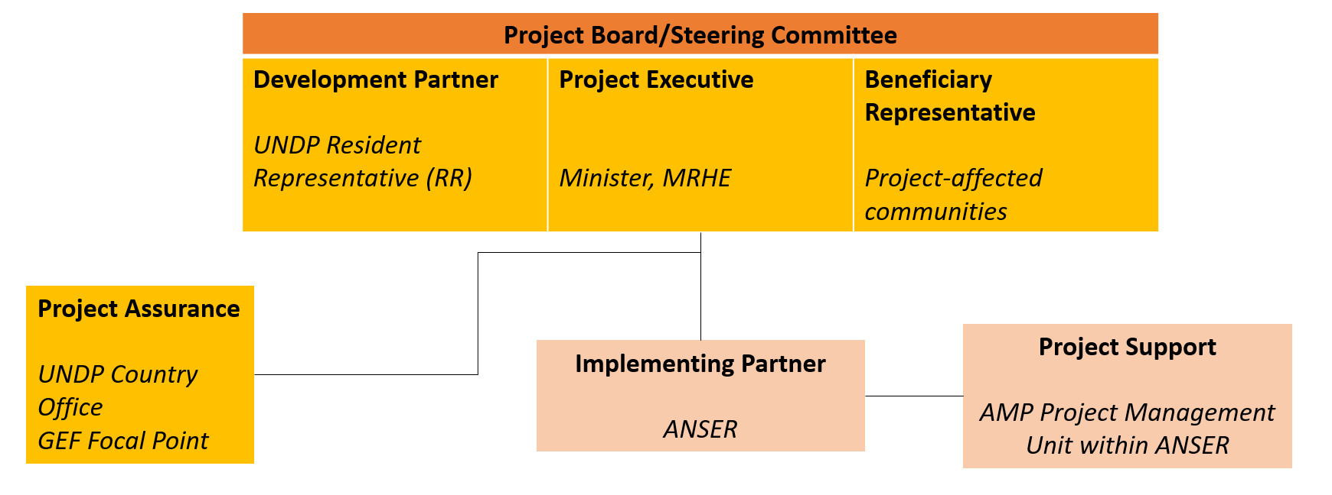
Figure 9: Project governance structure

The UNDP Resident Representative assumes full responsibility and accountability for oversight and quality assurance of this Project and ensures its timely implementation in compliance with the GEF-or PDL-145T specific requirements and UNDP’s Programme and Operations Policies and Procedures (POPP), its Financial Regulations and Rules and Internal Control Framework. A representative of the UNDP Country Office will assume the assurance role and will present assurance findings to the Project Board, and therefore attends Project Board meetings as a non-voting member.

Section 3: Segregation of duties and firewalls vis-à-vis UNDP representation on the project board:

As noted in the Minimum Fiduciary Standards for GEF Partner Agencies, in cases where a GEF Partner Agency (i.e., UNDP) carries out both implementation oversight and execution of a project, the GEF Partner Agency (i.e., UNDP) must separate its project implementation oversight and execution duties, and describe in the relevant project document a: 1) Satisfactory institutional arrangement for the separation of implementation oversight and executing functions in different departments of the GEF Partner Agency; and 2) Clear lines of responsibility, reporting and accountability within the GEF Partner Agency between the project implementation oversight and execution functions.
In this case, UNDP is only performing an implementation oversight role in the project vis-à-vis our role in the project board and in the project assurance function and therefore a full separation of project implementation oversight and execution duties has been assured.

Section 4: Roles and Responsiblities of the Project Organization Strucutre:

Project Board: All UNDP projects must be governed by a multi-stakeholder board or committee established to review performance based on monitoring and evaluation, and implementation issues to ensure quality delivery of results. The Project Board (also called the Project Steering Committee) is the most senior, dedicated oversight body for a project.

The two main (mandatory) roles of the project board are as follows:

- High-level oversight of the execution of the project by the Implementing Partner (as explained in the “Provide Oversight” section of the POPP). This is the primary function of the project board and includes annual (and as-needed) assessments of any major risks to the project, and decisions/agreements on any management actions or remedial measures to address them effectively. The Project Board reviews evidence of project performance based on monitoring, evaluation and reporting, including progress reports, evaluations, risk logs and the combined delivery report. The Project Board is responsible for taking corrective action as needed to ensure the project achieves the desired results.
- Approval of strategic project execution decisions of the Implementing Partner with a view to assess and manage risks, monitor and ensure the overall achievement of projected results and impacts and ensure long term sustainability of project execution decisions of the Implementing Partner (as explained in the “Manage Change” section of the POPP).

- Requirements to serve on the Project Board:
- Agree to the Terms of Reference of the Board and the rules on protocols, quorum and minuting.
- Meet annually; at least once.
- Disclose any conflict of interest in performing the functions of a Project Board member and take all measures to avoid any real or perceived conflicts of interest. This disclosure must be documented and kept on record by UNDP.
- Discharge the functions of the Project Board in accordance with UNDP policies and procedures.
- Ensure highest levels of transparency and ensure Project Board meeting minutes are recorded and shared with project stakeholders.

- Responsibilities of the Project Board:
- Consensus decision making:
  - The project board provides overall overall guidance and direction to the project, ensuring it remains within any specified constraints, and providing overall oversight of the project implementation.
  - Review project performance based on monitoring, evaluation and reporting, including progress reports, risk logs and the combined delivery report;
  - The project board is responsible for making management decisions by consensus.
  - In order to ensure UNDP’s ultimate accountability, Project Board decisions should be made in accordance with standards that shall ensure management for development results, best value money, fairness, integrity, transparency and effective international competition.
  - In case consensus cannot be reached within the Board, the UNDP representative on the board will mediate to find consensus and, if this cannot be found, will take the final decision to ensure project implementation is not unduly delayed.
- Oversee project execution:
  - Agree on project manager’s tolerances as required, within the parameters outlined in the project document, and provide direction and advice for exceptional situations when the project manager’s tolerances are exceeded.
- Appraise annual work plans prepared by the Implementing Partner for the Project; review combined delivery reports prior to certification by the implementing partner.
- Address any high-level project issues as raised by the project manager and project assurance;
- Advise on major and minor amendments to the project within the parameters set by UNDP and the donor and refer such proposed major and minor amendments to the UNDP BPPS Nature, Climate and Energy Executive Coordinator (and the GEF, as required by GEF policies);
- Provide high-level direction and recommendations to the project management unit to ensure that the agreed deliverables are produced satisfactorily and according to plans.
- Track and monitor co-financed activities and realisation of co-financing amounts of this project.
- Approve the Inception Report, GEF annual project implementation reports, mid-term review and terminal evaluation reports.
- Ensure commitment of human resources to support project implementation, arbitrating any issues within the project.
- Risk Management:
  - Provide guidance on evolving or materialized project risks and agree on possible mitigation and management actions to address specific risks.
  - Review and update the project risk register and associated management plans based on the information prepared by the Implementing Partner. This includes risks related that can be directly managed by this project, as well as contextual risks that may affect project delivery or continued UNDP compliance and reputation but are outside of the control of the project. For example, social and environmental risks associated with co-financed activities or activities taking place in the project’s area of influence that have implications for the project.
  - Address project-level grievances.
- Coordination:
  - Ensure coordination between various donor and government-funded projects and programmes.
  - Ensure coordination with various government agencies and their participation in project activities.

- Composition of the Project Board:
The composition of the Project Board must include individuals assigned to the following three roles:

- Project Executive: This is an individual who represents ownership of the project and chairs (or co-chairs) the Project Board. The Executive usually is the senior national counterpart for nationally implemented projects (typically from the same entity as the Implementing Partner), and it must be UNDP for projects that are direct implementation (DIM). In exceptional cases, two individuals from different entities can co-share this role and/or co-chair the Project Board. If the project executive co-chairs the project board with representatives of another category, it typically does so with a development partner representative. The Project Executive will be the Minister or a high-level representative of the Ministry in charge of Energy, i.e., General Secretary.
- Beneficiary Representative(s): Individuals or groups representing the interests of those groups of stakeholders who will ultimately benefit from the project. Their primary function within the board is to ensure the realization of project results from the perspective of project beneficiaries. Often representatives from civil society, industry associations, or other government entities benefiting from the project can fulfil this role. There can be multiple beneficiary representatives in a Project Board. The Beneficiary representative will be the head or high-level representative of one or more non-governmental or civil society organizations which will be selected by the Project Board by consensus. The Project Board will include civil society organizations or associations as part of the Beneficiary Representatives. Specific organizations or associations could not yet be determined, as the siting of the 172 minigrids is still being finalized. Once sites are confirmed, organizations or associations will be identified by the PMU and Board membership decided upon by the other members of the Project Board (executive, development).
- Development Partner(s): Individuals or groups representing the interests of the parties concerned that provide funding, strategic guidance and/or technical expertise of the project and the PDL-145T project. The Development Partner is the UNDP DRC Country Office Resident Representative.

- Project Assurance:
Project assurance is the responsibility of each project board member; however, UNDP has a distinct assurance role for all UNDP projects in carrying out objective and independent project oversight and monitoring functions. UNDP performs quality assurance and supports the Project Board (and Project Management Unit) by carrying out objective and independent project oversight and monitoring functions, including compliance with the risk management and social and environmental standards of UNDP. The Project Board cannot delegate any of its quality assurance responsibilities to the Project Manager. Project assurance is totally independent of project execution.
A designated representative of UNDP playing the project assurance role is expected to attend all board meetings and support board processes as a non-voting representative. It should be noted that while in certain cases UNDP’s project assurance role across the project may encompass activities happening at several levels (e.g. global, regional), at least one UNDP representative playing that function must, as part of their duties, specifically attend board meeting and provide board members with the required documentation required to perform their duties. The UNDP representative playing the main project assurance function will be a relevant staff member in the UNDP Country Office or in the UNDP PDL-145T Team, as designated by the Resident Representative.
- Project Management – Execution of the Project:
The Project Manager (PM) (also called project coordinator) is the senior most representative of the Project Management Unit (PMU) and is responsible for the overall day-to-day management of the project on behalf of the Implementing Partner, including the mobilization of all project inputs, supervision over project staff, responsible parties, consultants and sub-contractors. The project manager typically presents key deliverables and documents to the board for their review and approval, including progress reports, annual work plans, adjustments to tolerance levels and risk registers.
A designated representative of the PMU is expected to attend all board meetings and support board processes as a non-voting representative.

The primary PMU representative attending board meetings is the AMP Project Manager.

- Technical Advisory Committee (TAC):
The function of the Technical Advisory Committee (TAC) is to provide technical advice and support to inform decision making by the Project Board. The TAC will consist of energy and other infrastructure experts from UNDP, and/or development partners, or other experts as defined by the Project Board who have experience in the DRC and can leverage their expertise to improve project outcomes. At least one senior expert of the UNDP PDL-145T unit involved in rural electrification will serve on the TAC. The TAC is expected to meet quarterly, and upon convening by the Project Board.
In addition to providing technical guidance, the TAC will serve as a coordination unit to align the project activities between the UNDP-led PDL-145T minigrid component and the AMP DRC Project. This coordination is critical to ensure that the timelines and outputs of the various activities of the AMP DRC Project are in sync with the PDL-145T. The TAC serves to formalize this coordination to ensure proper processes and procedures are followed and the coordination takes place during regular intervals.

VIII. Financial Planning and Management

The total cost of the project is USD 61,550,716. This is financed through a GEF grant of USD USD 408,716, and UNDP TRAC cash co-financing of USD 500,000 to be administered by UNDP, and additional co-financing support of USD 60,642,000. UNDP, as the GEF Implementing Agency, is responsible for the oversight of the GEF resources and the cash co-financing transferred to UNDP bank account only.

- Co-financing:
The actual realization of project co-financing amounts will be monitored by the UNDP Country Office and the PMU on an annual basis in the GEF PIF and will be reported to the GEF during the mid-term review and terminal evaluation process as follows:

Co-financing source | Co-financing type | Name of Co-financier | Investment Mobilized | Co-financing amount
GEF Agency | Grant | UNDP | Investment mobilized | 500,000
Donor Agency | Grant | AfDB | Investment mobilized | 592,000
Recipient country government (Implemented by GEF Agency) | Cash | Government of the DRC (Implemented via cost sharing agreement with UNDP DRC CO) | Investment mobilized | 43,250,000
Recipient country government (Implemented by GEF Agency) | Grant | Government of the DRC (Implemented via cost sharing agreement with UNDP DRC CO) | Investment mobilized | 16,800,000
Total |  |  |  | 61,142,000

- Budget Revision and Tolerance
As per UNDP POPP, the project board may agree with the project manager on a tolerance level for each detailed plan under the overall multi-year workplan. The agreed tolerance should be written in the project document or approved project board meeting minutes. It should normally not exceed 10 percent of the agreed annual budget at the activity level, but within the overall approved multi-year workplan at the activity level. Within the agreed tolerances, the project manager can operate without intervention from the project board. Restrictions apply as follows:

Should the following deviations occur, the Project Manager/IP through UNDP Country Office will seek the approval of the BPPS/NCE-VF team to ensure accurate reporting to the GEF. It is strongly encouraged to maintain the expenditures within the approved budget at the budgetary account and at the component level:

- Budget reallocations must prove that the suggested changes in the budget will not lead to material changes in the results to be achieved by the project. A strong justification is required and will be approved on an exceptional basis. Budget re-allocations among the components (including PMC) of the approved Total Budget and Work Plans (TBWP) that represent a value greater than 10% of the total GEF grant.
- Introduction of new outputs/activities (i.e. budget items) that were not part of the agreed project document and TBWP that represent a value greater than 5% of the total GEF grant. The new budget items must be eligible as per the GEF and UNDP policies.
- Project management cost (PMC): budget under PMC component is capped and cannot be increased.

UNDP is not in a position to increase the total budget above the amount approved by the donor, therefore any over-expenditure would have to be absorbed from non-GEF resources by the Implementing Partner (GEF Executing Entity)
- Project extensions: The UNDP-BPPS-NCE team Executive Coordinator must approve all requests for extension of the Project Completion Date and for other milestone extensions with hard deadlines. All extensions impose additional time and cost burdens at all levels and the GEF project budget cannot be increased beyond its originally approved amount. A single extension may be granted on an exceptional basis and subject to the conditions and maximum durations set out in the UNDP POPP. The project management costs during the extension period must remain within the originally approved amount, and any increase in PMC costs shall be covered by non-GEF resources; the additional UNDP oversight costs during the extension period must be covered by non-GEF resources, in accordance with UNDP’s policy as set out in UNDP POPP.

For any extension request, UNDP CO and IP will consult and jointly present a clear plan indicating how and from which specific sources the additional oversight costs that will be incurred by UNDP will be covered during the extended period. The BPPS-NCE Executive Coordinator will consult the Regional Bureaux (RBX) and may reject the extension request if no (external co-financing by the IP or internal UNDP CO resources) can be identified.

All extension requests, along with all supporting documentation, shall be submitted by the IP to the UNDP CO in line with the requirements and within the deadlines set out in the UNDP SOPs and policies in UNDP POPP.

- Audit: The project will be audited as per UNDP Financial Regulations and Rules and applicable audit policies. Audit cycle and process must be discussed during the Inception workshop. If the Implementing Partner is an UN Agency, the project will be audited according to that Agencies applicable audit policies.

- Transfer or disposal of assets: In consultation with the Implementing Partner and other parties of the project, UNDP is responsible for deciding on the transfer or other disposal of assets. Transfer or disposal of assets is recommended to be reviewed and endorsed by the project board following UNDP rules and regulations. Assets may be transferred to the government for project activities managed by a national institution at any time during the life of a project, however, must be done before the operational closure date. In all cases of transfer, a transfer document must be prepared and kept on file. The transfer should be done before Project Management Unit complete their assignments.

- Completion Date: The project completion date is the date of Project Document Signature plus project duration. This date can only be extended through a formal extension request. Prior to completion date, all UNDP-financed inputs must be provided and related activities for the Project completed. No activities, except for the final clearance of the Terminal Evaluation Report and the corresponding management response and the end-of-project review Project Board Meeting should take place after the Completion Date.

- Project Closure: Project closure will be conducted as per UNDP requirements outlined in the UNDP POPP. All costs incurred to close the project must be included in the project closure budget and reported as final project commitments presented to the Project Board during the final project review. The only costs a project may incur following the final project review are those included in the project closure budget.

- Operational Closure: Operational closure must happen within 9 months from project completion date. Prior to operational closure, the Terminal Evaluation must have been submitted and the corresponding TE management response and the end-of-project review Project Board meeting must have been completed. The Implementing Partner through a Project Board decision will notify the UNDP Country Office when operational closure has been completed. Before Operational Closure, the project must have completed the transfer or disposal of any equipment that is still the property of UNDP.
- Financial Closure: Financial closure must happen within 6 months of operational closure or after the date of cancellation. The project will be financially closed when the following conditions have been met: a) the project is operationally completed or has been cancelled; b) the Implementing Partner has reported all financial transactions to UNDP; c) UNDP has closed the accounts for the project; d) UNDP and the Implementing Partner have certified a final Combined Delivery Report (which serves as final budget revision).
Between operational and financial closure, the implementing partner will identify and settle all financial obligations and prepare a final expenditure report. The UNDP Country Office will send the final signed closure documents including confirmation of final cumulative expenditure and unspent balance to BPPS/NCE for confirmation before the project will be financially closed in Quantum by the UNDP Country Office.

- Cancellation and Suspension: All projects considering going through cancellation or suspension must follow UNDP and GEF requirements. Guidance can be found in the UNDP POPP (SOPs for management actions of Vertical Fund projects escalated to the Executive Coordinator and Guidance for GEF project revisions).

- Refund to GEF: Should a refund of unspent funds to the GEF be necessary, this will be managed directly by the BPPS/NCE team Directorate in New York. No action is required by the UNDP Country Office on the actual refund from UNDP project to the GEF. Unspent project balance is not permitted to be transferred to any other projects.

IX. Total Budget and Work Plan

Total Budget and Work Plan
Quantum Business Unit | UNDP-COD10
Quantum Project ID: | 01001601 | Quantum Project Title: | Africa Minigrids Program – DRC-UNDP-COD-00134210
Quantum Award ID: | 1212265 | Quantum Award Title: | Africa Minigrids Program – DRC-UNDP-COD-00134210
UNDP-GEF PIMS No. | 6702
Implementing Partner | Agence Nationale de l’Electrification et des Services Energétiques en milieux Rural et Périurbain (ANSER)

Quantum Outcome  (GEF Component) | Quantum Output  (GEF Outcome) | Quantum Activity  (GEF Output) | Quantum Responsible Party (UNDP, IP, or Responsible Party ) | Quantum Fund ID | Quantum Donor ID | Quantum Budgetary Account Code | Quantum Budget Account Description | Amount  Year 1  (USD) |  |  | Amount Year 2 (USD) |  |  | Amount Year 3  (USD) |  |  | Amount Year 4  (USD) |  |  | Total (USD) |  |  | See Budget Note:
Component 1 - Policy and Regulation | Outcome 1: Stakeholder ownership in a national minigrid delivery model is advanced, and appropriate policies and regulations are adopted to facilitate investment in low-carbon minigrids | Output 1.1 An inclusive national dialogue to identify minigrid delivery models is facilitated, clarifying priority interventions for an integrated approach to off-grid electrification | ANSER | 62000 | 010003 | 71300 | Local Consultants | 16,900 |  |  | 16,900 |  |  | 16,900 |  |  | 16,900 |  |  | 67,600 |  |  | 1
 |  |  |  |  |  | 75700 | Training, Workshops and Confer | 5,000 |  |  | 5,000 |  |  | 5,000 |  |  | 5,000 |  |  | 20,000 |  |  | 2
Component 1 - Policy and Regulation |  |  | Sub Total Output 1.1 - GEF |  |  |  |  | 21,900 |  |  | 21,900 |  |  | 21,900 |  |  | 21,900 |  |  | 87,600
Component 1 - Policy and Regulation |  |  | ANSER | 04000 | 00012 | 72800 | Local Consultants | 19,475 |  |  | 19,475 |  |  | 19,475 |  |  | 19,475 |  |  | 77,900 |  |  | 3
 |  |  |  |  |  | 72800 | Information Technology Equipmt | 10,000 |  |  |  |  |  |  |  |  |  |  |  | 10,000 |  |  | 4
 |  |  |  |  |  | 71600 | Travel | 5,000 |  |  | 5,000 |  |  | 5,000 |  |  | 5,000 |  |  | 20,000 |  |  | 5
Component 1 - Policy and Regulation |  |  | Sub Total Output 1.1 - UNDP |  |  |  |  | 34,475 |  |  | 24,475 |  |  | 24,475 |  |  | 24,475 |  |  | 107,900
Component 1 - Policy and Regulation |  | Total Output 1.1. |  |  |  |  |  |  | 56,375 |  |  | 46,375 |  |  | 46,375 |  |  | 46,375 |  |  | 195,500
Component 1 - Policy and Regulation |  | Output 1.2. Targeted policy and financial derisking instruments of the Minigrid DREI techno-economic analyses implemented and contributing to AMP Flagship Report on Cost Reduction | ANSER | 62000 | 010003 | 71200 | International Consultants | 37,500 |  |  |  |  |  |  |  |  |  |  |  | 37,500 |  |  | 6
 |  |  |  |  |  | 71300 | Local Consultants | 8,000 |  |  |  |  |  |  |  |  |  |  |  | 8,000 |  |  | 7
 |  |  |  |  |  | 71600 | Travel | 4,000 |  |  | 3,750 |  |  |  |  |  |  |  |  | 7,750 |  |  | 8
Component 1 - Policy and Regulation |  |  | Sub Total Output 1.2 - GEF |  |  |  |  | 49,500 |  |  | 3,750 |  |  | - |  |  | - |  |  | 53,250
Component 1 - Policy and Regulation |  |  | ANSER | 400 | 00012 | 72800 | Local Consultants | 2,400 |  |  | - |  |  | - |  |  | - |  |  | 2,400 |  |  | 9
Component 1 - Policy and Regulation |  |  | Sub Total Output 1.2 - UNDP |  |  |  |  | 2,400 |  |  | - |  |  | - |  |  | - |  |  | 2,400
Component 1 - Policy and Regulation |  | Total Output 1.2 |  |  |  |  |  |  | 51,900 |  |  | 3,750 |  |  | - |  |  | - |  |  | 55,650
Component 1 - Policy and Regulation |  | Output 1.3. Capacity building provided to public officials (regulator, ministries) to support cost-reduction levers and innovative business models | ANSER | 62000 | 010003 | 72100 | Contractual Services-Companies | 27,391 |  |  | 27,391 |  |  | 27,392 |  |  | 27,392 |  |  | 109,566 |  |  | 10
Component 1 - Policy and Regulation |  |  | ANSER | 62000 | 010003 | 72100 | International Consultants | 7,500 |  |  |  |  |  |  |  |  |  |  |  | 7,500 |  |  | 11
Component 1 - Policy and Regulation |  |  | ANSER | 62000 | 010003 | 71300 | Local Consultants | 3,000 |  |  |  |  |  |  |  |  |  |  |  | 3,000 |  |  | 12
Component 1 - Policy and Regulation |  |  | ANSER | 62000 | 010003 | 71600 | Travel | 7,400 |  |  |  |  |  |  |  |  |  |  |  | 7,400 |  |  | 13
Component 1 - Policy and Regulation |  |  | Sub Total Output 1.3 - GEF |  |  |  |  | 45,291 |  |  | 27,391 |  |  | 27,392 |  |  | 27,392 |  |  | 127,466
Component 1 - Policy and Regulation |  |  | ANSER | 400 | 00012 | 72800 | Local Consultants | 750 |  |  | 750 |  |  | 750 |  |  | 750 |  |  | 3,000 |  |  | 14
Component 1 - Policy and Regulation |  |  | ANSER | 400 | 00012 | 72800 | International Consultants | 7,000 |  |  | - |  |  | - |  |  | - |  |  | 7,000 |  |  | 15
Component 1 - Policy and Regulation |  |  | Sub Total Output 1.3 - UNDP |  |  |  |  | 7,750 |  |  | 750 |  |  | 750 |  |  | 750 |  |  | 10,000
Component 1 - Policy and Regulation |  | Total Output 1.3 |  |  |  |  |  |  | 53,041 |  |  | 28,141 |  |  | 28,142 |  |  | 28,142 |  |  | 137,466
Component 1 - Policy and Regulation | Sub Total Outcome 1 - UNDP |  |  |  |  |  |  |  | 44,625 |  |  | 25,225 |  |  | 25,225 |  |  | 25,225 |  |  | 120,300
Component 1 - Policy and Regulation | Sub Total Outcome 1 - GEF |  |  |  |  |  |  |  | 116,691 |  |  | 53,041 |  |  | 49,292 |  |  | 49,292 |  |  | 268,316
Component 1 - Policy and Regulation | Total Outcome 1 |  |  |  |  |  |  |  | 161,316 |  |  | 78,266 |  |  | 74,517 |  |  | 74,517 |  |  | 388,616
Total Component 1 |  |  |  |  |  |  |  |  |  | 161,316 |  |  | 78,266 |  |  | 74,517 |  |  | 74,517 |  |  | 388,616
Component 2. Business Model Innovation with Private Sector | Outcome 2: Innovative business models based on cost reduction are operationalized, with strengthened private sector participation in low-carbon/renewable energy minigrid development | Output 2.1 Feedback loop established between the project and the PDL-145T minigrid pilots | ANSER | 62000 | 010003 | 71200 | International Consultants | 8,875 |  |  | 1,875 |  |  | 1,875 |  |  | 1,875 |  |  | 14,500 |  |  | 16
Component 2. Business Model Innovation with Private Sector |  |  | Sub Total Output 2.1 - GEF |  |  |  |  | 8,875 |  |  | 1,875 |  |  | 1,875 |  |  | 1,875 |  |  | 14,500
Component 2. Business Model Innovation with Private Sector |  | Total Output 2.1. |  |  |  |  |  |  | 8,875 |  |  | 1,875 |  |  | 1,875 |  |  | 1,875 |  |  | 14,500
Component 2. Business Model Innovation with Private Sector | Sub Total Outcome 2 - GEF |  |  |  |  |  |  |  | 8,875 |  |  | 1,875 |  |  | 1,875 |  |  | 1,875 |  |  | 14,500
Component 2. Business Model Innovation with Private Sector | Total Outcome 2 |  |  |  |  |  |  |  | 8,875 |  |  | 1,875 |  |  | 1,875 |  |  | 1,875 |  |  | 14,500
Total Component 2 |  |  |  |  |  |  |  |  |  | 8,875 |  |  | 1,875 |  |  | 1,875 |  |  | 1,875 |  |  | 14,500
Component 3. Digital & Knowledge Management | Outcome 3: Digitalization and data mainstreamed, across stakeholders, into local minigrid market development. Increased knowledge, awareness and network opportunities in the minigrid market and among stakeholders, including benefitting from linkages to international good practice | Output 3.1. A project digital strategy is developed and implemented, including linkages to and following guidance from the AMP Regional Project | ANSER | 62000 | 010003 | 71200 | International Consultants | 18,750 |  |  |  |  |  |  |  |  |  |  |  | 18,750 |  |  | 17
 |  |  |  |  |  | 71600 | Travel | 3,000 |  |  |  |  |  |  |  |  |  |  |  | 3,000 |  |  | 18
 |  |  |  |  |  | 75700 | Training, Workshops and Confer | 3,000 |  |  |  |  |  |  |  |  |  |  |  | 3,000 |  |  | 19
Component 3. Digital & Knowledge Management |  |  | Sub Total Output 3.1 - GEF |  |  |  |  | 24,750 |  |  | - |  |  | - |  |  | - |  |  | 24,750
Component 3. Digital & Knowledge Management |  |  | ANSER | 400 | 00012 | 72800 | Local Consultants | 1,500 |  |  | - |  |  | - |  |  | - |  |  | 1,500 |  |  | 20
Component 3. Digital & Knowledge Management |  |  | Sub Total Output 3.1 - UNDP |  |  |  |  | 1,500 |  |  | - |  |  | - |  |  | - |  |  | 1,500
Component 3. Digital & Knowledge Management |  | Total Output 3.1. |  |  |  |  |  |  | 26,250 |  |  | - |  |  | - |  |  | - |  |  | 26,250
Component 3. Digital & Knowledge Management |  | Output 3.2. A ‘Minigrids Digital and Data Management Platform’ is implemented to run tenders and manage data from pilots, and to support minigrids scale-up and cost-reduction | ANSER | 04000 | 00012 | 72100 | Contractual Services-Companies | 100,000 |  |  | 10,460 |  |  | 10,460 |  |  | 10,460 |  |  | 131,380 |  |  | 21
 |  |  |  |  |  | 72800 | Information Technology Equipmt | 20,000 |  |  | 2,000 |  |  | 2,000 |  |  | 2,000 |  |  | 26,000 |  |  | 22
Component 3. Digital & Knowledge Management |  | Total Output 3.2. |  |  |  |  |  |  | 120,000 |  |  | 12,460 |  |  | 12,460 |  |  | 12,460 |  |  | 157,380
Component 3. Digital & Knowledge Management |  | Output 3.3. A Quality Assurance and Monitoring Framework for measuring, reporting and verification of the sustainable development impacts of all minigrids pilots supported, including GHG emission reductions, is adopted and operationalized based on standardized guidance from the regional project | ANSER | 62000 | 010003 | 71200 | International Consultants | 3,750 |  |  |  |  |  |  |  |  |  |  |  | 3,750 |  |  | 23
Component 3. Digital & Knowledge Management |  | Total Output 3.3. |  |  |  |  |  |  | 3,750 |  |  | - |  |  | - |  |  | - |  |  | 3,750
Component 3. Digital & Knowledge Management |  | Output 3.4. Engage with regional project, including, but not limited to, via (i) participating in Communities of Practice and (ii) capturing and sharing lessons learned | ANSER | 62000 | 010003 | 72100 | Contractual Services-Companies |  |  |  | 3,000 |  |  | 3,000 |  |  | 3,000 |  |  | 9,000 |  |  | 24
 |  |  |  |  |  | 71600 | Travel |  |  |  | 4,000 |  |  | 4,000 |  |  | 4,000 |  |  | 12,000 |  |  | 25
Component 3. Digital & Knowledge Management |  |  | Sub Total Output 3.4 - GEF |  |  |  |  | - |  |  | 7,000 |  |  | 7,000 |  |  | 7,000 |  |  | 21,000
Component 3. Digital & Knowledge Management |  |  | ANSER | 400 | 00012 | 72800 | Local Consultants | - |  |  | 1,500 |  |  | 1,500 |  |  | 1,500 |  |  | 4,500 |  |  | 26
Component 3. Digital & Knowledge Management |  |  | Sub Total Output 3.4 - UNDP |  |  |  |  | - |  |  | 1,500 |  |  | 1,500 |  |  | 1,500 |  |  | 4,500
Component 3. Digital & Knowledge Management |  | Total Output 3.4. |  |  |  |  |  |  | - |  |  | 8,500 |  |  | 8,500 |  |  | 8,500 |  |  | 25,500
 | Sub Total Outcome 3 - UNDP |  |  |  |  |  |  |  | 121,500 |  |  | 13,960 |  |  | 13,960 |  |  | 13,960 |  |  | 163,380
 | Sub Total Outcome 3 - GEF |  |  |  |  |  |  |  | 28,500 |  |  | 7,000 |  |  | 7,000 |  |  | 7,000 |  |  | 49,500
 | Total Outcome 3 |  |  |  |  |  |  |  | 150,000 |  |  | 20,960 |  |  | 20,960 |  |  | 20,960 |  |  | 212,880
Total Component 3 |  |  |  |  |  |  |  |  |  | 150,000 |  |  | 20,960 |  |  | 20,960 |  |  | 20,960 |  |  | 212,880
Component 4. Monitoring and Evaluation (M&E) | M&E | Output 4.1. Monitoring and Evaluation (M&E) and Reporting, including (i) Conducting Inception workshop and preparing report, (ii) Ongoing M&E, (iii) Mid-Term Evaluation and (iv) Terminal Evaluation | ANSER | 62000 | 010003 | 71200 | International Consultants |  |  |  | 15,000 |  |  |  |  |  | 25,000 |  |  | 40,000 |  |  | 27
Component 4. Monitoring and Evaluation (M&E) | M&E |  | Sub Total Output 4.1 - GEF |  |  |  |  | - |  |  | 15,000 |  |  | - |  |  | 25,000 |  |  | 40,000
Component 4. Monitoring and Evaluation (M&E) | M&E |  | ANSER | 04000 | 00012 | 71300 | Local Consultants |  |  |  | 8,000 |  |  |  |  |  | 10,000 |  |  | 18,000 |  |  | 28
 |  |  |  |  |  | 71600 | Travel | 2,000 |  |  | 2,000 |  |  | 2,000 |  |  | 2,000 |  |  | 8,000 |  |  | 29
 |  |  |  |  |  | 75700 | Training, Workshops and Confer | 3,000 |  |  |  |  |  |  |  |  | 3,000 |  |  | 6,000 |  |  | 30
Component 4. Monitoring and Evaluation (M&E) | M&E |  | Sub Total Output 4.1 - UNDP |  |  |  |  | 5,000 |  |  | 10,000 |  |  | 2,000 |  |  | 15,000 |  |  | 32,000
Component 4. Monitoring and Evaluation (M&E) | Sub Total Outcome 3 - UNDP |  |  |  |  |  |  |  | 5,000 |  |  | 10,000 |  |  | 2,000 |  |  | 15,000 |  |  | 32,000
Component 4. Monitoring and Evaluation (M&E) | Sub Total Outcome 3 - GEF |  |  |  |  |  |  |  | - |  |  | 15,000 |  |  | - |  |  | 25,000 |  |  | 40,000 |  | -
Component 4. Monitoring and Evaluation (M&E) | Total Outcome 3 |  |  |  |  |  |  |  | 5,000 |  |  | 25,000 |  |  | 2,000 |  |  | 40,000 |  |  | 72,000
Total Component 4 |  |  |  |  |  |  |  |  |  | 5,000 |  |  | 25,000 |  |  | 2,000 |  |  | 40,000 |  |  | 72,000
Project Management Cost (PMC) | PMC | PMC | ANSER | 62000 | 010003 | 74100 | Professional Services | 3,000 |  |  | 3,000 |  |  | 3,000 |  |  | 3,000 |  |  | 12,000 |  |  | 31
 |  |  |  |  |  | 72200 | Equipment and Furniture | 14,400 |  |  |  |  |  |  |  |  |  |  |  | 14,400 |  |  | 32
 |  |  |  |  |  | 72800 | Information Technology Equipmt | 10,000 |  |  |  |  |  |  |  |  |  |  |  | 10,000 |  |  | 33
Project Management Cost (PMC) | PMC | PMC | Sub Total PMC - GEF |  |  |  |  | 27,400 |  |  | 3,000 |  |  | 3,000 |  |  | 3,000 |  |  | 36,400
Project Management Cost (PMC) | PMC | PMC | ANSER | 04000 | 00012 | 64397 | Direct Project Cost-Staff | 46,080 |  |  | 46,080 |  |  | 46,080 |  |  | 46,080 |  |  | 184,320 |  |  | 34
Project Management Cost (PMC) | PMC | PMC | Sub Total PMC - UNDP |  |  |  |  | 46,080 |  |  | 46,080 |  |  | 46,080 |  |  | 46,080 |  |  | 184,320
Total Project Management Cost |  |  |  |  |  |  |  |  |  | 73,480 |  |  | 49,080 |  |  | 49,080 |  |  | 49,080 |  |  | 220,720
Total GEF |  |  |  |  |  |  |  |  |  | 181,466 |  |  | 79,916 |  |  | 61,167 |  |  | 86,167 |  |  | 408,716
Total UNDP |  |  |  |  |  |  |  |  |  | 217,205 |  |  | 95,265 |  |  | 87,265 |  |  | 100,265 |  |  | 500,000
Total Project |  |  |  |  |  |  |  |  |  | 398,671 |  |  | 175,181 |  |  | 148,432 |  |  | 186,432 |  |  | 908,716

Table 9: Budget Notes
Budget Note No. | Project Output (Description)
1 | 3 national consultants (one in capital Kinshasa, 2 in ANSER's regional offices) to support national, provincial, and local working groups (each 5 days per month @ $200/day); 46.944% funded by GEF, 53.056% funded by UNDP
2 | Various meetings, trainings and workshops hosted at ANSER HQ or regional offices (per year: 20 events @ $250 each)
3 | 1 national gender consultant to ensure integration of women’s organizations into the multi-stakeholder working group (1,25 days per year @ $300/day)
4 | Laptops, software, etc. (2 x meeting room IT equipment @ $3,000; 3 x laptops @ $1,000 each; computer equipment such as monitors, keyboards and mouses for $500; required software @ $500)
5 | Travel to local sites across 9 provinces (per year: 10 national travels @ $200 each; 10 days DSA @ $250/day; 10 days car rental @ $50/day)
6 | 1 international technical consultant to conduct DREI analysis, including interviews, financial models, and knowledge products (50 days, @ $750/day)
7 | 1 national consultant to support international consultant with coordination and technical analysis(20 days, @ $400/day)
8 | Costs for missions (2 international flights @ $2,000 each; 4 national travels @ $200 each; 11 days DSA @ $250 each)
9 | 1 national gender consultant to consider the gender effects of any connection subsidies (8 days @ $300/day)
10 | Costs to hire firm for capacity building, all expenses included
11 | 1 international capacity building consultant to perform capacity needs assessment (10 days @ $750/day)
12 | 1 local capacity building consultant to to support capacity needs assessment (10 days @ $300/day)
13 | Costs for mission for international and local consultant (1 international return flight @ $2,000 each; 2 national travels @ $200 each; 20 days DSA @ $250/day)
14 | 1 national gender consultant to ensure equal access to training for male and female officials (2,5 days per year @ $300/day)
15 | 1 international gender consultant to provide capacity building on gender issues/ opportunities related to minigrids (10 days @ $700/day)
16 | 1 international consultant to review the final implementation plan of the PDL-145T and incorporate it into the AMP project via the Minigrid Pilot Plan (10 days @ $750/day)  1 international gender and E&S consultant to review PDL-145T gender and social and environmental approach and documentation and verify alignment with UNDP SES (10 days @ $700/day)
17 | International consultant to develop a digital strategy for the project and to align the AMP-QAMF to the specific case of DRC (25 days @ $750/day)
18 | Travel required for inception and validation workshop (1 international return flight @ $2,000, 4 days of DSA @ $250/day)
19 | Costs to cover organization of a workshop (1 workshop to validate results @ $3,000)
20 | 1 national gender consultant to digital strategy is gender sensitive (5 days @ $300/day)
21 | Procurement of digital tools based on digital strategy (initial procurement and development of the digital tools/platform @ $100,000; additional funding for ongoing tech support and revisions and upgrades to the system for three years @ $31,380)
22 | Server, domain name and other costs (1 x purchase of domain name @ $1,000; 1 x purchase and installation of server @ $16,000; maintenance and hardware upgrade costs @ $9,000)
23 | International consultant to align the AMP-QAMF to the specific case of DRC (5 days @ $750/day)
24 | Gather data and audio-visual content for the "insight brief" (local company), incl. translation into English (1 contract with national firm @ $3,000 per year)
25 | Regional AMP workshops, meetings or training events (5 international return flights @ $2,000 each; 8 days of DSA @ $250/day)
26 | 1 national gender consultant to document success stories and insight briefs on gender and mini grid topics (15 days @ $300/day)
27 | Evaluations: Costs including lump sum for travels (international & national)
28 | Evaluations: Costs including lump sum for travels (national)  1 national gender consultant to document the gender sensitive indicators as included in the M&E Plan (20 days @ $300/day)
29 | Travel for PMU for M&E related activities (per year: 3 days of national travel @ $200 each; 4 days DSA @ $250/day; 8 days car rental @ $50/day)
30 | Project inception and closure workshop (2 workshops @ $3,000 each)
31 | Audit costs (annual audit @ $3,000/year)
32 | Office equipment (1 x meeting room furniture including large desk and chairs @ $7,000/piece; 2 x office room furniture including desk, chair, and document and IT storage @ $3,700/piece)
33 | Laptops, software, etc. (1 x meeting room IT equipment @ $3,000; 2 x staff computers and laptops @ $2,000 each; computer equipment such as monitors, keyboards and mice for $2,000; required software for all hardware @ $1,000)
34 | Project Manager - 1 FTE for 4 years (FTE @ $2,000/m + 20% taxes)  Financial Assistant - 1 FTE for 4 years (FTE @ $1,200/m + 20% taxes)

X. Legal Context
This project document shall be the instrument referred to as such in Article 1 of the Standard Basic Assistance Agreement between the Government of the Democratic Republic of Congo and UNDP, signed on 27/05/1976All references in the SBAA to “Executing Agency” shall be deemed to refer to “Implementing Partner.”

This project will be implemented by Agence Nationale de l’Electrification et des Services Energétiques en milieux Rural et Périurbain (ANSER) (“Implementing Partner”) in accordance with its financial regulations, rules, practices and procedures only to the extent that they do not contravene the principles of the Financial Regulations and Rules of UNDP. Where the financial governance of an Implementing Partner does not provide the required guidance to ensure best value for money, fairness, integrity, transparency, and effective international competition, the financial governance of UNDP shall apply.

XI. Risk Management

- Consistent with the Article III of the SBAA [or the Supplemental Provisions to the Project Document], the responsibility for the safety and security of the Implementing Partner and its personnel and property, and of UNDP’s property in the Implementing Partner’s custody, rests with the Implementing Partner. To this end, the Implementing Partner shall:
- put in place an appropriate security plan and maintain the security plan, taking into account the security situation in the country where the project is being carried;
- assume all risks and liabilities related to the Implementing Partner’s security, and the full implementation of the security plan.

- UNDP reserves the right to verify whether such a plan is in place, and to suggest modifications to the plan when necessary. Failure to maintain and implement an appropriate security plan as required hereunder shall be deemed a breach of the Implementing Partner’s obligations under this Project Document.

- The Implementing Partner agrees to undertake all reasonable efforts to ensure that no UNDP funds received pursuant to the Project Document are used to provide support to individuals or entities associated with terrorism and that the recipients of any amounts provided by UNDP hereunder do not appear on the United Nations Security Council Consolidated Sanctions List, and that no UNDP funds received pursuant to the Project Document are used for money laundering activities. The United Nations Security Council Consolidated Sanctions List can be accessed via https://www.un.org/securitycouncil/content/un-sc-consolidated-list.

- The Implementing Partner acknowledges and agrees that UNDP will not tolerate sexual harassment and sexual exploitation and abuse of anyone by the Implementing Partner, and each of its responsible parties, their respective sub-recipients and other entities involved in Project implementation, either as contractors or subcontractors and their personnel, and any individuals performing services for them under the Project Document.
(a) In the implementation of the activities under this Project Document, the Implementing Partner, and each of its sub-parties referred to above, shall comply with the standards of conduct set forth in the Secretary General’s Bulletin ST/SGB/2003/13 of 9 October 2003, concerning “Special measures for protection from sexual exploitation and sexual abuse” (“SEA”).
(b) Moreover, and without limitation to the application of other regulations, rules, policies and procedures bearing upon the performance of the activities under this Project Document, in the implementation of activities, the Implementing Partner, and each of its sub-parties referred to above, shall not engage in any form of sexual harassment (“SH”). SH is defined as any unwelcome conduct of a sexual nature that might reasonably be expected or be perceived to cause offense or humiliation, when such conduct interferes with work, is made a condition of employment or creates an intimidating, hostile or offensive work environment. SH may occur in the workplace or in connection with work. While typically involving a pattern of conduct, SH may take the form of a single incident. In assessing the reasonableness of expectations or perceptions, the perspective of the person who is the target of the conduct shall be considered.
- a) In the performance of the activities under this Project Document, the Implementing Partner shall (with respect to its own activities), and shall require from its sub-parties referred to in paragraph 4 (with respect to their activities) that they, have minimum standards and procedures in place, or a plan to develop and/or improve such standards and procedures in order to be able to take effective preventive and investigative action. These should include: policies on sexual harassment and sexual exploitation and abuse; policies on whistleblowing/protection against retaliation; and complaints, disciplinary and investigative mechanisms. In line with this, the Implementing Partner will and will require that such sub-parties will take all appropriate measures to:
  - Prevent its employees, agents or any other persons engaged to perform any services under this Project Document, from engaging in SH or SEA;
  - Offer employees and associated personnel training on prevention and response to SH and SEA, where the Implementing Partner and its sub-parties referred to in paragraph 4 have not put in place its own training regarding the prevention of SH and SEA, the Implementing Partner and its sub-parties may use the training material available at UNDP;
  - Report and monitor allegations of SH and SEA of which the Implementing Partner and its sub-parties referred to in paragraph 4 have been informed or have otherwise become aware, and status thereof;
  - Refer victims/survivors of SH and SEA to safe and confidential victim assistance; and
  - Promptly and confidentially, record and investigate any allegations credible enough to warrant an investigation of SH or SEA. The Implementing Partner shall advise UNDP of any such allegations received and investigations being conducted by itself or any of its sub-parties referred to in paragraph 4 with respect to their activities under the Project Document, and shall keep UNDP informed during the investigation by it or any of such sub-parties, to the extent that such notification (i) does not jeopardize the conduct of the investigation, including but not limited to the safety or security of persons, and/or (ii) is not in contravention of any laws applicable to it. Following the investigation, the Implementing Partner shall advise UNDP of any actions taken by it or any of the other entities further to the investigation.
- The Implementing Partner shall establish that it has complied with the foregoing, to the satisfaction of UNDP, when requested by UNDP or any party acting on its behalf to provide such confirmation. Failure of the Implementing Partner, and each of its sub-parties referred to in paragraph 4, to comply of the foregoing, as determined by UNDP, shall be considered grounds for suspension or termination of the Project.
- Social and environmental sustainability will be enhanced through application of the UNDP Social and Environmental Standards (http://www.undp.org/ses) and related Accountability Mechanism (http://www.undp.org/secu-srm).
- The Implementing Partner shall: (a) conduct project and programme-related activities in a manner consistent with the UNDP Social and Environmental Standards, (b) implement any management or mitigation plan prepared for the project or programme to comply with such standards, and (c) engage in a constructive and timely manner to address any concerns and complaints raised through the Accountability Mechanism. UNDP will seek to ensure that communities and other project stakeholders are informed of and have access to the Accountability Mechanism.
- All signatories to the Project Document shall cooperate in good faith with any exercise to evaluate any programme or project-related commitments or compliance with the UNDP Social and Environmental Standards. This includes providing access to project sites, relevant personnel, information, and documentation.
- The Implementing Partner will take appropriate steps to prevent misuse of funds, fraud or corruption, by its officials, consultants, responsible parties, subcontractors and sub-recipients in implementing the project or using UNDP funds.

- In the implementation of the activities under this Project Document, UNDP places reasonable reliance upon the Implementing Partner for it to apply its laws, regulations and processes, and applicable international laws regarding anti money laundering and countering the financing of terrorism, to ensure consistency with the principles of then in force the UNDP Anti-Money Laundering and Countering the Financing of Terrorism Policy.

- The Implementing Partner will ensure that its financial management, anti-corruption, anti-fraud and anti-money laundering and countering the financing of terrorism policies are in place and enforced for all funding received from or through UNDP.

- The requirements of the following documents, then in force at the time of signature of the Project Document, apply to the Implementing Partner: (a) UNDP Policy on Fraud and other Corrupt Practices and (b) UNDP Office of Audit and Investigations Investigation Guidelines. The Implementing Partner agrees to the requirements of the above documents, which are an integral part of this Project Document and are available online at www.undp.org.

- In the event that an investigation is required, UNDP has the obligation to conduct investigations relating to any aspect of UNDP projects and programmes in accordance with UNDP’s regulations, rules, policies and procedures. The Implementing Partner shall provide its full cooperation, including making available personnel, relevant documentation, and granting access to the Implementing Partner’s (and its consultants’, responsible parties’, subcontractors’ and sub-recipients’) premises, for such purposes at reasonable times and on reasonable conditions as may be required for the purpose of an investigation. Should there be a limitation in meeting this obligation, UNDP shall consult with the Implementing Partner to find a solution.

- The signatories to this Project Document will promptly inform one another in case of any incidence of inappropriate use of funds, or credible allegation of fraud or corruption with due confidentiality.

Where the Implementing Partner becomes aware that a UNDP project or activity, in whole or in part, is the focus of investigation for alleged fraud/corruption, the Implementing Partner will inform the UNDP Resident Representative/Head of Office, who will promptly inform UNDP’s Office of Audit and Investigations (OAI). The Implementing Partner shall provide regular updates to the head of UNDP in the country and OAI of the status of, and actions relating to, such investigation.

- UNDP shall be entitled to a refund from the Implementing Partner of any funds provided that have been used inappropriately, including through fraud, corruption or other financial irregularity, or otherwise paid other than in accordance with the terms and conditions of the Project Document. Such amount may be deducted by UNDP from any payment due to the Implementing Partner under this or any other agreement. Recovery of such amount by UNDP shall not diminish or curtail the Implementing Partner’s obligations under this Project Document.

Where such funds have not been refunded to UNDP, the Implementing Partner agrees that donors to UNDP (including the Government) whose funding is the source, in whole or in part, of the funds for the activities under this Project Document, may seek recourse to the Implementing Partner for the recovery of any funds determined by UNDP to have been used inappropriately, including through fraud, corruption or other financial irregularity, or otherwise paid other than in accordance with the terms and conditions of the Project Document.

Note: The term “Project Document” as used in this clause shall be deemed to include any relevant subsidiary agreement further to the Project Document, including those with responsible parties, subcontractors and sub-recipients.

- Each contract issued by the Implementing Partner in connection with this Project Document shall include a provision representing that no fees, gratuities, rebates, gifts, commissions or other payments, other than those shown in the proposal, have been given, received, or promised in connection with the selection process or in contract execution, and that the recipient of funds from the Implementing Partner shall cooperate with any and all investigations and post-payment audits.

- Should UNDP refer to the relevant national authorities for appropriate legal action any alleged wrongdoing relating to the project, the Government will ensure that the relevant national authorities shall actively investigate the same and take appropriate legal action against all individuals found to have participated in the wrongdoing, recover and return any recovered funds to UNDP.

- The Implementing Partner shall ensure that all of its obligations set forth under this section entitled “Risk Management” are passed on to each responsible party, subcontractor and sub-recipient and that all the clauses under this section entitled “Risk Management Standard Clauses” are included, mutatis mutandis, in all sub-contracts or sub-agreements entered into further to this Project Document.

XII. Mandatory Annexes

- GEF Budget Template (available from BPPS NCE-VF)
- GEF Execution Support Letter
- Project Map and geospatial coordinates of the project area
- Multiyear Workplan
- Social and Environmental Screening Procedure (SESP)
- UNDP Atlas Risk Register
- Overview of technical consultancies/subcontracts
- Stakeholder Engagement Plan
- Environmental Social Management Framework (ESMF) or other SES frameworks/plans, if required
- Gender Analysis and Gender Action Plan
- Procurement Plan – for first year of implementation especially
- GEF focal area specific annexes (e.g. METT, GHG calculations, target landscape profile, feasibility study, other technical reports)
- Co-financing letters
- GEF and/or LDCF/SCCF Core indicators
- GEF Taxonomy
- Partners Capacity Assessment Tool and HACT assessment
- UNDP Project Quality Assurance Report (to be completed in UNDP online corporate planning system)

Annex 1: GEF Budget Template
Expenditure Category | Detailed Description | Component (USDeq.) |  |  |  |  |  |  |  |  |  |  |  | Responsible Entity
Expenditure Category | Detailed Description | Component 1 |  |  | Component 2 | Component 3 |  |  | M&E | Sub-Total | PMC | Total (USDeq.) | (Executing Entity receiving funds from the GEF Agency)[1]
Expenditure Category | Detailed Description | Outcome 1 |  |  | Outcome 2 | Outcome 3
Expenditure Category | Detailed Description | Output 1.1 | Output 1.2 | Output 1.3 | Output 2.1 | Output 3.1 | Output 3.3 | Output 3.4
Equipment | Office equipment (1 x meeting room furniture including large desk and chairs @ $7,000/piece; 2 x office room furniture including desk, chair, and document and IT storage @ $3,700/piece) |  |  |  |  |  |  |  |  |  | 14,400 | 14,400 | Agence Nationale de l’Electrification et des Services Energétiques en milieux Rural et Périurbain (ANSER)
Equipment | Laptops, software, etc. (1 x meeting room IT equipment @ $3,000; 2 x staff computers and laptops @ $2,000 each; computer equipment such as monitors, keyboards and mice for $2,000; required software for all hardware @ $1,000) |  |  |  |  |  |  |  |  |  | 10,000 | 10,000 | Agence Nationale de l’Electrification et des Services Energétiques en milieux Rural et Périurbain (ANSER)
Contractual services-Company | 1 local capacity building consultant to to support capacity needs assessment (10 days @ $300/day) |  |  | 109,566 |  |  |  |  |  | 109,566 |  | 109,566 | Agence Nationale de l’Electrification et des Services Energétiques en milieux Rural et Périurbain (ANSER)
Contractual services-Company | Costs for mission for international and local consultant (1 international return flight @ $2,000 each; 2 national travels @ $200 each; 20 days DSA @ $250/day) |  |  | 7,500 |  |  |  |  |  | 7,500 |  | 7,500 | Agence Nationale de l’Electrification et des Services Energétiques en milieux Rural et Périurbain (ANSER)
Contractual services-Company | Project inception and closure workshop (2 workshops @ $3,000 each) |  |  |  |  |  |  | 9,000 |  | 9,000 |  | 9,000 | Agence Nationale de l’Electrification et des Services Energétiques en milieux Rural et Périurbain (ANSER)
International Consultants | 1 national Consultant (20 days, @ $400/day) |  | 37,500 |  |  |  |  |  |  | 37,500 |  | 37,500 | Agence Nationale de l’Electrification et des Services Energétiques en milieux Rural et Périurbain (ANSER)
International Consultants | Office equipment (1 x meeting room furniture including large desk and chairs @ $7,000/piece; 2 x office room furniture including desk, chair, and document and IT storage @ $3,700/piece) |  |  |  |  |  |  |  | 40,000 | 40,000 |  | 40,000 | Agence Nationale de l’Electrification et des Services Energétiques en milieux Rural et Périurbain (ANSER)
International Consultants | Procurement of digital tools based on digital strategy (initial procurement and development of the digital tools/platform @ $100,000; additional funding for ongoing tech support and revisions and upgrades to the system for three years @ $40,000) |  |  |  | 14,500 |  |  |  |  | 14,500 |  | 14,500 | Agence Nationale de l’Electrification et des Services Energétiques en milieux Rural et Périurbain (ANSER)
International Consultants | Server, domain name and other costs (1 x purchase of domain name @ $1,000; 1 x purchase and installation of server @ $16,000; maintenance and hardware upgrade costs @ $9,000) |  |  |  |  | 18,750 |  |  |  | 18,750 |  | 18,750 | Agence Nationale de l’Electrification et des Services Energétiques en milieux Rural et Périurbain (ANSER)
International Consultants | Travel for PMU for M&E related activities (per year: 3 days of national travel @ $200 each; 4 days DSA @ $250/day; 8 days car rental @ $50/day) |  |  |  |  |  | 3,750 |  |  | 3,750 |  | 3,750 | Agence Nationale de l’Electrification et des Services Energétiques en milieux Rural et Périurbain (ANSER)
Local Consultants | 1 international consultant to review the final implementation plan of the PDL-145T and incorporate it into the AMP project via the Minigrid Pilot Plan (10 days @ $750/day)1 international gender and E&S consultant to review PDL-145T gender and social and environmental approach and documentation and verify alignment with UNDP SES (10 days @ $750/day) |  |  | 3,000 |  |  |  |  |  | 3,000 |  | 3,000 | Agence Nationale de l’Electrification et des Services Energétiques en milieux Rural et Périurbain (ANSER)
Local Consultants | 3 national consultants (one in capital Kinshasa, 2 in ANSER's regional offices) to support national, provincial, and local working groups (each 5 days per month @ $200/day) | 67,600 |  |  |  |  |  |  |  | 67,600 |  | 67,600 | Agence Nationale de l’Electrification et des Services Energétiques en milieux Rural et Périurbain (ANSER)
Local Consultants | Costs for missions (2 international flights @ $2,000 each; 4 national travels @ $200 each; 11 days DSA @ $250 each) |  | 8,000 |  |  |  |  |  |  | 8,000 |  | 8,000 | Agence Nationale de l’Electrification et des Services Energétiques en milieux Rural et Périurbain (ANSER)
Training, Workshops, Meetings | Gather data and audio-visual content for the "insight brief" (local company), incl. translation into English (1 contract with national firm @ $3,000 per year) |  |  |  |  | 3,000 |  |  |  | 3,000 |  | 3,000 | Agence Nationale de l’Electrification et des Services Energétiques en milieux Rural et Périurbain (ANSER)
Training, Workshops, Meetings | Various meetings, trainings and workshops hosted at ANSER HQ or regional offices (per year: 20 events @ $250 each) | 20,000 |  |  |  |  |  |  |  | 20,000 |  | 20,000 | Agence Nationale de l’Electrification et des Services Energétiques en milieux Rural et Périurbain (ANSER)
Travel | Costs to hire firm for capacity building, all expenses included |  | 7,750 |  |  |  |  |  |  | 7,750 |  | 7,750 | Agence Nationale de l’Electrification et des Services Energétiques en milieux Rural et Périurbain (ANSER)
Travel | International consultant to align the AMP-QAMF to the specific case of DRC (5 days @ $750/day) |  |  |  |  | 3,000 |  |  |  | 3,000 |  | 3,000 | Agence Nationale de l’Electrification et des Services Energétiques en milieux Rural et Périurbain (ANSER)
Travel | International consultant to develop a digital strategy for the project and to align the AMP-QAMF to the specific case of DRC (25 days @ $750/day) |  |  | 7,400 |  |  |  |  |  | 7,400 |  | 7,400 | Agence Nationale de l’Electrification et des Services Energétiques en milieux Rural et Périurbain (ANSER)
Travel | Project Manager - 1 FTE for 4 years (FTE @ $2,000/m + 20% taxes)Financial Assistant - 1 FTE for 4 years (FTE @ $1,500/m + 20% taxes) |  |  |  |  |  |  | 12,000 |  | 12,000 |  | 12,000 | Agence Nationale de l’Electrification et des Services Energétiques en milieux Rural et Périurbain (ANSER)
Other Operating Costs | Audit costs (annual audit @ $3,000/year) |  |  |  |  |  |  |  |  |  | 12,000 | 12,000 | Agence Nationale de l’Electrification et des Services Energétiques en milieux Rural et Périurbain (ANSER)
 | Total | 87,600 | 53,250 | 127,466 | 14,500 | 24,750 | 3,750 | 21,000 | 40,000 | 372,316 | 36,400 | 408,716

Annex 2: GEF execution support letter Services (Not applicable)

Annex 3: Project map and Geospatial Coordinates of project sites

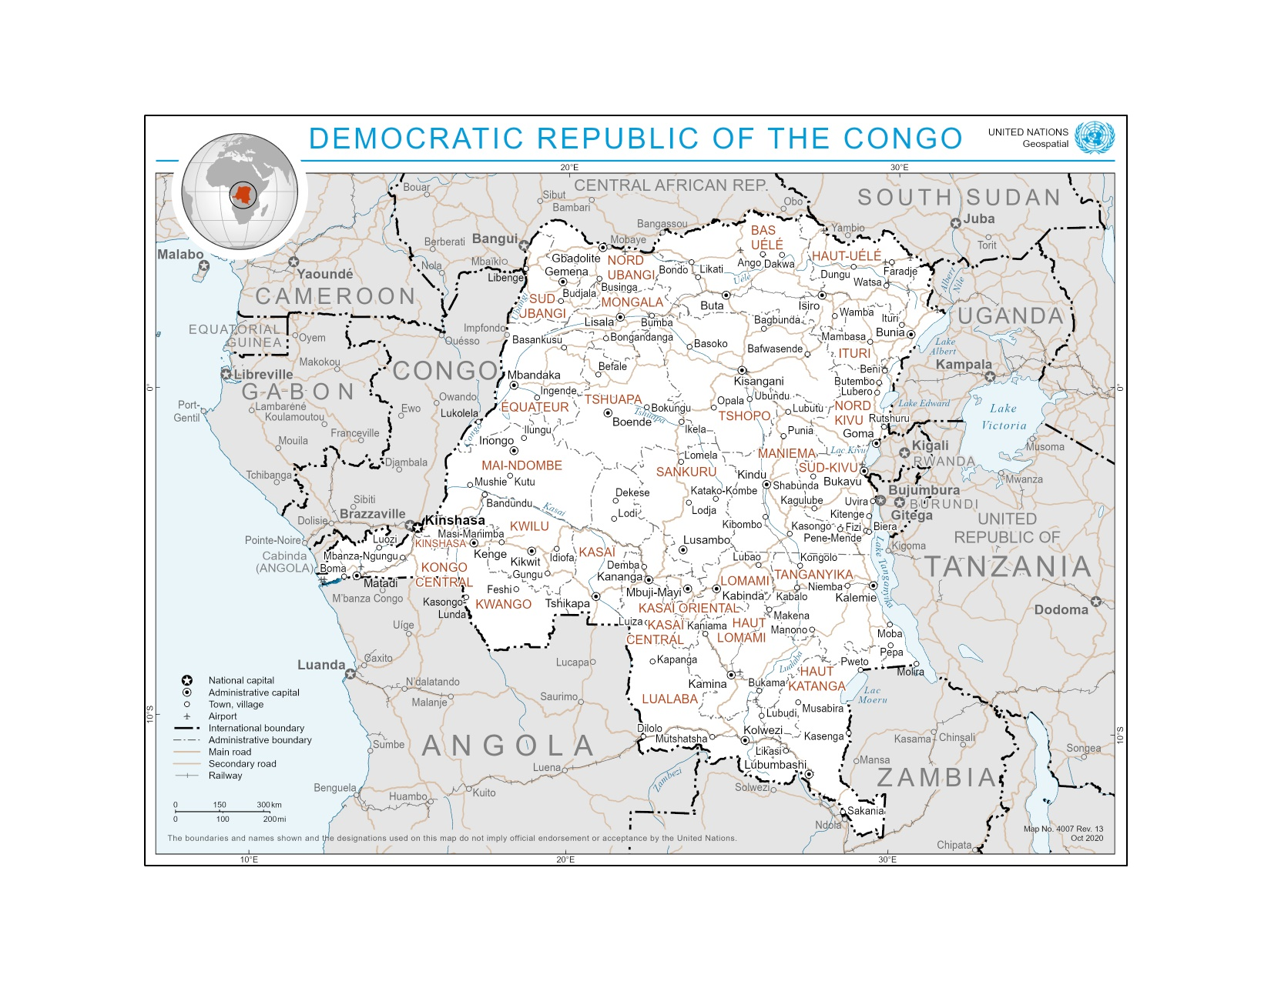
Source: https://www.un.org/geospatial/content/democratic-republic-congo-2

Annex 4: Multi Year Work Plan

 | Policy de-risking |  | Minigrid investment pilot(s) |  | Institutional and individual capacity building |  | M&E, QA and KM

Components | Outcomes | Outputs | Year 1  (2023/2024) |  |  |  | Year 2  (2024/2025) |  |  |  | Year 3  (2025/2026) |  |  |  | Year 4  (2026/2027)
Components | Outcomes | Outputs | Q1 | Q2 | Q3 | Q4 | Q1 | Q2 | Q3 | Q4 | Q1 | Q2 | Q3 | Q4 | Q1 | Q2 | Q3 | Q4
Component 1:  Policy and regulation | Outcome 1:  Stakeholder ownership in a national mini-grid delivery model is advanced, and appropriate policies and regulations are adopted to facilitate investment in low-carbon minigrids. | Output 1.1: An inclusive national dialogue to identify mini-grid delivery models is facilitated, clarifying priority interventions for an integrated approach to off-grid electrification
Component 1:  Policy and regulation |  | Output 1.2: Minigrid DREI techno-economic analyses carried out to propose most cost-effective basket of policy and financial derisking instruments and contribute to AMP Flagship Report on Cost Reduction
Component 1:  Policy and regulation |  | Output 1.3: Capacity building provided to public officials (regulator, ministries) specifically to design procurement/tender processes that incorporate cost-reduction levers and innovative business models
Component 2:  Business Model innovation with private sector | Outcome 2:  Innovative business models based on cost reduction operationalized, with strengthened private sector participation in low-carbon mini-grid development. | Output 2.1 Feedback loop established between the project and the PDL-145T minigrid pilots
Component 3:  Digital, and Knowledge Management (KM) | Outcome 3:  Digital and data are mainstreamed, across stakeholders, into local mini-grid market development. Increased knowledge, awareness and network opportunities in the mini-grid market and among stakeholders, including benefitting from linkages to international good practice. | Output 3.1 A project digital strategy is developed and implemented, including linkages to and following guidance from the AMP Regional Project
Component 3:  Digital, and Knowledge Management (KM) |  | Output 3.2 - Minigrids digital platform implemented to run tenders and manage data from pilots, and to support minigrids scale-up and cost-reduction
Component 3:  Digital, and Knowledge Management (KM) |  | Output 3.3: A Quality Assurance and Monitoring Framework for measuring, reporting and verification of the sustainable development impacts of all minigrids pilots supported, including GHG emission reductions, is adopted and operationalized based on standardized guidance from the regional project
Component 3:  Digital, and Knowledge Management (KM) |  | Output 3.4: Engage with regional project, including, but not limited to, via (i) participating in Communities of Practice and (ii) capturing and sharing lessons learnt.
Component 4:  Monitoring and Evaluation (M&E) |  | 4.1. M&E and Reporting, including (i) Conducting inception workshop and preparing report, (ii) Ongoing M&E, (iii) Mid-term Review (MTR), and (iv) Terminal Evaluation (TE).

Annex 5: UNDP Social and Environmental Screening Procedure (SESP)

Project Information

Project Information
1. Project Title | Democratic Republic of Congo National Child Project under the Africa Minigrids  Program
2. Project Number r (i.e., Atlas project ID, PIMS+) | PIMS 6702
3. Location (Global/Region/Country) | DRC
4. Project stage (Design or Implementation) | Design stage
5. Date | 08-11-2023

Part A. Integrating Programming Principles to Strengthen Social and Environmental Sustainability

QUESTION 1: How Does the Project Integrate the Programming Principles in order to Strengthen Social and Environmental Sustainability?
Briefly describe in the space below how the project mainstreams the human-rights based approach
Access to electricity (% of population) in the DRC is 49.7% in 2021 with 67% in urban areas and 12.4% in rural areas. The project objective is to support access to clean energy by increasing the financial viability, and promoting scaled-up commercial investment, in low-carbon minigrids in the DRC with a focus on cost-reduction levers and innovative business models. The Project will be nationally implemented by the Agence Nationale de l’Electrification et des Services Energétiques en milieux Rural et Périurbain (ANSER) over a 4-year period. The project is aligned with and will directly support the implementation of the minigrid component of the ‘Local Development Program dedicated to the 145 territories’ (PDL-145T), the largest rural infrastructure investment program of the government to date aiming to improve living conditions in rural territories hitherto underserved by basic infrastructure and social services.
Briefly describe in the space below how the project is likely to improve gender equality and women’s empowerment
As the implications of gender in the sector are not fully understood or appreciated, a gender analysis has been conducted during project preparation to fully gauge the gender implications, identify possible interventions that can meaningfully improve and enhance women’s participation, and develop specific indicators and targets related to gender equality. Based on that, a gender action plan has been established at the same phase for the preparation of specific investment interventions that will include along the whole project cycle special attention for vulnerable groups, especially women and girls, who face multiple and intersecting forms of discrimination in the energy sector and in general in the society. Women are often marginalized and excluded from other forms of formal participation in the sector and the economy; often, they are reduced to the lower positions in the job market and as beneficiaries. The project will ensure integration of women’s organizations into multi-stakeholder working groups discussing the minigrid delivery model used for the PDL-145T, ensure equal access to training for male and female officials, and strengthen ANSER’s capacity on gender issues/ opportunities related to minigrids embedded in agricultural value chains. Also, minigrid investment pilots developed under the PDL-145T will promote the development of revitalized and dynamic rural and local economies, by enabling and promoting the electrification of agricultural activities as well as other productive uses of electricity. In doing so, the PDL-145T will consider the needs and provide business development support for youth and female entrepreneurs to avoid exacerbating gender power imbalances and to ensure benefits from the projects improve gender equality and women’s empowerment. The number of direct beneficiaries is estimated at 342,168 people, of which at least 50% percent are women, as a result of 69,133 new minigrid connections.
Briefly describe in the space below how the project mainstreams sustainability and resilience
The project includes four country-level components: (i) policy and regulations, (ii) business model innovation with private sector, (iii) digital and knowledge management, and (iv) monitoring and evaluation (M&E).
This project will contribute to the following Sustainable Development Goals (SDGs):
- SDG7: Ensure access to affordable, reliable, sustainable and modern energy for all
- SDG 7.1 By 2030, ensure universal access to affordable, reliable and modern energy services
- SDG 7.2 By 2030, increase substantially the share of renewable energy in the global energy mix
- SDG13: Take urgent action to combat climate change and its impacts;
- SDG5: Achieve gender equality and empower all women and girls

The project is expected to bring about the commissioning of at least 11.971 MW in solar photovoltaic (PV) generation capacity and 29.187 MWh of battery storage. The lifetime greenhouse gas (GHG) emissions reduction from project activities, particularly investment in minigrid pilots, is estimated at 665,103 metric tons of carbon dioxide equivalent (tCO2eq) (direct) and 3,195,842 tCO2eq (indirect).
Briefly describe in the space below how the project strengthens accountability to stakeholders
The Stakeholder Engagement Plan, the Grievance Redress Mechanism (GRM) and the Accountability Mechanism will strengthen remarkably the accountability of the Project as related to the most vulnerable groups and individuals affected by the Project. In addition, a multi-stakeholder platform will be set up which will include government, donors, local authorities, civil society, local media, private sector, rural populations to identify the optimal models for achieving minigrids development.

Part B. Identifying and Managing Social and Environmental Risks

QUESTION 2: What are the Potential Social and Environmental Risks?  Note: Complete SESP Attachment 1 before responding to Question 2. | QUESTION 3: What is the level of significance of the potential social and environmental risks?  Note: Respond to Questions 4 and 5below before proceeding to Question 5 |  |  | QUESTION 6: Describe the assessment and management measures for each risk rated Moderate, Substantial or High
Risk Description  (broken down by event, cause, impact) | Impact and Likelihood (1-5) | Significance (Low, Moderate, Substantial, High) | Comments (optional) | Description of assessment and management measures for risks rated as Moderate, Substantial or High
Risk 1: Marginalization of vulnerable groups during project activities  Related to:  - Human Rights; P.4, P.5, P.6  - Accountability; P.13, P.14 | I = 3  L = 2 | Moderate | This risk is associated with all project activities. | Through the Stakeholder Engagement Plan, the Project shall give priority to community engagement to ensure that No-one is Left Behind. This will imply a proactive attitude to reach out to vulnerable people and groups and treat people equally.  The project GRM will also help in managing this risk by providing a means for affected stakeholders to raise concerns and/or grievances.
Risk 2: Reproducing existing discriminations against women through excluding them from decision-making on project activities, benefiting from project outputs and capacity building initiatives  Related to:  - Gender Equality and Women Empowerment; P.10 | I = 3  L = 3 | Moderate | This risk is associated with all project activities.  In the DRC, the labor force participation rate among females is 63.1% and among males is 69.5% for 2022.  Therefore, women may face challenges in participating in decisions-making level and to benefit from project activities. | The Gender Action Plan (GAP) ensures that gender aspects are fully included in all project activities in terms of target population, activities, organization, performance indicators and are fully reflected in the project through gender-sensitive indicators. gender.  Gender mainstreaming is an integral part of the project, from design to implementation phase. The project will ensure that its benefits are equally accessible to women, girls and all vulnerable groups in the target communities.

 | QUESTION 4: What is the overall project risk categorization?
 | Low Risk | ☐
 | Moderate Risk | X
 | Substantial Risk | ☐
 | High Risk | ☐

 | QUESTION 5: Based on the identified risks and risk categorization, what requirements of the SES are triggered? (check all that apply)
 | Question only required for Moderate, Substantial and High Risk projects
 | Is assessment required? (check if “yes”) | X |  |  | Status? (completed, planned)
 | if yes, indicate overall type and status |  | X | Targeted assessment(s) | Completed during PPG: gender analysis, stakeholder analysis
 | if yes, indicate overall type and status |  | □ | ESIA (Environmental and Social Impact Assessment) | -
 | if yes, indicate overall type and status |  | □ | SESA (Strategic Environmental and Social Assessment) | -
 | Are management plans required? (check if “yes) | X
 | If yes, indicate overall type |  | X | Targeted management plans (e.g. Gender Action Plan, Emergency Response Plan, Waste Management Plan, others) | Completed during PPG: Gender Action Plan, Stakeholder Engagement Plan
 | If yes, indicate overall type |  | □ | ESMP (Environmental and Social Management Plan which may include range of targeted plans) | -
 | If yes, indicate overall type |  | □ | ESMF (Environmental and Social Management Framework) | -
 | Based on identified risks, which Principles/Project-level Standards triggered? |  | Comments (not required)
 | Overarching Principle: Leave No One Behind
 | Human Rights | X
 | Gender Equality and Women’s Empowerment | X
 | Accountability | X
 | 1. Biodiversity Conservation and Sustainable Natural Resource Management | □
 | 2. Climate Change and Disaster Risks | □
 | 3. Community Health, Safety and Security | □
 | 4. Cultural Heritage | □
 | 5. Displacement and Resettlement | □
 | 6. Indigenous Peoples | □
 | 7. Labour and Working Conditions | □
 | 8. Pollution Prevention and Resource Efficiency | □

Final Sign Off
Signature | Date | Description
QA Assessor |  | UNDP staff member responsible for the Project, typically a UNDP Programme Officer. Final signature confirms they have “checked” to ensure that the SESP is adequately conducted.
QA Approver |  | UNDP senior manager, typically the UNDP Deputy Country Director (DCD), Country Director (CD), Deputy Resident Representative (DRR), or Resident Representative (RR). The QA Approver cannot also be the QA Assessor. Final signature confirms they have “cleared” the SESP prior to submittal to the PAC.
PAC Chair |  | UNDP chair of the PAC. In some cases, PAC Chair may also be the QA Approver. Final signature confirms that the SESP was considered as part of the Project appraisal and considered in recommendations of the PAC.

Final Sign Off

Signature | Date | Description
QA Assessor |  | UNDP staff member responsible for the Project, typically a UNDP Programme Officer. Final signature confirms they have “checked” to ensure that the SESP is adequately conducted.
QA Approver |  | UNDP senior manager, typically the UNDP Deputy Country Director (DCD), Country Director (CD), Deputy Resident Representative (DRR), or Resident Representative (RR). The QA Approver cannot also be the QA Assessor. Final signature confirms they have “cleared” the SESP prior to submittal to the PAC.
PAC Chair |  | UNDP chair of the PAC. In some cases, PAC Chair may also be the QA Approver. Final signature confirms that the SESP was considered as part of the Project appraisal and considered in recommendations of the PAC.

SESP Attachment 1. Social and Environmental Risk Screening Checklist
Checklist Potential Social and Environmental Risks
INSTRUCTIONS: The risk screening checklist will assist in answering Questions 2-6 of the Screening Template. Answers to the checklist questions help to (1) identify potential risks, (2) determine the overall risk categorization of the project, and (3) determine required level of assessment and management measures. Refer to the SES toolkit for further guidance on addressing screening questions.
Overarching Principle: Leave No One Behind  Human Rights | Answer  (Yes/No)
P.1 Have local communities or individuals raised human rights concerns regarding the project (e.g. during the stakeholder engagement process, grievance processes, public statements)? | No
P.2 Is there a risk that duty-bearers (e.g. government agencies) do not have the capacity to meet their obligations in the project? | No
P.3 Is there a risk that rights-holders (e.g. project-affected persons) do not have the capacity to claim their rights? | No
Would the project potentially involve or lead to:
P.4 adverse impacts on enjoyment of the human rights (civil, political, economic, social or cultural) of the affected population and particularly of marginalized groups? | Yes
P.5 inequitable or discriminatory impacts on affected populations, particularly people living in poverty or marginalized or excluded individuals or groups, including persons with disabilities? | Yes
P.6 restrictions in availability, quality of and/or access to resources or basic services, in particular to marginalized individuals or groups, including persons with disabilities? | Yes
P.7 exacerbation of conflicts among and/or the risk of violence to project-affected communities and individuals? | No
Gender Equality and Women’s Empowerment
P.8 Have women’s groups/leaders raised gender equality concerns regarding the project, (e.g. during the stakeholder engagement process, grievance processes, public statements)? | No
Would the project potentially involve or lead to:
P.9 adverse impacts on gender equality and/or the situation of women and girls? | No
P.10 reproducing discriminations against women based on gender, especially regarding participation in design and implementation or access to opportunities and benefits? | Yes
P.11 limitations on women’s ability to use, develop and protect natural resources, taking into account different roles and positions of women and men in accessing environmental goods and services?  For example, activities that could lead to natural resources degradation or depletion in communities who depend on these resources for their livelihoods and well being | No
P.12 exacerbation of risks of gender-based violence?  For example, through the influx of workers to a community, changes in community and household power dynamics, increased exposure to unsafe public places and/or transport, etc. | No
Sustainability and Resilience: Screening questions regarding risks associated with sustainability and resilience are encompassed by the Standard-specific questions below
Accountability
Would the project potentially involve or lead to:
P.13 exclusion of any potentially affected stakeholders, in particular marginalized groups and excluded individuals (including persons with disabilities), from fully participating in decisions that may affect them? | Yes
P.14 grievances or objections from potentially affected stakeholders? | Yes
P.15 risks of retaliation or reprisals against stakeholders who express concerns or grievances, or who seek to participate in or to obtain information on the project? | No
Project-Level Standards
Standard 1: Biodiversity Conservation and Sustainable Natural Resource Management
Would the project potentially involve or lead to:
1.1 adverse impacts to habitats (e.g. modified, natural, and critical habitats) and/or ecosystems and ecosystem services?  For example, through habitat loss, conversion or degradation, fragmentation, hydrological changes | No
1.2 activities within or adjacent to critical habitats and/or environmentally sensitive areas, including (but not limited to) legally protected areas (e.g. nature reserve, national park), areas proposed for protection, or recognized as such by authoritative sources and/or indigenous peoples or local communities? | No
1.3 changes to the use of lands and resources that may have adverse impacts on habitats, ecosystems, and/or livelihoods? (Note: if restrictions and/or limitations of access to lands would apply, refer to Standard 5) | No
1.4 risks to endangered species (e.g. reduction, encroachment on habitat)? | No
1.5 exacerbation of illegal wildlife trade? | No
1.6 introduction of invasive alien species? | No
1.7 adverse impacts on soils? | No
1.8 harvesting of natural forests, plantation development, or reforestation? | No
1.9 significant agricultural production? | No
1.10 animal husbandry or harvesting of fish populations or other aquatic species? | No
1.11 significant extraction, diversion or containment of surface or ground water?  For example, construction of dams, reservoirs, river basin developments, groundwater extraction | No
1.12 handling or utilization of genetically modified organisms/living modified organisms? | No
1.13 utilization of genetic resources? (e.g. collection and/or harvesting, commercial development) | No
1.14 adverse transboundary or global environmental concerns? | No
Standard 2: Climate Change and Disaster Risks
Would the project potentially involve or lead to:
2.1 areas subject to hazards such as earthquakes, floods, landslides, severe winds, storm surges, tsunami or volcanic eruptions? | No
2.2 outputs and outcomes sensitive or vulnerable to potential impacts of climate change or disasters?  For example, through increased precipitation, drought, temperature, salinity, extreme events, earthquakes | No
2.3 increases in vulnerability to climate change impacts or disaster risks now or in the future (also known as maladaptive or negative coping practices)?  For example, changes to land use planning may encourage further development of floodplains, potentially increasing the population’s vulnerability to climate change, specifically flooding | No
2.4 increases of greenhouse gas emissions, black carbon emissions or other drivers of climate change? | No
Standard 3: Community Health, Safety and Security
Would the project potentially involve or lead to:
3.1 construction and/or infrastructure development (e.g. roads, buildings, dams)? (Note: the GEF does not finance projects that would involve the construction or rehabilitation of large or complex dams) | No
3.2 air pollution, noise, vibration, traffic, injuries, physical hazards, poor surface water quality due to runoff, erosion, sanitation? | No
3.3 harm or losses due to failure of structural elements of the project (e.g. collapse of buildings or infrastructure)? | No
3.4 risks of water-borne or other vector-borne diseases (e.g. temporary breeding habitats), communicable and noncommunicable diseases, nutritional disorders, mental health? | No
3.5 transport, storage, and use and/or disposal of hazardous or dangerous materials (e.g. explosives, fuel and other chemicals during construction and operation)? | No
3.6 adverse impacts on ecosystems and ecosystem services relevant to communities’ health (e.g. food, surface water purification, natural buffers from flooding)? | No
3.7 influx of project workers to project areas? | No
3.8 engagement of security personnel to protect facilities and property or to support project activities? | No
Standard 4: Cultural Heritage
Would the project potentially involve or lead to:
4.1 activities adjacent to or within a Cultural Heritage site? | No
4.2 significant excavations, demolitions, movement of earth, flooding or other environmental changes? | No
4.3 adverse impacts to sites, structures, or objects with historical, cultural, artistic, traditional or religious values or intangible forms of culture (e.g. knowledge, innovations, practices)? (Note: projects intended to protect and conserve Cultural Heritage may also have inadvertent adverse impacts) | No
4.4 alterations to landscapes and natural features with cultural significance? | No
4.5 utilization of tangible and/or intangible forms (e.g. practices, traditional knowledge) of Cultural Heritage for commercial or other purposes? | No
Standard 5: Displacement and Resettlement
Would the project potentially involve or lead to:
5.1 temporary or permanent and full or partial physical displacement (including people without legally recognizable claims to land)? | No
5.2 economic displacement (e.g. loss of assets or access to resources due to land acquisition or access restrictions – even in the absence of physical relocation)? | No
5.3 risk of forced evictions? | No
5.4 impacts on or changes to land tenure arrangements and/or community based property rights/customary rights to land, territories and/or resources? | No
Standard 6: Indigenous Peoples
Would the project potentially involve or lead to:
6.1 areas where indigenous peoples are present (including project area of influence)? | No
6.2 activities located on lands and territories claimed by indigenous peoples? | No
6.3 impacts (positive or negative) to the human rights, lands, natural resources, territories, and traditional livelihoods of indigenous peoples (regardless of whether indigenous peoples possess the legal titles to such areas, whether the project is located within or outside of the lands and territories inhabited by the affected peoples, or whether the indigenous peoples are recognized as indigenous peoples by the country in question)?  If the answer to screening question 6.3 is “yes”, then the potential risk impacts are considered significant and the project would be categorized as either Substantial Risk or High Risk | No
6.4 the absence of culturally appropriate consultations carried out with the objective of achieving FPIC on matters that may affect the rights and interests, lands, resources, territories and traditional livelihoods of the indigenous peoples concerned? | No
6.5 the utilization and/or commercial development of natural resources on lands and territories claimed by indigenous peoples? | No
6.6 forced eviction or the whole or partial physical or economic displacement of indigenous peoples, including through access restrictions to lands, territories, and resources?  Consider, and where appropriate ensure, consistency with the answers under Standard 5 above | No
6.7 adverse impacts on the development priorities of indigenous peoples as defined by them? | No
6.8 risks to the physical and cultural survival of indigenous peoples? | No
6.9 impacts on the Cultural Heritage of indigenous peoples, including through the commercialization or use of their traditional knowledge and practices?  Consider, and where appropriate ensure, consistency with the answers under Standard 4 above. | No
Standard 7: Labour and Working Conditions
Would the project potentially involve or lead to: (note: applies to project and contractor workers)
7.1 working conditions that do not meet national labour laws and international commitments? | No
7.2 working conditions that may deny freedom of association and collective bargaining? | No
7.3 use of child labour? | No
7.4 use of forced labour? | No
7.5 discriminatory working conditions and/or lack of equal opportunity? | No
7.6 occupational health and safety risks due to physical, chemical, biological and psychosocial hazards (including violence and harassment) throughout the project life-cycle? | No
Standard 8: Pollution Prevention and Resource Efficiency
Would the project potentially involve or lead to:
8.1 the release of pollutants to the environment due to routine or non-routine circumstances with the potential for adverse local, regional, and/or transboundary impacts? | No
8.2 the generation of waste (both hazardous and non-hazardous)? | No
8.3 the manufacture, trade, release, and/or use of hazardous materials and/or chemicals? | No
8.4 the use of chemicals or materials subject to international bans or phase-outs?  For example, DDT, PCBs and other chemicals listed in international conventions such as the Montreal Protocol, Minamata Convention, Basel Convention, Rotterdam Convention, Stockholm Convention | No
8.5 the application of pesticides that may have a negative effect on the environment or human health? | No
8.6 significant consumption of raw materials, energy, and/or water? | No

Annex 6: UNDP (Atlas) Risk Register
Project Title: | Project Number: | Date: Click or tap to enter a date.

# | Event | Cause | Impact(s) | Risk Category and Sub-category (including Risk Appetite) | Impact, Likelihood & Risk Level  (see Annex 3 Risk Matrix) | Risk Valid From/To | Risk Owner  (individual accountable for managing the risk) | Risk Treatment and Treatment Owner
1 | There is a risk that the timeline of the PDL-145T will be delayed. | This might be caused by the government not providing the agreed upon funding to the UNDP PDL-145T PMU, a change in government strategy regarding the PDL-145T, or a change in government resulting in the reallocation of these funds. | In case of a significant delay of more than four years, it might occur that the PDL-145T minigrid investment do not occur during the timeframe of the AMP DRC Project. This would impact the overall delivery of the program, as the AMP DRC Project targets its TA activities toward the implementation of the PDL-145T project. | 4. ORGANIZATIONAL (4.2. Execution capacity) - UNDP Risk Appetite: EXPLORATORY TO OPEN | Likelihood:  2 - Low likelihood  Impact:  4 - Extensive  Risk level:  SUBSTANTIAL (equates to a risk appetite of OPEN) | From: 01-Jan-24  To: 31-Dec-28 | Project Manager | Risk Treatment 1.1: The PMU will ensure close collaboration with the UNDP PDL-145T and the government offices formally overseeing the implementation of the PDL-145T, including the Office of the President. In case of any perceived delays or other challenges, the PMU will coordinate with higher-level UNDP representatives to obtain information about any potential changes and subsequently, if applicable, review and adjust the timeline of activities.  Risk Treatment Owner: Project Manager
2 | There is a risk that public institutions will fail to sufficiently coordinate on the implementation of the PDL-145T minigrids. | Currently there is some friction among public-sector institutions in the energy sector in the wake of the recent liberalization of the energy sector and the creation of ARE and ANSER as regulator and rural electrification agency. These changes have shifted mandates and responsibilities, which las led to a certain degree of disapproval among existing institutions. | A lack of sufficient coordination might have significant impacts. For example, the tariff for all minigrid projects must be reviewed by ARE, which must be sufficiently prepared to review a large number of applications and process them in a feasible timeframe. Another example is the mandate to launch procurement within the energy sector, which is currently the responsibility of ARE, and which must be considered for procurements which ANSER wants to launch as part of the PDL-145T. | 7. STRATEGIC (7.3. Stakeholder relations and partnerships) - UNDP Risk Appetite: OPEN TO SEEKING | Likelihood:  2 - Low likelihood  Impact:  4 - Extensive  Risk level:  MODERATE (equates to a risk appetite of EXPLORATORY) | From: 01-Jan-24  To: 31-Dec-28 | Project Manager | Risk Treatment 2.1: A key activity of the AMP DRC Project is to create coordination forums at the national, provincial, and local levels to anticipate and pre-empt such coordination challenges as early as possible.  Risk Treatment Owner: Project Manager
3 | There is a risk that the implementing partner ANSER will face challenges implementing the project. | ANSER is a new organization that was operationalized in 2020. The agency has not yet implemented many development projects and thus might lack certain capacities. | A lack of implementation capacity would hinder the overall progress of the project and reduce its impact. | 4. ORGANIZATIONAL (4.2. Execution capacity) - UNDP Risk Appetite: EXPLORATORY TO OPEN | Likelihood:  1 - Not likely  Impact:  4 - Extensive  Risk level:  LOW (equates to a risk appetite of CAUTIOUS) | From: 01-Jan-24  To: 31-Dec-28 | Project Manager | Risk Treatment 3.1: Capacity building is a key part of the AMP DRC Project. In case the PMU identifies the lack of appropriate capacity to execute the project as a challenge, the capacity building activity can be used to improve ANSER’s capacity in this regard.  Risk Treatment Owner: Project Manager
4 | There is a risk that the deployed minigrids will be discontinued before their lifetime due to batteries and other equipment not being properly replaced during their lifetime | Minigrids are expensive capital projects with high upfront costs and small revenue, creating a risk that even subsidized systems might not generate sufficient revenue to fund their operation.  Additionally, the maintenance of minigrids in rural areas presents a challenge due to the difficulty of obtaining qualified staff and required hardware, equipment, and spare parts. | If PDL-145T minigrids are not maintained properly and can’t operate, the project will not achieve its intended objectives of reducing GHG emissions and providing electricity access via minigrids. | 4. ORGANIZATIONAL (4.2. Execution capacity) - UNDP Risk Appetite: EXPLORATORY TO OPEN | Likelihood:  3 - Moderately likely  Impact:  2 - Minor  Risk level:  MODERATE (equates to a risk appetite of EXPLORATORY) | From: 01-Jan-24  To: 31-Dec-28 | ANSER | Risk Treatment 4.1: This is a key risk which will be mitigated through the operations and maintenance contracts for the minigrids. ANSER will need to ensure that the tender incorporates and mitigates this risk, e.g. by setting certain requirements to ensure sufficient capitalization and professionalism by the selected firms and by ensuring that the tariff methodology allows for a viable, long-term business model to ensure the minigrids’ operation.  Risk Treatment Owner: ANSER
5 | Energy market risk  Currently, no minigrid-specific regulations are in place in the DRC, requiring minigrid developers to follow relatively onerous processes for obtaining approvals and permits. | The government liberalized the electricity sector in 2014, but has not passed any regulations specific to off-grid energy. | The lack of minigrid specific regulation and frameworks will likely impact the development timelines for the minigrids. | 6. REGULATORY (6.1. Changes in the regulatory framework within the country of operation) - UNDP Risk Appetite: CAUTIOUS | Likelihood:  2 - Low likelihood  Impact:  2 - Minor  Risk level:  LOW (equates to a risk appetite of CAUTIOUS) | From: 01-Jan-24  To: 31-Dec-28 | Project Manager | Risk Treatment 5.1: ANSER is in discussion with ARE to create minigrid specific regulations and approval processes. The AMP DRC Project will support this dialogue through its coordination and capacity building activities.  Risk Treatment Owner: Project Manager
6 | Social acceptance risk  It is unclear how familiar rural households are with RE technologies and specifically minigrids. Since minigrids typically charge a higher tariff than subsidized grid connections, operators might face resistance to these tariffs.  Surveys are needed to determine people´s willingness to pay, price elasticity, and acceptable tariff levels. Detailed studies and recommendations can help minigrid developers to prepare financially feasible proposals for concession. | Given the very low energy access rates in rural areas of the DRC, these populations are often not familiar with RE technologies. | This might impact the deployment of minigrids and might require intensive sensitization of the community to minigrids and their respective technologies and business models. | 1. SOCIAL AND ENVIRONMENTAL (1.3. Grievances (Accountability to stakeholders)) - UNDP Risk Appetite: CAUTIOUS | Likelihood:  2 - Low likelihood  Impact:  3 - Intermediate  Risk level:  MODERATE (equates to a risk appetite of EXPLORATORY) | From: 01-Jan-24  To: 31-Dec-28 | UNDP PDL-145T PMU | Risk Treatment 6.1: The PMU is conducting detailed feasibility studies to better understand local contexts and local understanding of minigrid systems. The deployment of minigrids will be based on these findings and entail comprehensive consultations with communities.  Risk Treatment Owner: UNDP PDL-145T PMU
7 | Hardware Risk  Harsh conditions in rural areas could lead to an early deterioration of minigrid equipment and components. | Failure to select appropriate rugged minigrid equipment for off-grid uses | This would severely impact the maintenance requirements of the systems and as such negatively impact the financial viability of the minigrids. | 4. ORGANIZATIONAL (4.9. Procurement) - UNDP Risk Appetite: EXPLORATORY TO OPEN | Likelihood:  1 - Not likely  Impact:  4 - Extensive  Risk level:  LOW (equates to a risk appetite of CAUTIOUS) | From: 01-Jan-24  To: 31-Dec-28 | UNDP PDL-145T PMU | Risk Treatment 7.1: Detailed feasibility assessments will be undertaken ahead of the procurement for the construction of the minigrids, ensuring that the Terms of Reference incorporate appropriate language to ensure the appropriateness of the equipment.  Risk Treatment Owner: UNDP PDL-145T PMU
8 | Labor Risk  A lack of skilled technicians might lead to several minigrid sites not being able to procure operators. | There is a shortage of skilled technicians and engineers in the DRC, particularly in remote areas. | The implementation arrangement for the PDL-145T minigrid component foresees the procurement of private operators for the minigrids. A lack of sufficient operators would lead to minigrids that are constructed and commissioned, but cannot be operated. | 4. ORGANIZATIONAL (4.2. Execution capacity) - UNDP Risk Appetite: EXPLORATORY TO OPEN | Likelihood:  2 - Low likelihood  Impact:  4 - Extensive  Risk level:  MODERATE (equates to a risk appetite of EXPLORATORY) | From: 01-Jan-24  To: 31-Dec-28 | UNDP PDL-145T PMU | Risk Treatment 8.1: A key activity of the AMP DRC Project is to ensure that the private sector is included in the implementation of the PDL-145T minigrid component. As such, both the UNDP PDL-145T and AMP DRC Project PMUs will be in regular communication with the private sector to understand its current capacities. In case of a shortage of capacity, this can therefore be anticipated at an early stage and addressed with other activites.  Risk Treatment Owner: UNDP PDL-145T PMU; Project Manager
9 | Sovereign risk  Political instability and conflict might lead to several minigrids becoming unoperational. | Decades of conflict have led to political instability. Conflicts might flare up in certain territories. | Certain minigrids could become unoperational due to conflict. | 8. SAFETY AND SECURITY (8.2. Political instability) - UNDP Risk Appetite: CAUTIOUS | Likelihood:  1 - Not likely  Impact:  4 - Extensive  Risk level:  LOW (equates to a risk appetite of CAUTIOUS) | From: 01-Jan-24  To: 31-Dec-28 | UNDP PDL-145T PMU | Risk Treatment 9.1: UNDP has longstanding experience in the DRC. The selection of minigrid sites will be based on this experience and thus try to avoid areas with any significant possibility of instability.  Risk Treatment Owner: UNDP PDL-145T PMU; Project Manager
10 | Minigrid investments will be implemented through government co-financing, through the PDL-145T, a separate project implemented by UNDP on behalf of the DRC government. | Environmental and social risks materialize, associated with the co-financed minigrid investments implemented under PDL-145T. | Potential for the AMP Project to be associated with co-financing activities inconsistent with UNDP’s SES. | 6. REGULATORY (6.3. Deviation from UNDP internal rules and regulations) - UNDP Risk Appetite: CAUTIOUS | Likelihood:  1 - Not likely  Impact:  3 - Intermediate  Risk level:  LOW (equates to a risk appetite of CAUTIOUS) | (From the beginning until the end of the implementation of the PDL-145T minigrids electrification component.)  From: 01-Jan-24  To: 31-Dec-24 | Project Manager | Risk Treatment 10.1: The UNDP PDL-145T PMU will conduct detailed Environmental and Social Impact Assessments (ESIA) and Environmental and Social Management Plans (ESMP) for the minigrid pilots.  Risk Treatment Owner: UNDP PDL-145T PMU  Risk Treatment 10.2: This project will strengthen ANSER's capacity to monitor compliance with relevant E&S standards with a focus on environmentally sound disposal of used batteries and equipment.  Risk Treatment Owner: Project Manager  Risk Treatment 10.3: The Minigrid Pilot Plan developed by the PMU will assess compliance with relevant E&S standards as well as progress in the implementation of gender actions under the PDL-145T.  Risk Treatment Owner: Project Manager  Risk Treatment 10.4: The AMP PMU will monitor this risk through close coordination and communication with PDL-145T to ensure continued consistency with the SES. This will be done through the DRC Country Office team as well as the Technical Advisory Committee.  Risk Treatment Owner: Project Manager
11 | There is a risk that the project could perpetuate existing gender inequalities in access to resources and to decision-making. | Women’s specific energy needs linked to domestic and care work or productive activities could be ignored. | Reinforcing gender inequality patterns. | 1. SOCIAL AND ENVIRONMENTAL (1.2. Gender equality and women’s empowerment) - UNDP Risk Appetite: CAUTIOUS | Likelihood:  1 - Not likely  Impact:  3 - Intermediate  Risk level:  LOW (equates to a risk appetite of CAUTIOUS) | From: 01-Jan-24  To: 31-Dec-28 | Project Manager | Following the Practical Action Guide for Gender Mainstreaming in the Energy Sector in DRC  to build the capacity of public institutions involved in rural electrification, particularly ANSER, to roll-out and oversee minigrid programs using different delivery and business models, and coordinating effectively with national, provincial, and local governments.

Annex 7: Overview of Project Staff and Technical Consultancies
Consultant | Time Input | Tasks, Inputs and Outputs
For Project Management
Local / National contracting
Project Manager/Coordinator  Rate: $500/week | FTE for full project duration | The Project Manager (PM), together with the Lead Technical Advisor will be responsible for the overall management of the project, including the mobilization of all project inputs, supervision over project staff, consultants and sub-contractors.  The Terms of Reference (ToR) for this position should include a clear statement indicating that a minimum of 10% of the person’s time will be allocated to AMP Regional Project activities. If the PM is also delegated as the ‘beneficiary(ies) representative’ on the AMP Regional Project board, this should also be included in their ToR.  Duties and Responsibilities  - Manage the overall conduct of the project.  - Plan the activities of the project and monitor progress against the approved workplan.  - Execute activities by managing personnel, goods and services, training and low-value grants, including drafting terms of reference and work specifications, and overseeing all contractors’ work.  - Monitor events as determined in the project monitoring plan, and update the plan as required.  - Provide support for completion of assessments required by UNDP, spot checks and audits.  - Manage requests for the provision of UNDP financial resources through funding advances, direct payments or reimbursement using the FACE form.  - Monitor financial resources and accounting to ensure the accuracy and reliability of financial reports.  - Monitor progress, watch for plan deviations and make course corrections when needed within project board-agreed tolerances to achieve results.  - Ensure that changes are controlled and problems addressed.  - Perform regular progress reporting to the project board as agreed with the board, including measures to address challenges and opportunities.  - Prepare and submit financial reports to UNDP on a quarterly basis.  - Manage and monitor the project risks – including social and environmental risks - initially identified and submit new risks to the Project Board for consideration and decision on possible actions if required; update the status of these risks by maintaining the project risks log;  - Capture lessons learned during project implementation.  - Prepare revisions to the multi-year workplan, as needed, as well as annual and quarterly plans if required.  - Prepare the inception report no later than one month after the inception workshop.  - Ensure that the indicators included in the project results framework are monitored annually in advance of the GEF PIR submission deadline so that progress can be reported in the GEF PIR.  - Prepare the GEF PIR;  - Assess major and minor amendments to the project within the parameters set by UNDP-GEF;  - Monitor implementation plans including the gender action plan, stakeholder engagement plan, and any environmental and social management plans;  - Monitor and track progress against the GEF Core indicators.  - Support the Mid-term review and Terminal Evaluation process.  - Liaise with the AMP Regional Project PMU Staff to request and receive operational and technical support as needed, to participate in activities led by the AMP Regional Project, and share data and information with the AMP Regional Project as required.  - Add technical tasks as necessary
Project Finance Assistant | FTE for full project duration | The Terms of Reference (ToR) for this position should include a clear statement indicating that a minimum of 10% of the person’s time will be allocated to AMP Regional Project activities. The Terms of Reference (ToR) for this position should clearly indicate commitment not only to the national project but also to the AMP Regional Project’s M&E protocols as regards provision of timely reporting data to the regional project staff.  Duties and Responsibilities  - Keep records of project funds and expenditures, and ensure all project-related financial documentation are well maintained and readily available when required by the Project Manager;  - Review project expenditures and ensure that project funds are used in compliance with the Project Document and GoI financial rules and procedures;  - Validate and certify FACE forms before submission to UNDP;  - Provide necessary financial information as and when required for project management decisions;  - Provide necessary financial information during project audit(s);  - Review annual budgets and project expenditure reports, and notify the Project Manager if there are any discrepancies or issues;  - Consolidate financial progress reports submitted by the responsible parties for implementation of project activities;  - Liaise and follow up with the responsible parties for implementation of project activities in matters related to project funds and financial progress reports.  - Liaise with the AMP Regional Project PMU Staff to request and receive operational and technical support as needed, to participate in activities led by the AMP Regional Project, and share data and information with the AMP Regional Project as required.
For Technical Assistance
Local / National contracting
Component 1: Policy and regulation
National Renewable Energy Specialist  Rate: $200/day | 5 days per month for full project duration | Work closely with the Project Manager to support the coordination groups on the national, provincial, and local levels. Activities will include:  - Create stakeholder assessment to ensure that all relevant stakeholders are invited at each level (national, provincial, and local)  - Organize coordination events, including the advance preparation of agendas and related documents and sharing thereof  - Produce comprehensive minutes for events and meetings, capturing feedback and comments from stakeholders  - If applicable, arrange bilateral follow-up meetings to discuss feedback, concerns, and comments in greater detail  - Systematically organize documentation of the coordination work, including agendas, presentation, feedback, etc. to create a reliable databse on exchanges.  - For the provincial and local levels, prepare standardized presentations explaining the PDL-145T, its implementation arrangement, minigrids under the aspect of technology and business model, as well as other subjects as needed.

Annex 8: Stakeholder Engagement Plan

- Introduction
This Stakeholder Engagement Plan (SEP) for the Africa Minigrids Program (AMP) in the DRC defines how the AMP will identify and engage key stakeholders, and integrate their inputs into project implementation and risk management. Implementation of this plan will provide stakeholders with meaningful access to dialogue and decision-making in the development and implementation of the project. By providing channels for all stakeholders, including the disadvantaged and vulnerable, effective stakeholder engagement helps to ensure understanding, acceptance, and ownership of the project, thereby strengthening its benefits and sustainability.
Stakeholder engagement is an end in itself, ensuring that no one is left behind and that disadvantaged and vulnerable project stakeholders have a voice in project development and implementation. It is also a means for improving project design, identifying and managing risks, and ensuring transparency, accountability and integrity. In this light, one important purpose of this plan is to provide a feedback and monitoring mechanism to ensure the project is achieving its intended results, and identifies potential unintended consequences.
The development and implementation of the SEP is part of the UNDP Social and Environmental Safeguards (SES) requirements. Hence, the presented SEP will be reviewed and updated during the course of the social and environmental assessment processes required for the development of the project’s Environmental and Social Management Framework (ESMF). See Annexes 6 (Social and Environmental Screening Procedure) and 10 (Environmental and Social Management Framework) for a full characterization of the social and environmental risks of the project, as well as proposed actions to manage them.
- Summary of project strategy and outputs
The objective of the Africa Minigrids Program (AMP) in the DRC is supporting access to clean energy by increasing the financial viability and promoting scaled-up commercial investment in renewable minigrids, with a focus on cost-reduction levers and innovative business models.

AMP consists of four components: (i) policy and regulations, (ii) business model innovation and private sector engagement, (iii)s caled-up financing, and (iv) digital technology and data, knowledge management, and monitoring and evaluation. These components are designed to systematically target and alleviate the investment risks that raise the costs of minigrid development, especially but not exclusively for the private secto. Removal of the risks will help reduce the costs of both financing and hardware, while also helping to improve revenue streams. Ultimately, accelerated deployment of minigrids leads to greenhouse gas emissions reductions, as well as to the socioeconomic benefits of poverty reduction and increased opportunity for women.

- Stakeholder identification
As part of the project preparatory process, several groups of key stakeholders have been identified.

  - National government agencies
- Ministry of Water Resources and Electricity (MRHE)
- Ministry of the Environment and Sustainable Development (MEDD)
- Ministry of the Portfolio (MPF)
- Electricity Regulatory Authority (ARE)
- National Agency for Electrification and Energy Services in rural and suburban areas (ANSER)
- National Energy Commission (CNE)
- Provincial governors and ministers provincial energy

  - Development partners supporting renewable minigrids
Several donor organizations are involved in the DRC’s minigrid sector:
- The World Bank
- United States Agency for International Development (USAID)
- Global Energy Alliance for People and the Planet (GEAPP)
- The African Development Bank (AfDB)
- UK Foreign, Commonwealth & Development Office (FCDO)

  - Private sector
The following minigrid developers were identified:
- Nuru
- Fonds de Promotion de industries (FPI)
- Equatorial Power
- Bboxx
- Manono PV powerplant

  - Local Communities
The AMP DRC Project will support the deployment of 172 minigrids in rural communities. These communities have not yet been identified and will be further studied during the site assessments during project implementation.
  - Additional Groups
- Indirect beneficiaries
  - Industry groups (agriculture, fisheries, manufacturing)
  - Non-governmental Organizations (NGOs) working on relevant projects and initiatives
- Other groups of beneficiaries and affected persons
  - Women
  - Youth
  - Children
  - Disabled population
  - Human rights activists
  - Land rights activists
  - Minority and vulnerable groups

- Stakeholder consultation and engagement during project development
As part of the project development phase, and in addition to the desk review and data collection exercise, the PPG team of National and International Consultants identified key stakeholders and engaged with them in a series of in-person and online meetings. The purpose of these meetings was to share information about the AMP, to seek firsthand information on baseline conditions and needs, and to scope out potential project activities and partnerships. The discussions also aimed to identify the gaps that the AMP can work to fill, especially in the presence of several projects targeting energy access and renewable energy development financed by development partners besides UNDP and the GEF.
The consultations included a Project Inception Workshop, a Project Validation Workshop, as well as various bilateral consultations that were hold both in person and online.
The following bilateral consultations were held:
1 | USAID / Power Africa | May 16,2023
2 | Global Energy Alliance for People and the Planet, GEAPP | May 17,2024
3 | World Bank Group (IBRD/IDA) | June 02,2023
4 | IFC | June 06,2024
5 | ANSER and UNDP PDL Team | June 19,2023
6 | Commission nationale de l'énergie | June 16,2023
7 | MRHE UCM | June 23,2023
8 | ARE | July 04,2023
9 | Inensus GmbH (UCM Consultant) | July 05,2023
10 | ARE | July 20,2023
11 | MRHE UCM | July 20,2023
12 | ANSER | July 20,2023
13 | UNDP PDL Team | July 20,2023

The attendance list for the inception and validation workshops will be shared as a separate document.
The primary feedback from most stakeholders was the lack of coordination in the minigrid sector. Both public and private sector participants explained that there are many initiatives related to off-grid electrification and minigrids, but that these projects are often not coordinated among the relevant parties nor among each other. This feedback was incorporated and reflected in the design of the project as one of the main project activities, i.e., coordination among all levels of minigrid development for all stakeholders.
Other feedback includes the lack of sufficient incentives and the high risk for investment, the lack of clear regulations and processes and the resulting administrative burden both for the private and public sectors, the lack of an electrification masterplan, and the lack of availability of data.

- Stakeholder Engagement Program (SEP)
  - Purpose and objectives
The overall objective of the stakeholder engagement program is to achieve a transparent decision-making process with greater input from stakeholders and their support of the decisions that are taken. The program seeks to define a technically and culturally appropriate approach to consultation and disclosure.
The goal of this SEP is to improve and facilitate decision making and create an atmosphere of understanding that actively involves project-affected people and other stakeholders in a timely manner, and that these groups are provided sufficient opportunity to voice their opinions and concerns that may influence project decisions. The SEP is intended as a useful tool to guide communications between the AMP project and stakeholders.
Unlike gird-connected power plants, the successful operation of minigrids requires continuous collaboration between operators and end-users. In the design of the pilots under the AMP in the DRC, it is important to understand the needs and priorities of minigrid system operators, but also the needs and priorities of the communities in which the minigrids will be located, to obtain the necessary local support and ensure sustainability and longevity of the intervention.
Furthermore, the enhancement of the commercial viability of solar PV systems depends on the level of flow of information between stakeholders from the private sector and decision makers in the public sector. This flow will guarantee that the decisions made are well-informed and constitute the best use of resources to serve the best interest of the country and beneficiaries. The flow will also guarantee that investors, developers and minigrid system operators are actively engaged in the continued development of regulations governing the energy sector before they become legally binding and are given the opportunity to utilize their technical expertise in the formulation of national plans and laws aiming to increase energy access rates and elevate the living conditions for populations in the rural areas.
The program therefore notes the methods and channels through which to disseminate project information as well as to ensure regular, accessible, transparent and appropriate consultation. The scope and frequency of communication will be tailored to the identified stakeholder list and the initial analysis of levels of interest for each stakeholder. The aim is to appropriately and effectively consult with and engage stakeholders to achieve transparency without overload. Accordingly, stakeholders with a high level of interest will be actively engaged, while others may receive less frequent and more targeted updates.

  - Engagement methods and communication mediums
The following list presents the main engagement mediums to be utilized by the project team during implementation to ensure continuous engagement and active participation of stakeholders.
1) In-person meetings:
- Consultation workshops: These workshops will have a pre-structured agenda, which will be designed to present a specific result/report and discuss with stakeholders the best way forward. These workshops will also be an opportunity to gain consensus from stakeholders on a specific action plan prior to proceeding with implementation. Therefore, stakeholder consultation meetings and workshops are included in the project design as part of the main activities to be carried out by the consultants in charge of each output.
- Interviews and focus groups: These will be conducted with different groups of indirect beneficiaries, with special attention to System Operators and NGOs, to overcome their generally low participation capacity and ensure that their input is integrated in the different stages of project implementation. The Project Manager will be responsible for ensuring that these interviews and focus groups have been conducted by the responsible consultants, as appropriate.
- Community based consultations and focus groups: These consultations will focus on the pilot locations to identify and discuss stakeholder concerns, needs and experience/impact within the community environment, but will also extend to neighboring villages and communities. The PMU, in support from the system operator or appointed service providers, will be responsible for conducting these consultations on a regular basis and reporting to the Project Steering Committee or Board.

2) Written communication:
- Emails: Email communication is widely used in the DRC to provide direct access to individuals and representatives of organizations. Emails will be used as the main tool for organizing meetings, i.e., sending invitations to participants, sending the meeting minutes after the meeting, etc.
- Letters: Being the formal method for communication and conveying messages between public parties, letters will be requested by the project team and provided by the relevant authority, as appropriate.
- Survey forms: Several activities under the project implementation strategy constitute undertaking a needs assessment or other types of analyses, with some involving undertaking a survey to collect information. The responsibility for the surveys is that of the consultant undertaking the analysis. However, the PMU will be responsible for supporting the project consultants with the sampling process and surveying procedure to ensure the results are as representative and inclusive as possible.
- Project brochures and manuals to present the results of specific studies and outcomes of certain activities.

3) Online meetings and phone calls: Virtual communication is sometimes preferred since it is quicker and easier compared with email and letters, and a viable alternative to in-person meetings. Online applications and telecommunication tools will be used throughout project implementation to facilitate the work and ensure the project team has easy access to stakeholders, and vice versa.
Although the mode of communication may vary according to task and participants, all consultations and engagement activities will be undertaken with the goal of ensuring full participation of relevant stakeholders, whereby all participants will be provided sufficient notice to prepare well and provide input for the project. Moreover, the AMP in the DRC project will also use all possible opportunity, i.e., workshops, meetings, trainings and awareness events, to promote diversity and gender balance. Balanced representation of relevant stakeholders will be ensured by reaching out to both men and women and different groups through appropriate communication means and encouraging their participation, noting the most socially and culturally acceptable method of communication and language and consultations for each group of stakeholders.

  - Public Disclosure of Information (PDI)
In the interest of transparency, the following measures will be established to receive feedback and to ensure ongoing communications with stakeholders (outside of a formal consultation meeting):
- A project website will be created to make available all project related information including reports, publications, events, training opportunities, etc.
- The project website will provide a facility to receive feedback and to ensure ongoing communications with stakeholders (outside of a formal consultation meeting). Additionally, a contact point within the PMU will be provided for this purpose.
- The Grievance Redress Mechanism (Section 7 below), further describes channels and opportunities for feedback and concerns to be raised.

  - Diversity, inclusion and gender-balance
From the social and environmental safeguards perspective, this is ensured by including at least one representative from each stakeholder group, including those representing vulnerable or disadvantaged groups.

- SEP Implementation: Resources, Responsibilities and Timeline
The size of the project does not allow for extensive stakeholder engagement measures or dedicated staff for this purpose. Stakeholder engagement will therefore form part of the broader interactions with project stakeholders. The frequency of communication will be guided by the specific level of stakeholder interest. Specific opportunities for engagement will coincide with anticipated outputs and the development phases for deliverables and milestones towards outputs. More deliberate consultation and engagement activities will be implemented for the two pilot projects and as part of the project monitoring and reporting activities.
At the national level, project-affected, marginalized and disadvantaged stakeholders have been identified, including persons with disabilities and other disadvantaged groups as per the list of stakeholder groups provided above in this document. This list will also be completed at the local level for the pilot sites. As relevant, the following assessments will be conducted as part of the stakeholder engagement taking into account their involvement in each project component:
- Identify limitations for understanding project information and participating in consultation process (e.g. language differences, lack of transportation, accessibility of venues, disability)
- Develop measures to support and accommodate engagement (e.g. provide information in accessible formats, choose convenient locations for consultations, ensure venues are accessible, provide transportation to meetings, change time of meetings to accommodate needs, provide facilitation and explain complex issues and terminology, provide support workers for assisting participants with disabilities, provide simultaneous interpretation (language, signing)
- There is no budget specified for SEP activities, but has been included in the budgets of related outputs, notably the interfacing for training with the regional program, National Dialogue, Community of Practice, stakeholder consultation for pilot projects and extensive data collection for the monitoring of impacts.

The anticipated stakeholder interfaces, parties responsible to lead engagement and ensuring communication to specified stakeholders as well as the frequency of communication is provided below:

Table 10: Stakeholder engagement plan

# | Stakeholder category (alphabetically listed) | Engagement approach | Type of Information (shared and collected) | Communication channels or methods | Frequency | Responsible party for engagement
1 | Academic community | Involve (potentially partner) | Policy, regulatory, technology  /industry and project developments. Training needs and training offerings. | Emails, website, webinars, workshops, community of practice events, meetings, training events | Frequent | PMU
2 | Baseline energy supplier(s) | Collaborate / Partner | Policy, regulatory, technology  /industry and project developments. Pilot project developments. Update on outputs and findings.  Active participation in project design and industry developments. | Progress updates, emails, newsletters, website, webinars, workshops, community of practice events, meetings, training events. | Very frequent | PMU
3.1 | Development Partner (general) | Consult | Policy, regulatory, technology  /industry and project developments. Project developments. Update on outputs and findings. | Progress updates, emails, newsletters, website, webinars, workshops, community of practice events, meetings, training events. | Frequent | PMU, Implementing Partner
3.2 | Development Partner (co- financier) | Involve | Policy, regulatory, technology  /industry and project developments. Pilot project developments. Update on outputs and findings.  Active participation in project design details and alignment / interface requirements, as relevant for areas of co-finance. | Progress updates, emails, newsletters, website, webinars, workshops, community of practice events, meetings, training events.  If interested, may participate in Project Board / Steering Committee. | Frequent | PMU, Project Board, Implementing Partner, National Dialogue
4 | Energy sector, suppliers and businesses | Involve | Policy, regulatory, technology  /industry and project developments. Project developments. Update on outputs and findings.  Invite inputs on design and sector developments. | Interviews with stakeholder representatives, Surveys, polls, and questionnaires, Public meetings, workshops, and/or focus groups with specific groups. Training and knowledge sharing events. Community of Practice. | Less frequent | PMU, identified project partners and Community of Practice
5 | Environmental activists | Consult | Policy, regulatory, technology  /industry and project developments. Project developments.  Invite questions, concerns and inputs on risks, opportunities and developments. | Interviews with stakeholder representatives, Surveys, polls, and questionnaires, Public meetings, workshops, and/or focus groups with specific groups. Training and knowledge sharing events. | Frequent | PMU, identified project partners and Community of Practice
6 | General public | Inform | General information on clean energy minigrid sector developments.  Detailed information related to pilot project scope of activities.  Invite questions, concerns and inputs on risks, opportunities and developments. | Newspapers, radio, website.  All project information available online and from the PMU. | Occasional | PMU
7.1 | Government (directly involved) | Collaborate / Partner | General information on clean energy minigrid sector developments.  Detailed information related to pilot project scope of activities.  Active engagement on industry / sector development, opportunities, roadmap / vision. | Part of Project Board / Steering Committee, progress updates, emails, newsletters, website, webinars, workshops, community of practice events, meetings, training events. | Very frequent | PMU, Project Board, National Dialogue
7.2 | Government (less directly involved) | Consult | Share general information on clean energy minigrid sector developments.  Consult regarding opportunities for collaboration and coordination.  Invite questions, concerns and inputs on risks, opportunities and developments. | Emails, website, webinars, newsletters. Invite to knowledge sharing events.  Interviews / meetings with stakeholder representatives. | Less frequent | PMU, Implementing Partner, National Dialogue
8 | Human rights protection / Law defenders | Keep informed | General information on clean energy minigrid sector developments.  Invite questions, concerns and inputs on risks, opportunities and developments. | Newspapers, radio, website.  All project information available online and from the PMU. | Occasional | PMU
9 | Impacted communities | Involve (potentially partner) | Detail pilot project information, design information and consultation on design elements, needs assessments, priorities, etc.  (Specific focus on youth, women and other vulnerable or marginalized groups that are identified). | Interviews with stakeholder representatives, surveys, polls, and questionnaires, Public meetings, workshops, and/or focus groups with specific groups (youth, women, etc.)  Compliance with government and UNDP stakeholder consultation / project disclosure with appropriate disclosure periods, as relevant. | Very frequent | PMU, Project Board, Implementing Partner
10 | Land rights | Keep informed | General information on clean energy minigrid sector developments.  Invite questions and inputs on risks, opportunities and developments. | Newspapers, radio, website.  All project information available online and from the PMU. | Occasional | PMU
11 | People with disabilities | Keep informed | General information on clean energy minigrid sector developments. | Newspapers, radio, website.  All project information available online and from the PMU. | Occasional | PMU
12.1 | Regulatory body (Energy) | Collaborate / Partner | General information on clean energy minigrid sector developments.  Detailed information related to pilot project scope of activities.  Active engagement on all aspects of overall project, industry / sector development, opportunities, roadmap / vision. | Progress updates, emails, newsletters, website, webinars, workshops, community of practice events, meetings, training events. | Very frequent | PMU, Project Board, Implementing Partner, National Dialogue
12.2 | Regulatory body (Environment, other) | Consult | General information on clean energy minigrid sector developments, highlighting specific matters with regulatory scope or area of interest.  Invite questions and inputs on risks, opportunities and developments. | Emails, website, webinars, newsletters. Invite to knowledge sharing events.  Interviews / meetings with stakeholder representatives.  Consult with regards specific regulatory aspects. | Frequent | PMU, Project Board, Implementing Partner
13 | Sustainable energy sector | Consult | Policy, regulatory, technology  /industry and project developments. Project developments. Update on outputs and findings.  Invite inputs on design and sector developments. | Interviews with stakeholder representatives, Surveys, polls, and questionnaires, Public meetings, workshops, and/or focus groups with specific groups. Training and knowledge sharing events. Community of Practice. | Less frequent | PMU, identified project partners and Community of Practice
14 | Women | Consult | General information on clean energy minigrid sector developments, highlighting specific relevance to women equity and empowerment.  Invite questions, concerns and inputs on risks, opportunities and developments. | Specific gender engagement as captured in gender action plan.  Pilot project beneficiaries as detailed for Impacted communities.  Women in general: newspapers, radio, website and | Less frequent | PMU
15 | Worker unions | Keep informed | General information on clean energy minigrid sector developments.  Invite questions, concerns and inputs on risks, opportunities and developments. | Newspapers, radio, website.  All project information available online and from the PMU. | Less frequent | PMU
16 | Youth | Keep informed | Policy, regulatory, technology  /industry and project developments. Training and/or career opportunities.  Withing pilot project communities, | Newspapers, radio, website.  Pilot project beneficiaries as detailed for Impacted communities.  All project information available online and from the PMU. | Less frequent | PMU

In implementing the SEP, the following requirements will apply:
- All communication will be available in French. English will be used to facilitate a common and broader project understanding outside of the country borders.
- At the discretion of the PMU, translations of printed material, written and spoken communication will be available in local languages. At the very least, communications to impacted communities, i.e., beneficiaries of the pilot projects, must be available in both French and the local language.

- Grievance Mechanism
As part of the project’s compliance with the UNDP SES requirements, the project shall ensure setting up a suitable Grievance Redress Mechanism (GRM). This includes a procedure for stakeholders and affected communities to express their grievances and communicate their concerns and recommendations to the project team, as well as a procedure for the project team to address these grievances by taking the necessary actions, i.e., providing clarifications, opening investigations, or making changes to the project’s implementation plan as may be required.
In the area of ensuring open communication on grievances, the project intends to implement the following measures:
- Two boxes will be installed at the pilot project sites. The first will be placed inside the pilot boundaries while the second will be located outside the project boundaries. These boxes will be checked on a regular basis by the system operator to check for new comments from stakeholders.
- A dedicated email will be established or earmarked for stakeholders to use for questions, recommendations and grievances. The email address will be made available on all printed material, in the email signature of the PMU team and displayed on the sign carrying the name of the pilot projects.
- The contact details for the project officers will be displayed at several central locations around the pilot location, i.e., community centers at villages receiving electricity from the pilot project and nearby villages as appropriate.

The responsibility of responding to or addressing the grievances received will depend on the nature of the grievance. Nevertheless, the PMU will be responsible for following up until actions are taken to close a grievance, including communicating with relevant persons and/or authorities on behalf of the project.
While it is not anticipated in the DRC, it should also be clarified to all relevant parties at pilot sites that there will be zero tolerance for any reprisals or retaliatory actions against any stakeholders. Should it be necessary, preventative and response measures specific to the circumstances should be identified together with relevant stakeholders. Measures may include respect for confidentiality; adjustments to means and timing of communications, meetings, transportation; use of trusted intermediaries, interpreters, facilitators and other consultants; clear response protocols for notification, reporting, and support for protection strategies.
All stakeholders should also be informed of the availability of UNDP’s Accountability Mechanism (Stakeholder Response Mechanism, SRM, and Social and Environmental Compliance Unit, SECU) as additional avenues of grievance redress.
- Monitoring and Reporting
Component 4 calls for annual progress reporting to include monitoring of any gender, environmental and social risks and related management plans. The need for social (including gender and youth) and environmental impacts to be baselined and tracked is also included as a priority under the respective pilot projects. Feedback from stakeholder engagements will be reported back to project-affected and broader stakeholder groups using a relevant channel or media which may include verbal feedback, tailored newsletters/bulletins or sharing of social and environmental assessment reports or monitoring reports.
As project information changes, the SEP should be reviewed and modified accordingly to ensure its effectiveness in securing meaningful and effective stakeholder participation. Hence, the SEP presented in this document will undergo further review and development by the project team throughout the project lifetime. Similarly, the scope and focus of the SEP will be modified to reflect the lessons learned from the implementation of SEP in the DRC, but also in other national projects participating in the AMP program. Equally important is the review and update of SEP procedures based on the feedback received from the Project Board and stakeholders.
- Attendance lists (Inception and Validation workshops)
Attendance List from Project Inception Workshop held on 26 April 2023

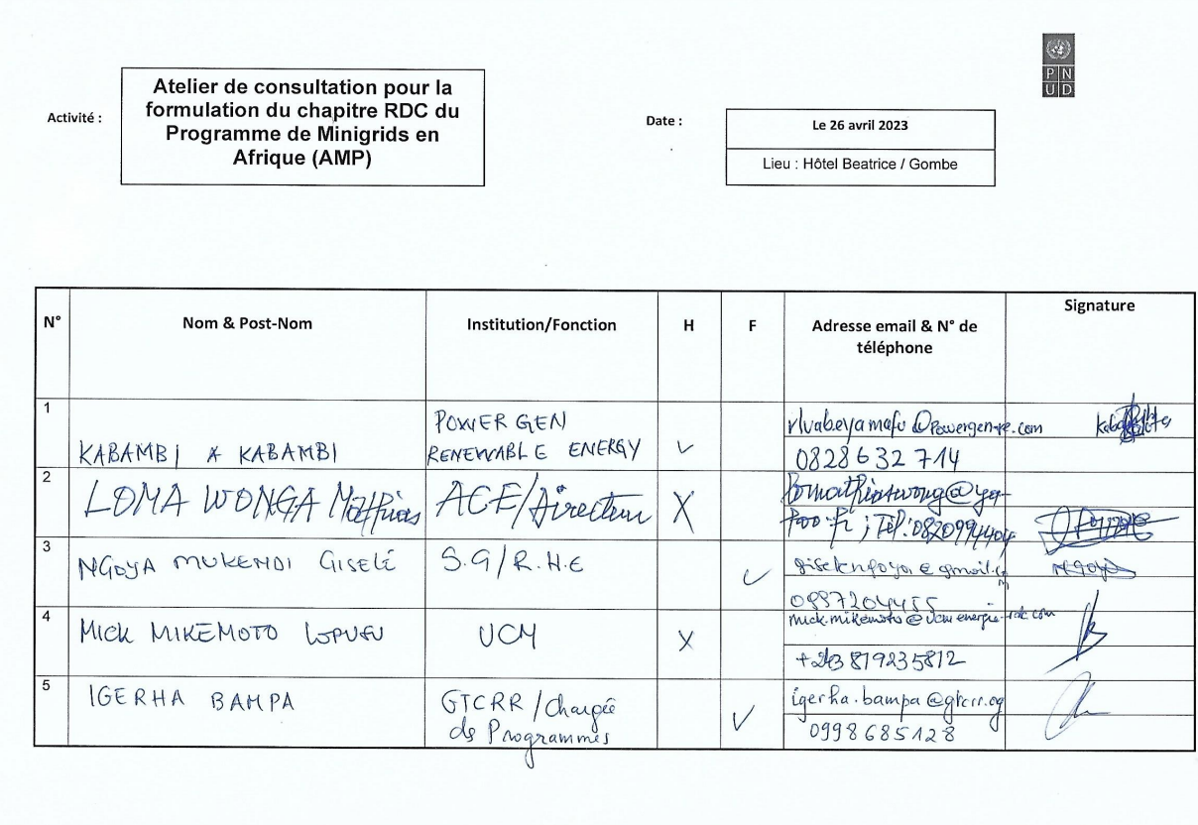
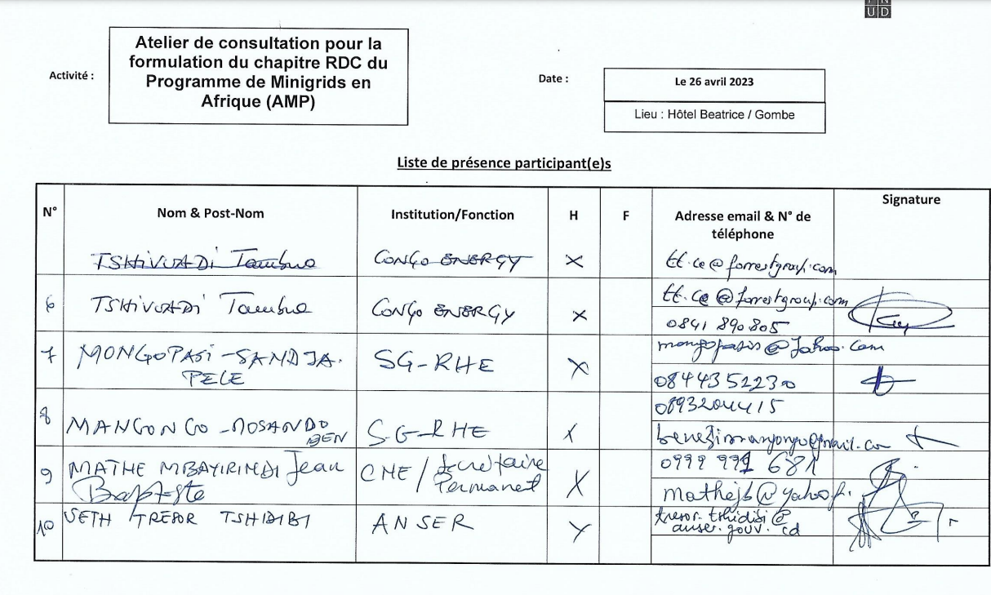

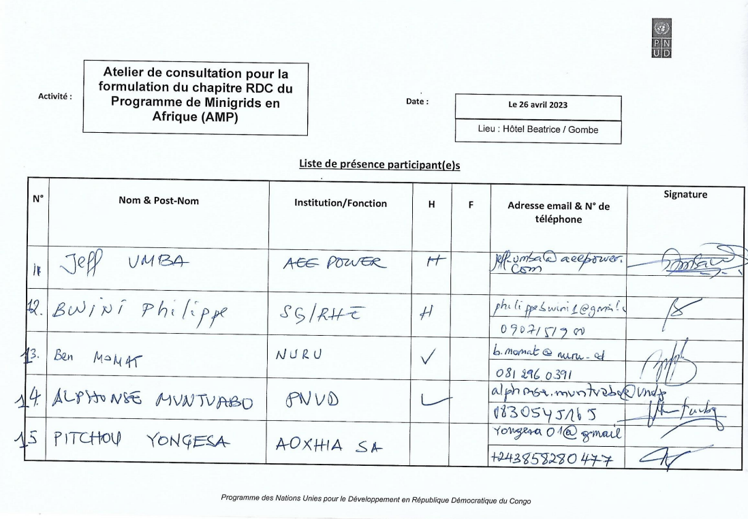
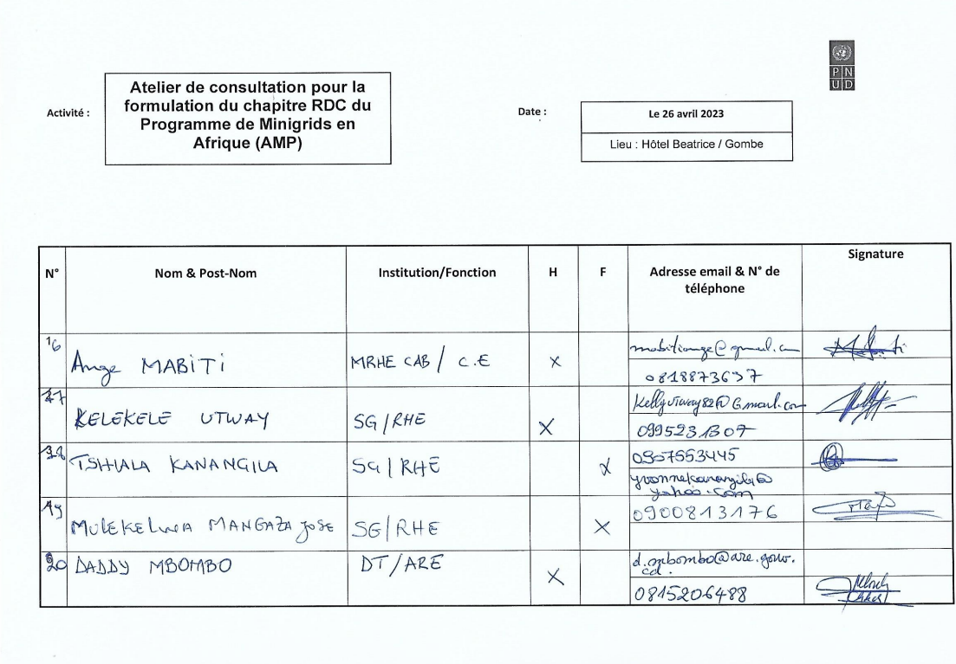
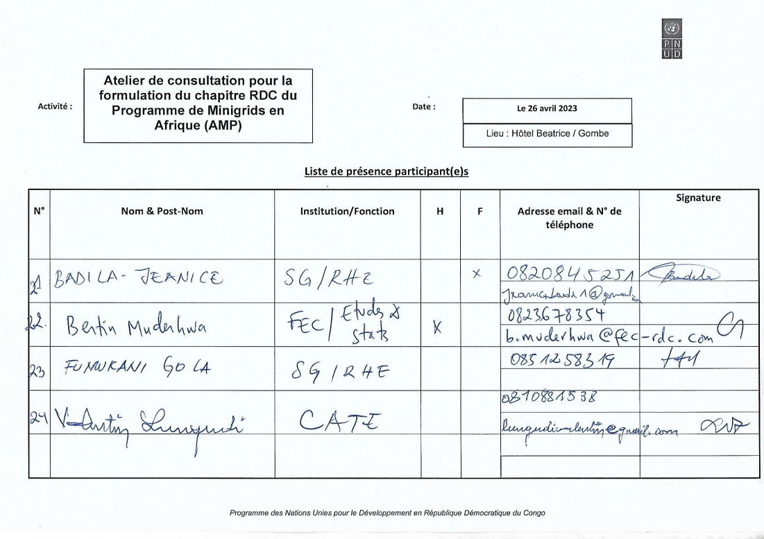
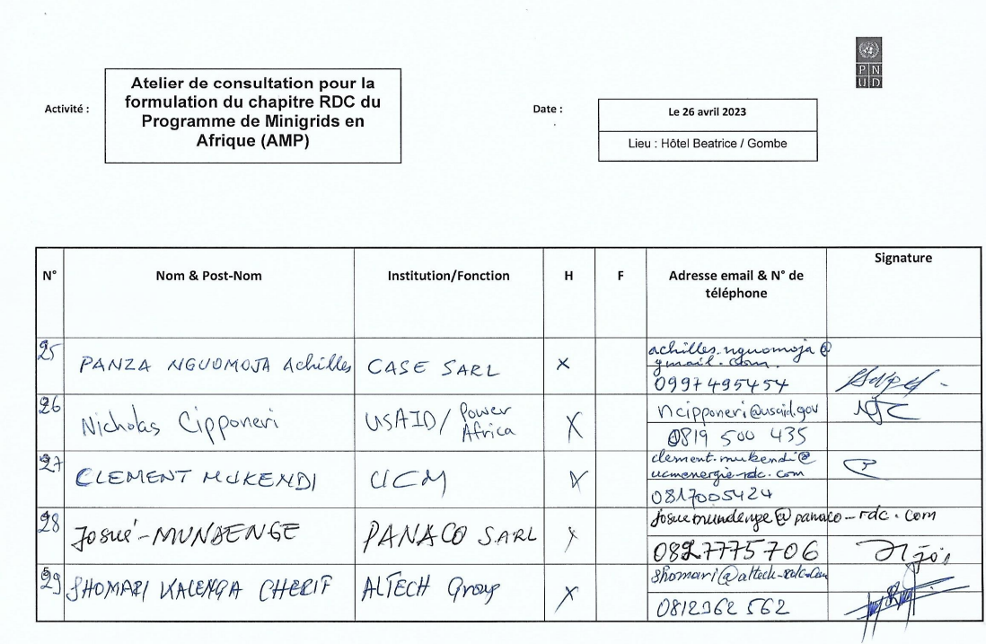
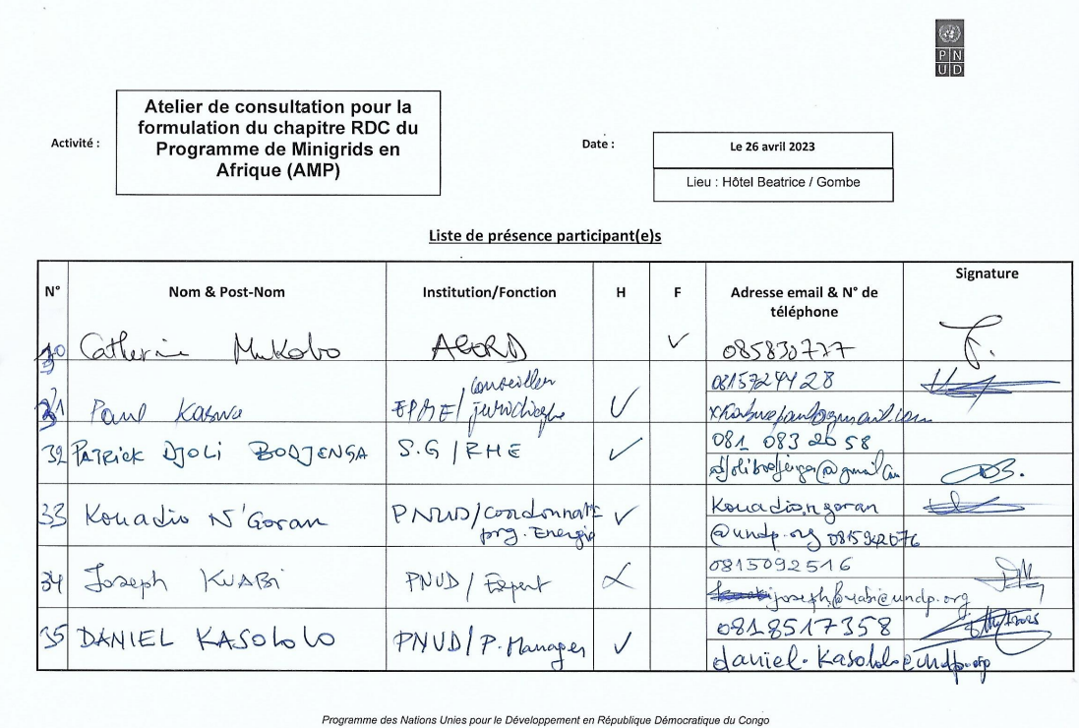

Attendance List from Project Validation Workshop held on 21 July 2023
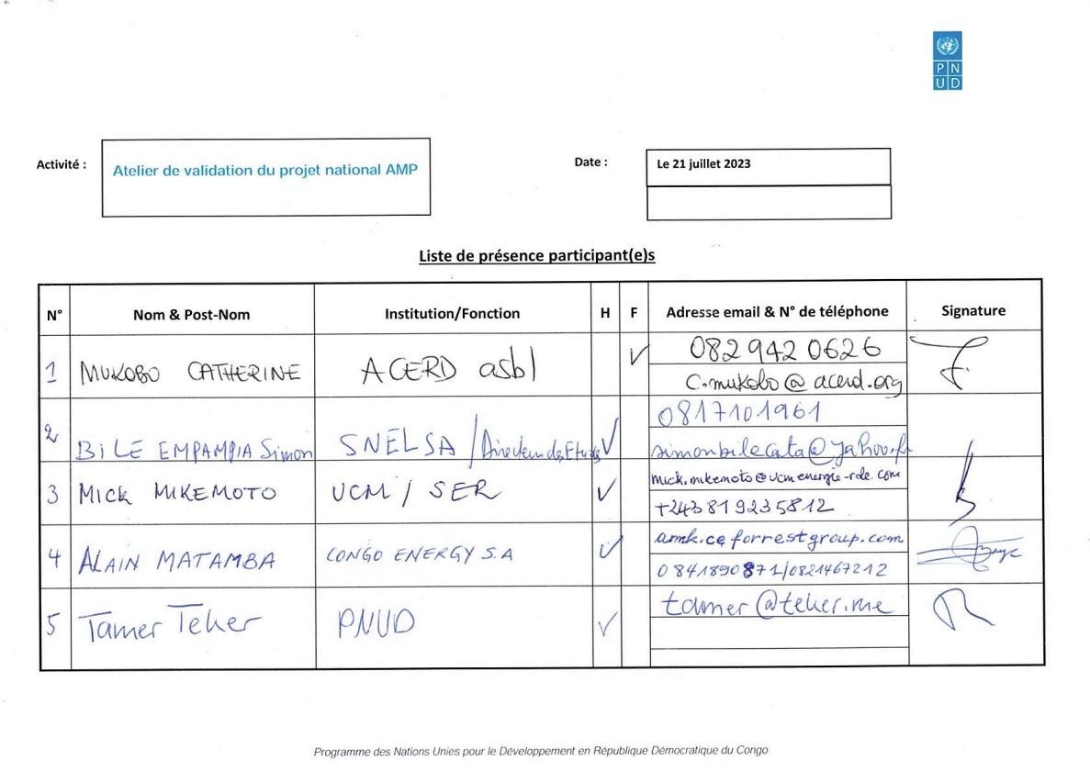
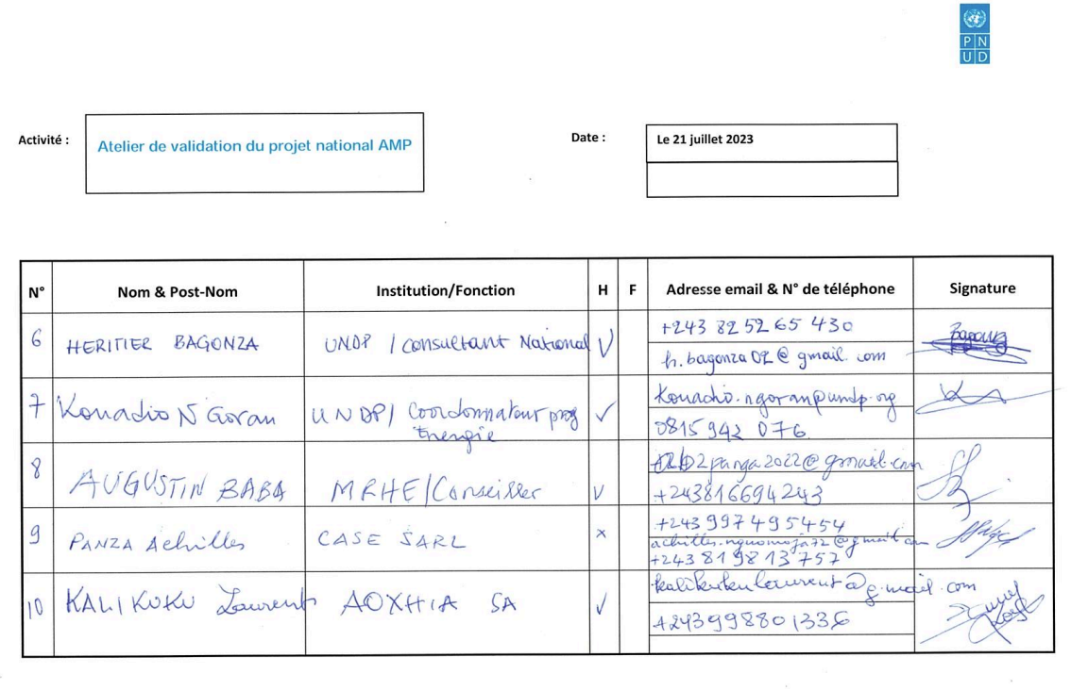
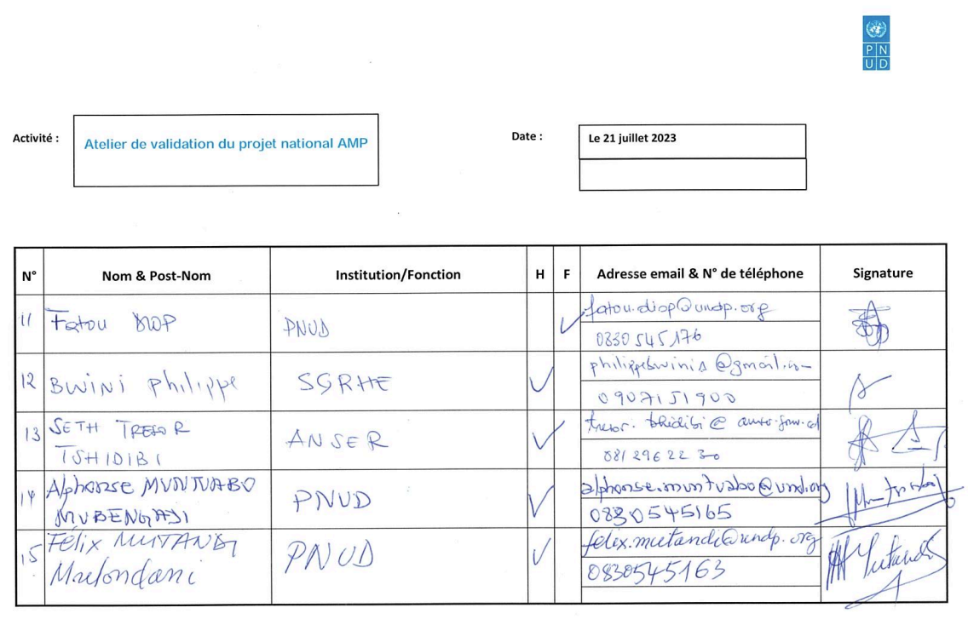
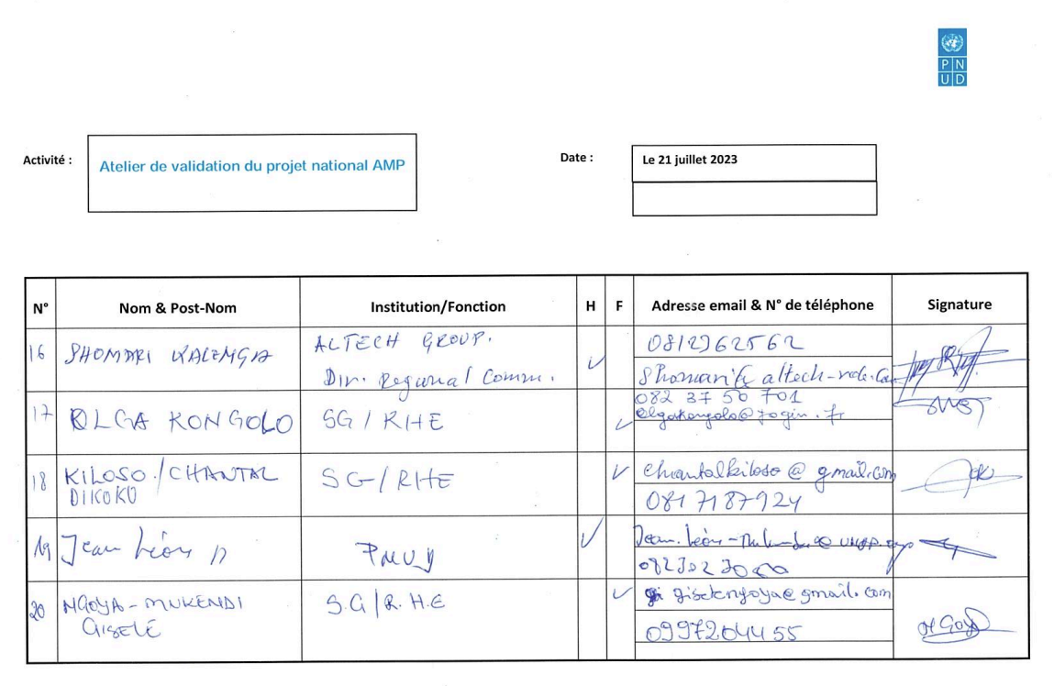
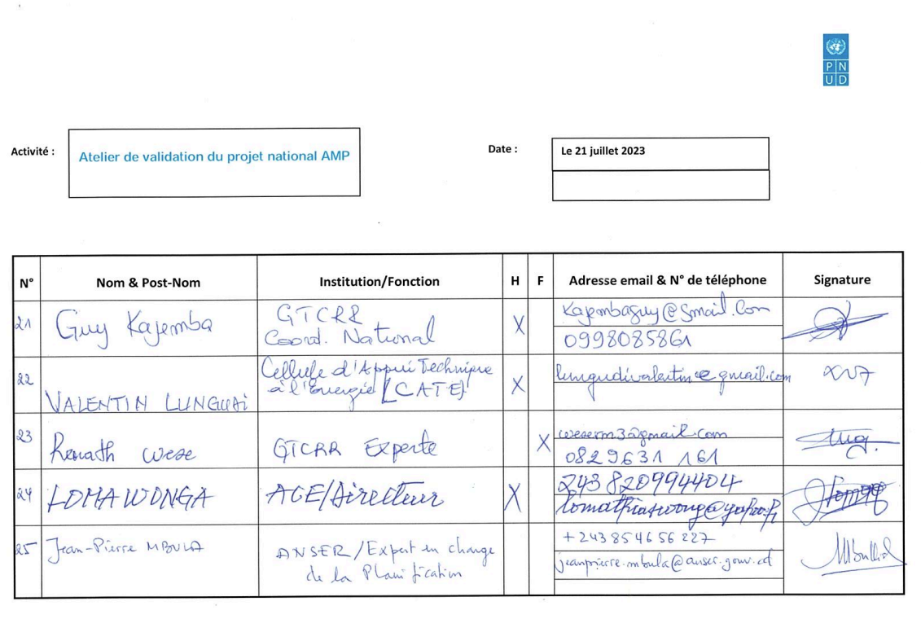
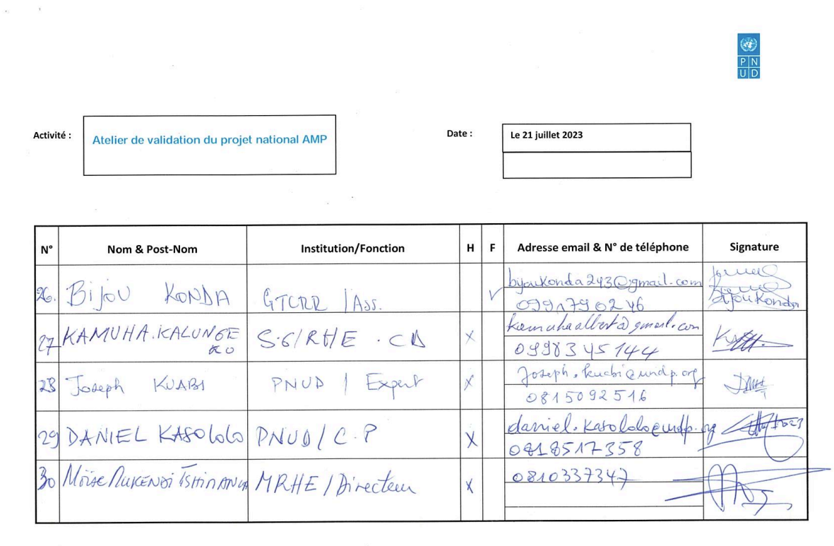
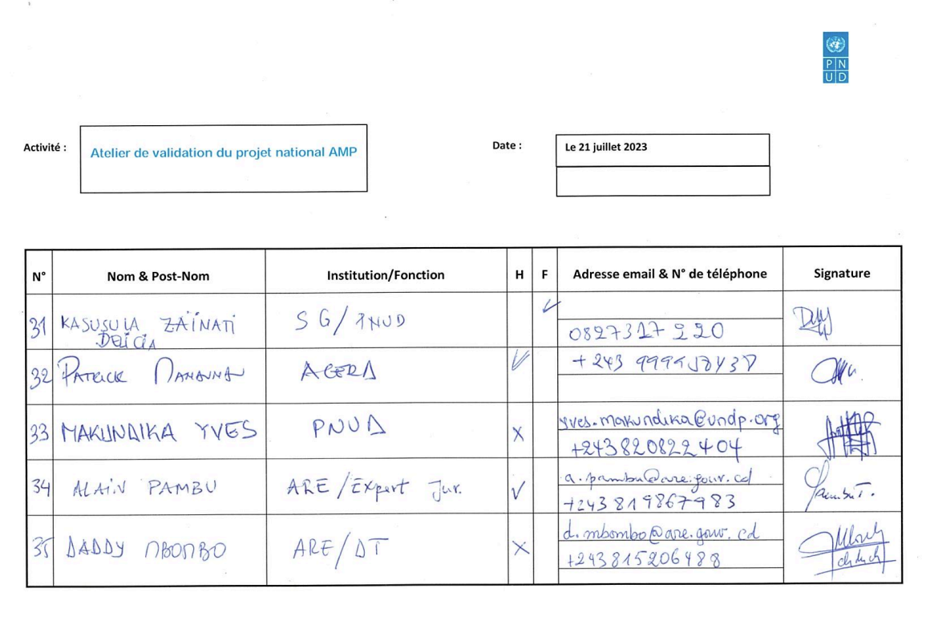
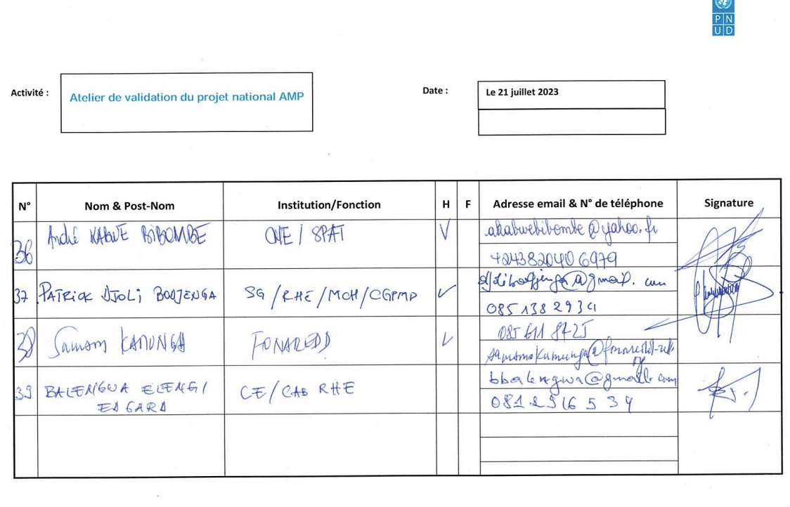

Annex 9: Environmental and Social Management Framework (ESMF)
N/A.

Annex 10: Gender Analysis and Gender Action Plan
Provided as separate document.

Annex 11: Procurement Plan

Procurement Rules Overview
The following procurement rules apply per UNDP Programme and Operations Policies and Procedures:
Procurement method | Contract value | Type of requirement | Method of solicitation | Type of competition
Micro-purchasing | Below US $5,000 ($10,000 if approved by the Bureau) | Goods, services or simple works | Canvassing (by phone, Internet, shopping, etc.) | Limited international or national
Request for quotation | US $5,000 ($10,000 if approved by the Bureau) to $199,999 | Goods, services or simple works | Written request for quotation | Limited international or national
Invitation to bid | US $200,000 and above | Goods or works | Advertisement in international media | Open international
Request for proposal | US $200,000 and above | Services | Advertisement in international media | Open international
Request for Proposal –for low value | Up to $199,999 | Services | Written request for proposal | Limited international or national
Direct contracting | Any amount within permissible circumstances | Services, goods or works | Direct invitation or negotiation | None

Procurement Plan
Table 1: Expected Goods and Non-Consulting Services
No | General Description | Contract Value USD (cumulative) | Procurement Method | Procured by | No. of contracts | Initiation of Procurement | Fulfillment of Procurement | Prior or Post Review
1 | Organization of various workshops, conferences, and meetings as part of Output 1.1. ($5000 per year, around 4-5 events) | 20,000 | Request for Quotation | ANSER | 20 | Q1/2024 | Q4/2028 | Post
2 | IT Equipment (laptops, software, etc.) to support Output 1.1. | 10,000 | Request for Quotation | ANSER | 1 | Q1/2024 | Q1/2024 | Post
3 | Organization of a workshop as part of Output 4.1. ($3000 per event) | 3,000 | Request for Quotation | ANSER | 1 | Q1/2024 | Q1/2024 | Post
4 | Server, domain name and other costs minigrids digital and data management platform as part of Output 4.2. | 26,000 | Request for Quotation | ANSER | 4 | Q1/2024 | Q4/2028 | Post
5 | Gather data and audio-visual content for the "insight brief" (local company), incl. translation into English, as part of Output 4.4 | 9,000 | Request for Quotation | ANSER | 1 | Q1/2025 | Q4/2028 | Post
6 | Organization of project inception and closure workshops as part of Output 5.1. | 6,000 | Request for Quotation | ANSER | 2 | Q1/2024 | Q4/2028 | Post
7 | Office equipment for PMU | 14,400 | Request for Quotation | ANSER | 1 | Q1/2024 | Q2/2024 | Post
8 | IT Equipment (laptops, software, etc.) for PMU | 10,000 | Request for Quotation | ANSER | 1 | Q1/2024 | Q1/2024 | Post

Table 2: Expected Contracted Consulting Services
No | General Description | Contract Value USD (cumulative) | Procurement Method | Procured by | No. of contracts | Initiation of Procurement | Fulfillment of Procurement | Prior or Post Review
1 | 3 national consultants (one in capital Kinshasa, 2 in ANSER's regional offices) to support national, provincial, and local working groups, as part of Output 1.1.  Each 5 days per month @ $200/day | 144,000 | Request for Quotation | ANSER | 3 | Q1/2024 | Q4/2028 | Post
2 | International consultant for DREI analysis, as part of Output 1.2.  50 days, @ $700/day | 37,500 | Request for Quotation | ANSER | 1 | Q1/2024 | Q4/2024 | Post
3 | 1 national consultant for DREI analysis, as part of Output 1.2  20 days, @ $400/day | 8,000 | Request for Quotation | ANSER | 1 | Q1/2024 | Q4/2024 | Post
4 | Costs to hire firm for capacity building, all expenses included, as part of Output 1.3. | 109,066 | Request for Quotation | ANSER | 4 | Q1/2024 | Q4/2028 | Post
5 | International capacity building consultant to perform capacity needs assessment, as part of Output 1.3.  10 days @ $750/day | 7,500 | Request for Quotation | ANSER | 1 | Q1/2024 | Q2/2024 | Post
6 | Local capacity building consultant to support capacity needs assessment, as part of Output 1.3.  10 days @ $300/day | 3,000 | Request for Quotation | ANSER | 1 | Q1/2024 | Q2/2024 | Post
7 | International consultant to review the final implementation plan of the PDL-145T and incorporate it into the AMP project via the Minigrid Pilot Plan, as part of Output 2.1.  10 days @ $750/day | 7,500 | Request for Quotation | ANSER | 1 | Q1/2024 | Q4/2024 | Post
8 | International gender and E&S consultant to review PDL-145T gender and social and environmental approach and documentation and verify alignment with UNDP SES, as part of Output 2.1.  10 days @ $700/day | 7,000 | Request for Quotation | ANSER | 1 | Q1/2024 | Q4/2028 | Post
9 | International consultant to develop a digital strategy for the project, as part of Output 3.1.  25 days @ $750/day | 18,750 | Request for Quotation | ANSER | 1 | Q1/2024 | Q4/2025 | Post
10 | International consultant to align the AMP-QAMF to the specific case of DRC, as part of Output 3.1.  5 days @ $750/day | 3,750 | Request for Quotation | ANSER | 1 | Q3/2024 | Q4/2025 | Post
11 | International consultant to perform mid-term and terminal evaluation as part of Output 4.1 | 40,000 | Request for Quotation | ANSER | 2 | Q3/2025 | Q4/2028 | Post
12 | National consultant to support mid-term and terminal evaluation as part of Output 4.1 | 12,000 | Request for Quotation | ANSER | 2 | Q3/2025 | Q4/2028 | Post
13 | Direct Contract PMU Staff:  Project Manager - 1 FTE for 4 years  FTE @ $2000/m + 20% taxes | 115,200 | Request for Quotation | ANSER | 1 | Q1/2024 | Q4/2028 | Post
14 | Direct Contract PMU Staff:  Financial Assistant - 1 FTE for 4 years  FTE @ $1200/m + 20% taxes | 69,120 | Request for Quotation | ANSER | 1 | Q1/2024 | Q4/2028 | Post
15 | National gender consultant to support various activities throughout the project (see gender action plan) | 21,900 | Request for Quotation | ANSER | 1 | Q1/2024 | Q4/2028 | Post

Annex 12: GEF focal area specific annexes
Provided as separate document.

Annex 13: Co-financing letters
Provided as separate document.

Annex 14: Additional agreements
N/A

Annex 15: Signed LOA between UNDP and IP requesting UNDP Support Services
N/A

Annex 16: GEF Core indicators

Core Indicator 6 | Greenhouse gas emission mitigated |  |  |  |  | (Metric tons of CO₂e )
 |  |  | Expected metric tons of CO₂e (6.1+6.2)
 |  |  | PIF stage | Endorsement | MTR | TE
 | Expected CO2e (direct) |  | 10,678 | 665,103
 | Expected CO2e (indirect) |  | 1,939,645 | 3,550,936
Indicator 6.4 | Increase in installed renewable energy capacity per technology
 |  | Technology | Capacity (MW/MWh)
 |  | Technology | Expected |  | Achieved
 |  | Technology | PIF stage | Endorsement | MTR | TE
 |  |  | 0.215 MW | 11.971 MW
 |  |  | 0 MWh | 29.187 MWh
Core Indicator 11 | Number of direct beneficiaries disaggregated by gender as co-benefit of GEF investment |  |  |  |  | (Number)
 |  |  | Number
 |  |  | Expected |  | Achieved
 |  |  | PIF stage | Endorsement | MTR | TE
 |  | Female | 5,384 | 171,084
 |  | Male | 5,384 | 171,084
 |  | Total | 10,769 | 342,168

Annex 17: GEF 7 Taxonomy

Level 1 | Level 2 | Level 3 | Level 4
Influencing models
 | Transform policy and regulatory environments
 | Strengthen institutional capacity and decision-making
 | Convene multi-stakeholder alliances
 | Demonstrate innovative approaches
 | Deploy innovative financial instruments
Stakeholders
 | Indigenous Peoples
 | Private Sector
 |  | Capital providers
 |  | Financial intermediaries and market facilitators
 |  | Large corporations
 |  | SMEs
 |  | Individuals/Entrepreneurs
 |  | Non-Grant Pilot
 |  | Project Reflow
 | Beneficiaries
 | Local Communities
 | Civil Society
 |  | Community Based Organization
 |  | Non-Governmental Organization
 |  | Academia
 |  | Trade Unions and Workers Unions
 | Type of Engagement
 |  | Information Dissemination
 |  | Partnership
 |  | Consultation
 |  | Participation
 | Communications
 |  | Awareness Raising
 |  | Education
 |  | Public Campaigns
 |  | Behavior Change
Capacity, Knowledge and Research
 | Enabling Activities
 | Capacity Development
 | Knowledge Generation and Exchange
 | Targeted Research
 | Learning
 |  | Theory of Change
 |  | Adaptive Management
 |  | Indicators to Measure Change
 | Innovation
 | Knowledge and Learning
 |  | Knowledge Management
 |  | Innovation
 |  | Capacity Development
 |  | Learning
 | Stakeholder Engagement Plan
Gender Equality
 | Gender Mainstreaming
 |  | Beneficiaries
 |  | Women groups
 |  | Sex-disaggregated indicators
 |  | Gender-sensitive indicators
 | Gender results areas
 |  | Access and control over natural resources
 |  | Participation and leadership
 |  | Access to benefits and services
 |  | Capacity development
 |  | Awareness raising
 |  | Knowledge generation
Focal Areas/Theme
 | Climate Change
 |  | Climate Change Mitigation
 |  |  | Agriculture, Forestry, and other Land Use
 |  |  | Energy Efficiency
 |  |  | Sustainable Urban Systems and Transport
 |  |  | Technology Transfer
 |  |  | Renewable Energy
 |  |  | Financing
 |  |  | Enabling Activities
 |  | United Nations Framework on Climate Change | Nationally Determined Contribution
 | Rio Markers
 |  | Paris Agreement
 |  | Sustainable Development Goals
 |  | Climate Change Mitigation 0
 |  | Climate Change Mitigation 1
 |  | Climate Change Mitigation 2
 |  | Climate Change Adaptation 0
 |  | Climate Change Adaptation 1
 |  | Climate Change Adaptation 2

Annex 18: Partners Capacity Assessment Tool and HACT assessment
Provided as separate document.

Annex 19: UNDP Project Quality Assurance Report
Will be prepared as a separate document by the Country Office after the project has been CEO endorsed by the GEF and made available to the LPAC members. It does not need to be submitted to the GEF and does not need to be part of the project document that is signed by the relevant parties.

https://unsdg.un.org/un-in-action/democratic-republic-congo
https://digitallibrary.un.org/record/3841153?ln=en
World Bank. 2023. Poverty & Equity Brief – Democratic Republic of Congo.
UNDP (United Nations Development Programme). 2022. Human Development Report 2021-22: Uncertain Times, Unsettled Lives: Shaping our Future in a Transforming World. New York.
World Bank. 2023. DataBank.
IMF (International Monetary Fund). 2023. IMF Country Report No. 23/244 – Democratic Republic of the Congo.
World Bank. 2022. Project Appraisal Document – Access, Governance, and Reform for the Electricity and Water Sectors Project – Democratic Republic of Congo.
IEA, IRENA, UNSD, World Bank, WHO. 2023. Tracking SDG 7: The Energy Progress Report.
Gouvernement de la République Démocratique du Congo. 2023. Programme de developpement local des 145 territoires.
IMF (International Monetary Fund). 2023. IMF Country Report No. 23/244 – Democratic Republic of the Congo.
Commission économique des Nations Unies pour l’Afrique & Fondation RES4Africa. 2022. Analyse du cadre politique et réglementaire du secteur de l’électricité en République démocratique du Congo : attirer les investissements du secteur privé.
World Bank. 2020. Increasing access to electricity in the Democratic Republic of Congo. Opportunities and challenges.
IEA, IRENA, UNSD, World Bank, WHO. 2023. Tracking SDG 7: The Energy Progress Report.
Commission économique des Nations Unies pour l’Afrique & Fondation RES4Africa. 2022. Analyse du cadre politique et réglementaire du secteur de l’électricité en République démocratique du Congo : attirer les investissements du secteur privé.
ANSER (Agence Nationale de l’Electrification et des Services Energetiques en milieux Rural et periurbain). 2022. https://anser.gouv.cd/wpfd_file/rapport-annuel-2021/.
ANSER (Agence Nationale de l’Electrification et des Services Energetiques en milieux Rural et periurbain). 2023. Rapport annuel 2022.
World Bank Group. 2022. Project Appraisal Document – Access, Governance, and Reform for the Electricity and Water Sectors Project – Democratic Republic of Congo.
FCDO (UK Foreign, Commonwealth & Development Office). 2022. Essor’s Access to Electricty (A2E) Mini-Grids Intervention – Case Study.
Sustainable Energy for All. 2023. Universal Energy Facility.
Sustainable Energy for All. 2023. Universal Energy Facility to grant up to USD 10.4 million for renewables in Democratic Republic of the Congo, Madagascar and Sierra Leone.
UNDP (United Nations Development Programme). 2016. Document de projet – Promotion de mini et microcentrales hydroélectriques en RDC.
UNDP (2018) Derisking Renewable Energy Investment: Off-Grid Electrification
A first round of 11 national projects approved at the concept stage in the GEF December 2019 work programme (Angola, Burkina Faso, Comoros, Djibouti, Ethiopia, Eswatini, Madagascar, Malawi, Nigeria, Somalia and Sudan). A second round of 7 national projects have been approved at the concept stage in the GEF June 2021 work programme (Benin, Chad, Niger, Mali, Mauritania, Sao Tome & Principe, and Zambia). A third round of 3 national projects (Burundi, DRC, Liberia) have been approved at the concept stage in the GEF June 2022 work programme.
IEA (2022), Tracking SDG7: The Energy Progress Report, 2022, IEA, Paris https://www.iea.org/reports/tracking-sdg7-the-energy-progress-report-2022
The designations employed and the presentation of material on this map do not imply the expression of any opinion whatsoever on the part of the Secretariat of the United Nations or UNDP concerning the legal status of any country, territory, city or area or its authorities, or concerning the delimitation of its frontiers or boundaries.
Solutions are commonly grouped into four categories: (i) digital planning, (ii) digital operations, (iii) digital aggregation platforms, and (iv) digital payments
As described by SEforAll, access to energy is not the end in itself, but a means to many ends. Reliable and affordable energy is needed to improve living standards, increase rural incomes, support delivery of health and educational services, and improve gender and social inequality. It also enables access to clean cooking technologies and fuels – essential to reducing indoor air pollution and associated health risks. https://www.seforall.org/sites/default/files/Beyond-Connections-Introducing-Multi-Tier-Framework-for-Tracking-Energy-Access.pdf
UNDP (United Nations Development Programme). 2021. Project Document – PDL-145T.
ANSER (Agence Nationale de l’Electrification et des Services Energetiques en milieux Rural et periurbain). 2023. Rapport annuel 2022.
Unlike for the 1st and 2nd Rounds of AMP national projects, the indirect GHG emission reduction targets for 3rd round AMP national projects (DRC, Liberia, Burundi) correspond to 100% of the indirect GHG benefits calculated for the project. For the 1st and 2nd Rounds of AMP national projects, 10% of the estimated indirect GHG mitigated of each project have been removed from the project and allocated to the AMP regional project, in line with the apportioning of the overall program budget and reflected in the Program Framework Document (PFD) allocation of GHG emissions reductions across the different AMP national projects. This reflects the benefits of AMP national projects accessing the regional project’s support which is expected to contribute and enhance the enabling conditions required for minigrids development across AMP countries. For the 3rd Round projects such allocation was not possible because the regional project had already been CEO Endorsed by the time of the submission of the 3rd round PFD Addendum and its accompanying Concepts (submitted for approval in the June 2022 GEF Council).
https://panorama.solutions/en
United Nations Development Assistance Frameworks (UNDAF)
Country Programme Document (CPD)
Regional Programme Document (RPD)
See https://www.thegef.org/projects-operations/policies-guidelines
See http://www.undp.org/content/undp/en/home/operations/transparency/information_disclosurepolicy/
See https://www.thegef.org/gef/policies_guidelines
Data collection methods should outline specific tools used to collect data and additional information as necessary to support monitoring. The PIR cannot be used as a source of verification.
See https://popp.undp.org/ https://popp-prod.acquia.undp.org/policy-page/close-and-transition.
World Bank. (2023). Retrieved from https://data.worldbank.org/indicator/EG.ELC.ACCS.ZS?locations=CG (Accessed 12 July 2023)
See “SESP Summary” for detailed breakdown by event, cause, impact.
World Bank Group (2023). Gender Data Portal. Retrieved from https://genderdata.worldbank.org/countries/congo-dem-rep/ (Accessed 12 July 2023)
Prohibited grounds of discrimination include race, ethnicity, sex, age, language, disability, sexual orientation, gender identity, religion, political or other opinion, national or social or geographical origin, property, birth or other status including as an indigenous person or as a member of a minority. References to “women and men” or similar is understood to include women and men, boys and girls, and other groups discriminated against based on their gender identities, such as transgender and transsexual people.
See the Convention on Biological Diversity and its Cartagena Protocol on Biosafety.
See the Convention on Biological Diversity and its Nagoya Protocol on access and benefit sharing from use of genetic resources.
Forced eviction is defined here as the permanent or temporary removal against their will of individuals, families or communities from the homes and/or land which they occupy, without the provision of, and access to, appropriate forms of legal or other protection. Forced evictions constitute gross violations of a range of internationally recognized human rights.
Inform (provide stakeholders with balanced and objective information to assist them with understanding developments, progress, issues, opportunities and solutions). Consult (obtain feedback from stakeholders on design, findings, analyses, options and/or decisions). Involve (Work directly with stakeholders throughout the process to ensure concerns and/or views are consistently understood and considered. Collaborate (Collaborate with stakeholders as partners throughout the process, including in the analyses and development of solutions and in making decisions).
Where Very frequent is likely to be ongoing or at least once a month, Frequent is likely to be monthly to quarterly, Less frequent: once or twice a year and Occasional: on an ad hoc basis, but with all general information readily available for access.
https://popp.undp.org/policy-page/procurement-methods

